Abstract

Title: Implant-related osteomyelitis after hip and limb prosthesis in dogs and cats*
Şengöz Şirin Ö¹, Barut A², Schwarz G³,
¹Department of Surgery, Faculty of Veterinary Medicine, University of Mehmet Akif Ersoy, Burdur, Turkey
²PetCode Animal Hospital, Ankara, Turkey
³Tierklinik, Hollabrunn, Austria

Keywords: Limb prosthesis, total hip prosthesis, Osteomyelitis, Radiography, Antimicrobial sensitivity,cat,dog.

- Abstract Body

Osteomyelitis is a term used to describe the infection that occurs in the bone. Bacteria, fungi, protozoa and viruses can cause osteomyelitis. Corrosion in foreign bodies and metallic implants is also indicated as the cause of osteomyelitis. The purpose of this study was to examine the causes of osteomyelitis in our prosthesis cases. Six patients with amputation indications and three patients with total hip prosthesis indications were included in the study. Electromyography recordings were taken before the operation of the affected limb and it was evaluated that there was no neurological damage suitable for the prosthesis. When everything is done according to surgical rules, complications still arise. Complications are inevitable in some cases when appropriate implantation is used, in which implant corrosion is considered to prevent biofilm formation. Radiological and histopathological examinations confirmed that the diagnosis of osteomyelitis in all complicated patients. The causative agent of osteomyelitis was isolated and identified by microbiological examination in cases.

- Images

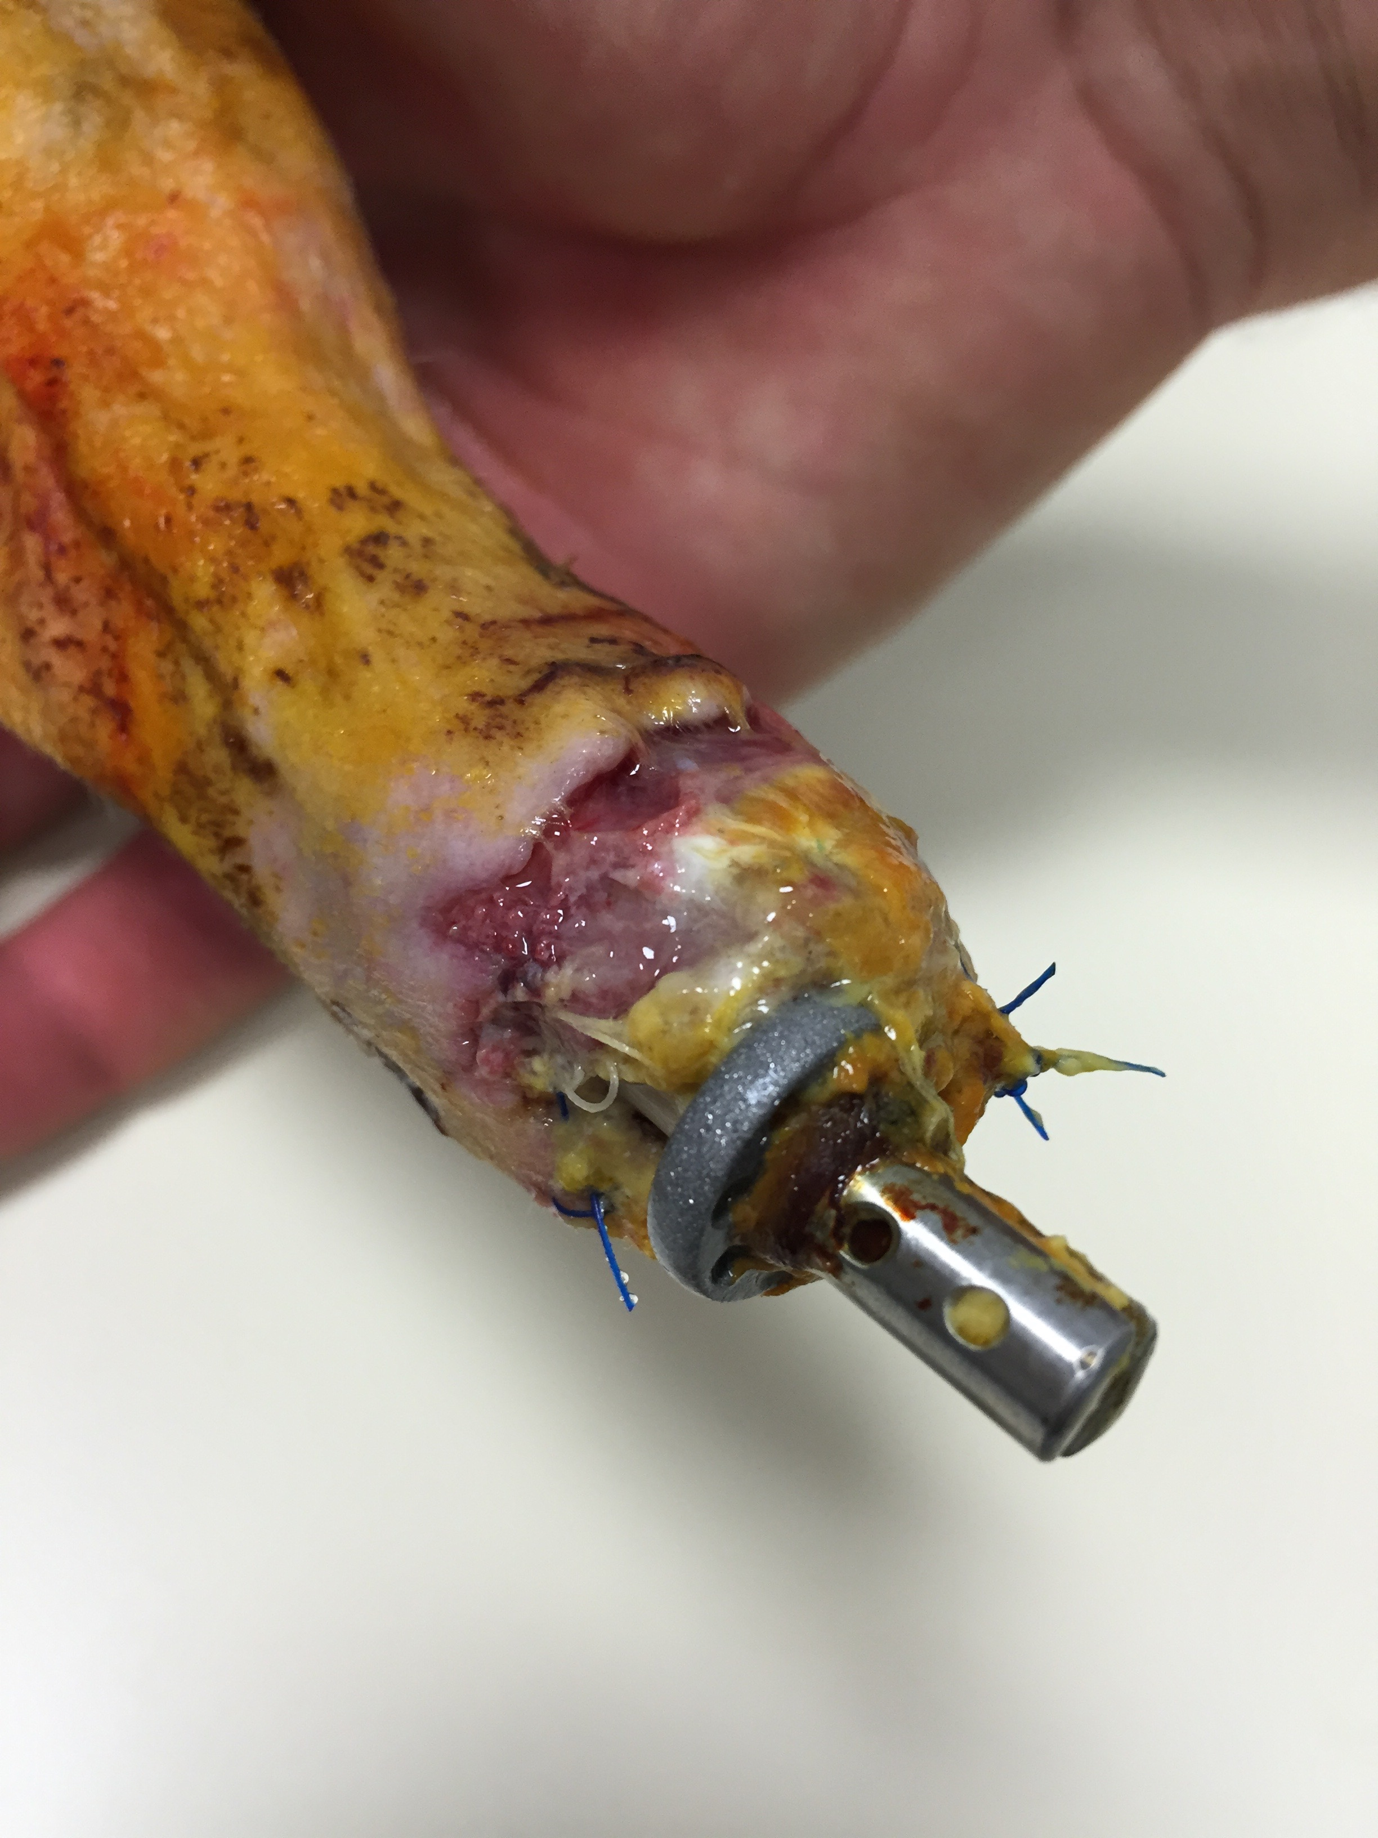
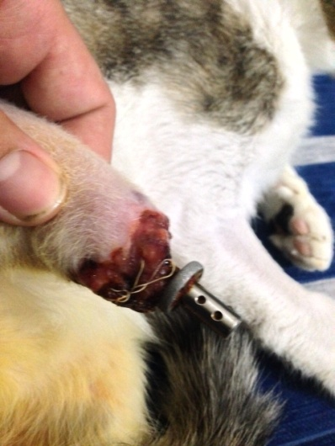
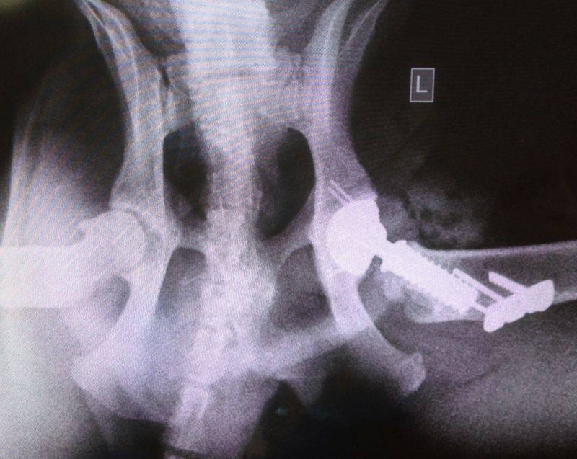
Clinical appearances in case 3 and 6. Note that infection areas surrounding limb prosthesis

Radiographical appearances in case 7

- Reference:
- Soontornvipart, K., Necas, A., Drovak, M.,2003. Effects of Metallic Implant on the Risk of Bacterial Osteomyelitis in Small Animal. Acta Vet Brno., 72: 235–247
- Hayes, G., Moens, N., Gibson, T., 2013. A review of local antibiotic implants and applications to veterinary orthopaedic surgery. Vet Comp Orthop Traumatol., 26: 251–259
- Genain, M.A.,Brioschi, V., Hare, C., Ortiz A.,Herratage, M.E. 2017. Osteomyelitis caused by β-haemolytic Listeria species in a dog Vet Rec Case Rep; 5:e000520
- Biography:
Özlem Şengöz Şirin has completed his PhD in 2008 from Ankara University and postdoctoral studies from Mehmet Akif Ersoy University School of Veterinary Medicine. She was the coordinator and instructor of the first AOVET course in Turkey. Additionaly, she is working in group of TINNET as a delegate of Turkey (TINNET is a European research network funded by the COST program under the Action number BM1306). She finished six important projects in her country and still she is dealing with two projects. She gives orthopedic trainings in her country. She is married and she has two children.

- Presenting author details


Full Name: Assist.Prof.Dr.Özlem ŞENGÖZ ŞİRİN
Contact number:+90 5306121621
Twitter account: https://twitter.com/ozlem_sengoz
Linked In account: https://www.linkedin.com/in/ozlem-sengoz-7180b310/
Session name/ number: Veterinary Surgery
Category: Oral presentation
* This study was supported by Mehmet Akif Ersoy University Scientific Research Projects Commission (Project number: 0237-Güdümlü-14).

