Recombinant Lactobacillus plantarum expressing HA2 antigen elicits protective immunity against H9N2 avian influenza virus in chickens
Wen-Tao Yang¹, Gui-Lian Yang¹, Xin Yang¹, Seria-Masole Shonyela¹, Liang Zhao¹, Yan-Long Jiang¹, Hai-Bin Huang¹, Chun-Wei Shi¹, Jian-Zhong Wang¹, Guan Wang¹, Jin-Hui Zhao¹, Chun-Feng Wang¹

Abstract
Low pathogenic H9N2 subtype avian influenza virus (AIV) can lead to moderate respiratory symptoms and low egg production rates in poultry. Due to its immunologic suppression, other various infectious pathogens give rise to the co-infection of hosts, causing heavy economic losses in the commercial poultry industry in both China and worldwide. Therefore, it is time to explore a novel, safe, and effective vaccine. We have already made use of the surface of Lactobacillus plantarum to display AIV HA2 (NC8-pSIP409-pgsA′-HA2), which demonstrated that it has a good immunogenicity. In this study, by evaluating the immune protection effect of NC8-pSIP409-pgsA′-HA2 on chickens, we found that the hemagglutination inhibition (HI) antibodies, specificity IgG antibody in chickens, the sIgA titer in broncho alveolar lavage fluids (BALF), and the T cell response were increased notably after oral vaccination with NC8-pSIP409-pgsA′-HA2. In addition, weight loss, lung titers, and lung pathologies were improved when chickens were orally vaccinated with NC8-pSIP409-pgsA′-HA2 after challenge with H9N2 AIV. This strategy lays the foundation for the development of recombinant L. plantarum oral vaccines in the prevention of AIV.
Image
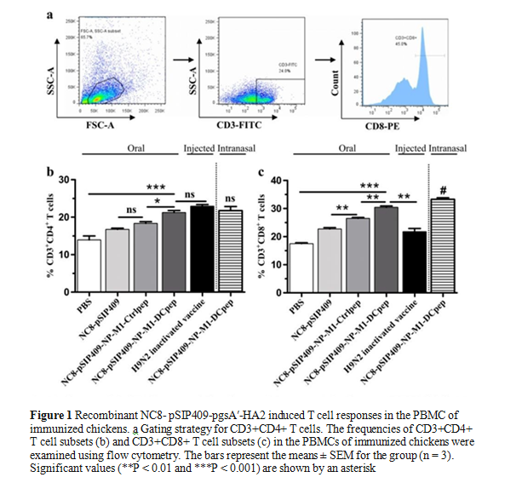
Recent Publications
- Shonyela SM, Wang G, Yang W, Yang G, Wang C: New Progress regarding the Use of Lactic Acid Bacteria as Live Delivery Vectors, Treatment of Diseases and Induction of Immune Responses in Different Host Species Focusing on &lt;i&gt;Lactobacillus&lt;/i&gt; Species. World Journal of Vaccines 2017, Vol.07No.04:33
- Jin Y-B, Yang W-T, Huang K-Y, Chen H-L, Shonyela S-M, Liu J, Liu Q, Feng B, Zhou Y, Zhi S-L et al: Expression and purification of swine RAG2 in E. coli for production of porcine RAG2 polyclonal antibodies. BBB 2017, 81(8):1489-1496.
- Yang WT, Yang GL, Yang X, Shonyela SM, Zhao L, Jiang YL, Huang HB, Shi CW, Wang JZ, Wang G et al: Recombinant Lactobacillus plantarum expressing HA2 antigen elicits protective immunity against H9N2 avian influenza virus in chickens. AMB 2017, 101(23-24):8475-8484.
- Shonyela SM, Mkupasi EM, Sikalizyo SC, Kabemba EM, Ngowi HA, Phiri I: An epidemiological survey of porcine cysticercosis in Nyasa District, Ruvuma Region, Tanzania. Parasite Epidemiology and Control 2017, 2(4):35-41

 Biography
Seria Masole is a native of Isyesye, Mbeya, Tanzania she was born and raised there. She is a Mother of 3 Children. Her Life style background has led her to work hard and to have a number of opportunities. Employment: Local government. Education: PHD (Doctor of Philosophy). Professional: she is Veterinary medicine doctor; when animal experience trauma, her greater enthusiasm is to convey healing. Institutions: SUA in Tanzania, UNZA in Zambia, WDM&M Course at the NWRC in Fort Collins, Colorado United State of America and JLAU in China.
Countries visited: South Africa, Botswana, Zimbabwe, Zambia, Kenya, Ethiopia, Egypt, Spain, U.S.A and China.
Languages: Excellent to speak, write and Listening: Safwa, Swahili, and English and Good/fair to speak, write and Listening: Chinese
Email: seria.masole@sacids.org

