RAW FEEDING OF DOGS IN HUNGARY – THROUGH THE EYES OF THE OWNERS
Kungl Krisztina, Department of Clinical Pathology and Oncology, University of Veterinary Medicine, Budapest, Hungary Wermer Kata Alina, Department and Clinic of Equine Medicine, University of Veterinary Medicine, Budapest, Hungary

Abstract

Introduction and goals: feeding RMBDs (raw meat-based diets) to dogs reached significant popularity recently in Hungary. We studied common motivations for feeding RMBDs to gain an insight into where/when the owners learned about it, what were the most important motivations to choose RMBDs.

Material and method: Our study was based on a standardized web-questionnaire for dog owners. 767 people filled in the questionnaire. We selected 3 groups based on diet: (1) only RMBD (NY – 438 responses); (2) mixed diet (RMBD and other) (V - 91); (3) non-RMBD feeders (E - 238).

Results: among non-RMDB feeders the most common source of advice was a veterinarian (38%), among RMBD feeders social media groups (34%), “a friend” (31%).

Motivation: 75% of RMBD feeders put emphasise on RMBD as „natural diet”, (10% for non-RMBD). Additionally, RMBD group: building muscle, weight-control, exact knowledge of feed composition, dental calculus prevention, good digestibility and hair-coat quality. 13% of this group claim RMBD safe, only 1 person expressed concern on infectious pathogens. For 82% of RMBD facebook was the primary and for 13% the only information source for the detailed diet. The non-raw feeders primarily identified the vet as a source of detailed information (53%).

Discussion: Info about raw meat-based diets reaches dog owners via non-scientific routes, meanwhile, more non-RMBD feeders follow diets advised by qualified persons. Owners first hear about raw diets from social network groups and friends, detailed info sources are mostly the same. Many RMBD feeders marked scientific articles as source of information, however, the authors found very limited access to such articles. RMBDs advantage claims are highly subjective and anecdotal, high quality scientific studies are lacking. The raw diet users are either unaware or are not willing to admit the increased risk of infection both of their pets and themselves.

Image
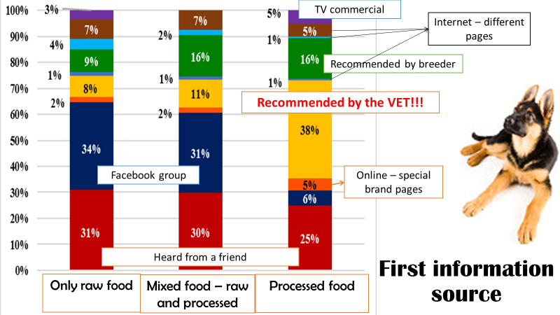
Recent Publications
- Axelsson, E., Ratnakumar, A., Arendt et.al. 2013: The genomic signature of dog domestication reveals adaptation to a starch-rich diet. Nature 495. 360–364.
- inley, R., Reid-Smith, R., Ribble, C. et al. 2008: The occurrence and antimicrobial susceptibility of Salmonellae isolated from commercially available canine raw food diets in three Canadian cities. Zoonoses and Public Health. 55. 8-10. p. 462–469.
- Freeman, L. M., Chandler, M. L., Hamper, B. A., Weeth, L. P., 2013: Current knowledge about the risks and benefits of raw meat–based diets for dogs and cats. Journal of the American Veterinary Medical Association. 243. 11. p. 1549-1558
- Lumbis, R., Chan, D. L., 2015: The raw deal: clarifying the nutritional and public health issues regarding raw meat-based diets. The veterinary Nurse. 6. 6. p. 336-341.
- Zeugswetter, F. K., Vogelsinger, K., Handl, S., 2013: Hyperthyroidism in dogs caused by consumption of thyroid-containing head meat. Schweiz Arch Tierheilkd. 155. 2. p. 149-152.

 Biography
Dr. Krisztina Kungl graduated at the Faculty of Veterinary Medicine, Wrocław University of Environmental and Life Sciences, Poland. In the Department of Internal Medicine and Clinic of Diseases of Horses, Dogs and Cats she was responsible teacher for Companion animal clinical nutrition and fodder hygiene. She completed her PhD research on the Effects of dietary supplementation of ω3 and ω6 fatty acids on hair coat and skin in the healthy dog, which resulted in a worldwide patent of the formula with Hoffmann-La Roche Ltd. She currently holds a post at the Department of Clinical Pathology and Oncology, University of Veterinary Medicine, Budapest, Hungary. She continues nutrition consultation and formulation of individualized home-made diets for dogs and cats and is lecturer of clinical pathology, pathophysiology and nutrition related topics of internal medicine. Previously she was Veterinary Affairs Manager, Hill’s Pet Nutrition CEER, also worked for the Hungarian Food Safety Office (HFSO).
Email: kungl.krisztina@univet.hu

Notes/Comments:

