Genetic Evaluation of Reproductive Traits in Teddy goats
Zulfiqar H Kuthu, B.V.Sc. & A.H, Ph.D, Dean Faculty of Veterinary & Animal Sciences, The University of Poonch, Rawalakot, Azad Kashmir, Pakistan

Abstract
Data available on 20455 kidding and performance records of 5545 Teddy goats and progeny of 406 sires maintained as separate flocks at three different locations Livestock Experiment Stations Rakh Ghulaman, Rakh Khariewala and Chak Katora (1971-2008) Punjab, Pakistan were analyzed for documenting reproductive traits and genetic sources which influence these traits. The data was analyzed using the GLM procedure (General Linear Models) of the Statistical Analysis Systems (SAS, 2004) to study the various reproductive traits. The genetic parameter estimation was done using REML procedure fitting an Individual Animal Model. The Least squares means for age at first service, age at first kidding, weight at first service, weight at first kidding, services per conception, service period, kidding interval, were 245.65±0.73 days, 14.07±0.01 kg, 394.14±0.76 days, 18.06±0 kg, 1.24±0.004, 153.58±0.73 days, 327.53±1.12 days, respectively. The percentage of single births was 43 percent, while multiple births were 57 percent. The sex ratio was 51:49 males and females. The heritability estimates for age at first service, weight at first service, age at first kidding, weight at first kidding, services per conception, service period and kidding interval were 0.19±0.22, 0.21±0.01, 0.19±0.04, 0.20±0.04, 0.07±0.01, 0.06±0.05 and 0.05±0.03, respectively. The repeatability estimates for services per conception, service period and kidding interval were 0.02±0.05, 0.01±0.04 and 0.05±0.03, respectively. It is envisaged from the present study that over the 34 years period selection remained ineffective to bring the desired changes and it will

remain so if random use of breeding animals is practiced. The possible use of ineffective selection could be unavailability of efficient techniques for the evaluation of animals and incorrect performance recording etc. It is therefore, necessary to correct all these discrepancies by taking corrective measures as discussed above.
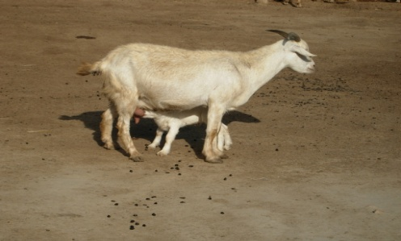
Figure 1: A teddy mother nursing a kid
Recent Publications (minimum 5)
- Abdelqader A, Yacoub A A, Gauly M (2012). Factors influencing productive longevity of Awassi and Najdi ewes in intensive production systems at arid regions. Small Rumin. Res. 104:37–44
- Bushara I, Abu Nikhaila A M M A, Mekki D M (2010). Productive and reproductive traits of Taggar goats as affected by type of ration under dry land farming system in western Sudan. Egypt. J. Sheep Goat Sci. 5:209–220.
- Ahuya C O, Ojango J M K, Mosi R O, Peacock C P, Okeyo A M ( 2009). Performance of Toggenburg dairy goats in smallholder production systems of the eastern highlands of Kenya. Small Rumin. Res. 83:7–13.
- Valencia M, Dobler J, Montaldo H H (2007). Genetic and phenotypic parameters for lactation traits in a flock of Saanen goats in Mexico. Small Rumin. Res. 68:318–322.
- Bagnicka E, Wallin E, Łukaszewicz M, Ådnøy T (2007). Heritability for reproduction traits in Polish and Norwegian populations of dairy goat. Small Rumin. Res. 68:256–262.

 Biography (150 word limit)

Zulfiqar H. Kuthu is expert has a Ph.D in Animal Breeding & Genetics. Presently working as Dean Faculty of Veterinary & Animal Sciences, The University of Poonch Rawalakot, Azad Kashmir, Pakistan. He is working on different aspects of genetics and breeding of different species of cattle, buffalo, sheep, chicken and goats. His studies on sheep, goat, buffalo and cattle of Azad Kashmir are first of its kind. He is a collaborative member of the team which has recently been able to win a major project worth $8.7 million for the establishment of Livestock center for genetics, breeding and genomics in Pakistan. He is presently working on 2 Higher Education Commission of Pakistan projects on buffalo and cattle.
Email: zulfiqar031970@gmail.com

Notes/Comments:

