Concurrent Analysis of Cytotoxic Markers by HPTLC Method in Plectranthus cylindraceus
Nawal M. Al Musayeib, KSU, SA.

Abstract
World is endowed with rich wealth of medicinal plants. Herbs have always been the principle form of medicine in the countries like India, china and currently they are becoming popular throughout the developed world for primary health care because of their curative properties due to the presence of various complex chemical substances of different composition, higher safety and low cost, but the challenges faced by these formulations arise because of their lack of complete standardization and in the global market there is no acceptance for non-standardized herbal extracts/ formulations. Thus the emerging need for chemically standardized herbal extracts/formulation based on isolated constituents, preferably bioactive ones to ensure the consistent quality of the preparation. As in herbal preparations the activity usually owe to a group of structurally related compound rather than to a single compound, suitable methods are need to be developed for the isolation, characterization of the pure biomolecules to be used as markers for standardization of the extracts/fractions/formulations by modern analytical methods viz. HPLC/HPTLC etc. In the present study, we report cytotoxic activity of the elthyl acetate fraction, as well as pure constituents isolated from the Plectranthus cylindraceus and development of development of a sensitive selective HPTLC method for the quantization of pure isolated constituents, in the P. cylindraceus fraction. The study describes a HPTLC procedure for resolution of constituents, identification and quantification of selected bioactive markers in P. cylindraceus fraction. Maaliol (1), penduletin (2) and chrysophenol D (3) were employed as external standards (Figure 1). The developed HPTLC method was a maiden method used for the quantitative analysis of cytotoxic markers Maaliol, Penduletin and Chrysophenol D in the P. cylindraceus extracts which can be further applied in the analysis of these biomarkers in other plant species extracts as well as in the marketed preparations and quality control of herbal drugs.

Image
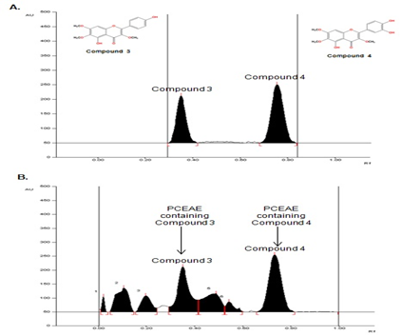
Figure 1.
Sharp intense, compact peaks for compound 2 and 3 at Rf = 0.37±0.002 and Rf = 0.77±0.003
Recent Publications
- Al Musayeib NM, Mothanaa RA, Mohamed GA, Ibrahim SRM, Maese L. (2014) Hypoestenonols A and B, new fusicoccane diterpenes from Hypoestes forskalei. Phytochem Lett. 10:23-27.
- Alam P, Parvez MK, Arbab A., Al-Dosari MS (2017) Quantitative analysis of rutin, quercetin, naringenin, and gallic acid by validated RP- and NP-HPTLC methods for quality control of anti-HBV active extract of Guiera senegalensis. Pharm Biol. 55:1317-1323.
- Burmistrova O, Perdomo J, Simões MF, et al (2015) The abietane diterpenoid parvifloron D from Plectranthus ecklonii is a potent apoptotic inducer in human leukemia cells. Phytomedicine. 22:1009-1016.
- Asresa K, Tadesse S, Mazumder A, Bucar F (2013) Essential oil of Plectranthus cylindraceus Hochst. ex. Benth from Ethiopia: Chemical composition and antimicrobial activity. J Essent Oil Bear. 16:136-143.
- Manjamalai A, Grace VM (2013) The chemotherapeutic effect of essential oil of Plectranthus amboinicus (Lour) on lung metastasis developed by B16F-10 cell line in C57BL/6 mice. Cancer Invest. 31:74-82.

Biography
Nawal Al Musayeib is a professor whose publication cover a broad spectrum of topics where by the focus is on phytochemistry and biological activity of natural products. They give substantial contribution to knowledge about chemical composition of plants, especially of those from Arabic countries, about activities and mode of a ction of plant compounds of different chemical groups.
Email: nalmusayeib@ksu.edu.sa

Notes/Comments:

