Green synthesis of silver nanoparticles using an aqueous extract of Cuminum cyminum L. seeds
Hashem Akhlaghi, Department of Chemistry, Sabzevar Branch, Islamic Azad University, Sabzevar, Iran

Abstract
There have been a growing number of reports on the preparation of nanomaterials in recent years. Nanoparticles produced by chemical methods have created significant concern due to the hazardous and toxic materials used and potential environmental damage. In the green synthesis of nanoparticles, natural compounds and eco-friendly solvents and chemicals play a major role. Silver nanoparticles are of interest because of their biological and medical applications. Plants, being inexpensive abundant and renewable resources, can be considered as good source for production of silver nanoparticles. Plants having easily oxidized secondary metabolites, such as flavonoids and other phenolic compounds can reduce silver ions to elemental silver. In this study, silver nanoparticles were synthesized using aqueous extracts from seeds of Cuminum cyminum L. (Cumin). The free radical scavenging activity and total phenolic content of the aqueous extracts were assayed by the DPPH and Folin–Ciocalteu methods, respectively. In addition, silver nanoparticles were successfully prepared and characterized by UV-Vis spectroscopy, particle size analysis, energy dispersive X-ray analysis (EDAX), Fourier transform-infrared spectroscopy (FT-IR) and transmission electron microscopy (TEM). Several parameters were varied in order to optimize synthesis of the silver nanoparticles, including pH, volume of extract, volume of silver ion solution and reaction time. The mean diameter of the silver particles was 85 nm. FT-IR revealed the presence of the same functional groups in synthesized nanoparticles as in the crude extract. Energy-dispersive X-ray spectroscopy (EDAX) showed the presence of elemental silver in the synthesized nanoparticles. TEM showed that major parts of nanoparticles have a spherical morphology, in which several nanoparticles were agglomerated. The silver nanoparticles also showed antioxidant activity. This fast and convenient method of synthesis can be used for the large-scale production of nanoparticles and can serve as an environmentally-friendly method with a variety of biotechnological, pharmaceutical and medical applications.

Image

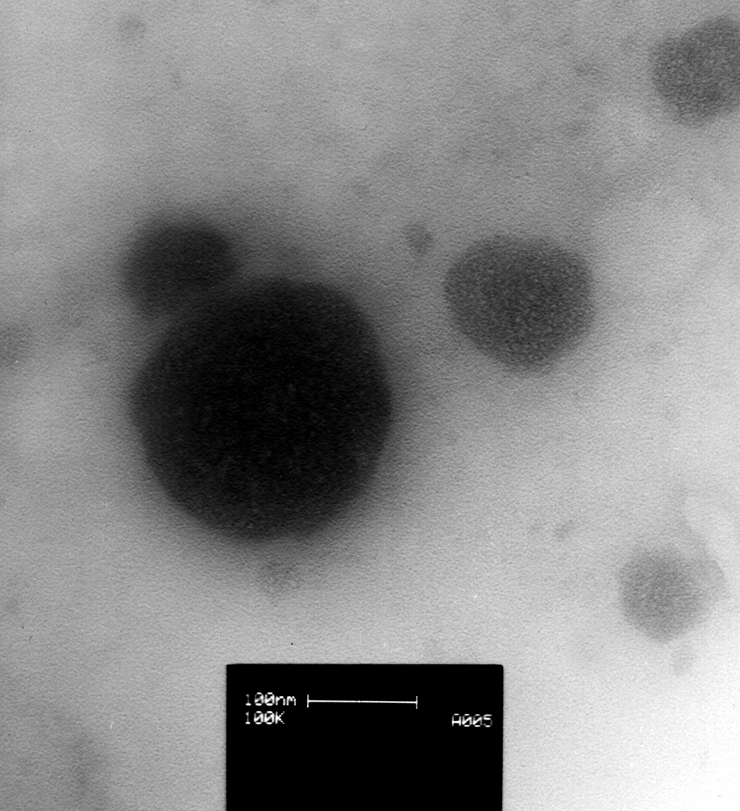
Figure 1. Transmission electron microscope image of silver nanoparticle synthesized by aqueous extract of Cuminum cyminum seeds.(Scale bar 100 nm)
Recent Publications
- Song JY, Kim BS (2009) Rapid biological synthesis of silver nanoparticles using plant leaf extracts. Bioprocessand Biosystems Engineering 32:79-84.
- Mittal AK, Chisti Y, Banerjee UC (2013) Synthesis of metallic nanoparticles using plant extracts. Biotechnology Advances 31:346-356.
- Prabhu S, Polusu EK (2012) Silver nanoparticles: mechanism of antimicrobial action, synthesis, medical applications and toxicity affects. International Nano Letters 2:32.
- Gopinath SM, Saha NS, John VJ, Khanum NS, Patil GMA (2013) Biological synthesis, characterization and application of silver nanoparticles. International Journal of Pharmaceutical Application 4:19-28.
5. Vijaykumar PPN, Pammi SVN, Kollu P, Satyanarayana, KVV, Shameem U (2014) Green synthesis and characterization of silver nanoparticles using Boerhaavia diffusa plant extract and their antibacterial activity. Industrial Crops and Products 52:562-566.

 Biography
Dr. Hashem Akhlaghi is an associate professor of analytical chemistry at the Islamic Azad University, Sabzevar Campus, Sabzevar, Iran. He specializes in the analysis of the essential oils of plants using GC-MS, green synthesis of silver nanoparticles using plant extracts and solid phase extraction/microextraction.
Email: hashemakhlaghi@hotmail.com

Notes/Comments:

