The role of Alzheimer’s disease relevant tau modifications in neurodegeneration and mitochondrial dysfunction with aging
Sanjib Guha^{1,}
¹University of Rochester, Department of Anesthesiology & Perioperative Medicine, Rochester, NY
Background: Alzheimer’s disease (AD) is a progressive neurodegenerative disorder whose pathological hallmarks include intraneuronal neurofibrillary tangles (NFTs) composed of the microtubule-associated protein Tau. Tau isolated from AD brain exhibits abnormally high levels of post-translational modifications (PTMs) including phosphorylation at specific epitope that increase with disease severity and age. Mitochondrial dysfunction is an early feature of AD, and abnormal, toxic tau PTM may contribute to disease pathogenesis. A major bottleneck in understanding the mechanisms behind the neurotoxicity of pathological forms of Tau is the lack of genetically tractable models that can recapitulate the effects of Tau PTM in a short time frame. Method: Human 0N4R Tau (wild type) was expressed in neurons through single-copy gene insertion. Mutation was introduced through CRISPR-Cas9 genome editing, including T231E, to mimic phosphorylation of a commonly observed pathological epitope. We then assessed their impact on age-dependent response to light touch, neurodegeneration, and mitochondrial parameters such as morphology, trafficking, and turnover, using fluorescent biosensors. Result: C. elegans single-copy expression of wild type human tau did not elicit overt pathological phenotypes at baseline. However, strains expressing disease associated PTM-mimetic (T231E) exhibited reduced touch sensation and neuronal morphological abnormalities that increased with age. Remarkably, the PTM-mimetic selectively impaired mitophagy following mitochondrial oxidative stress, but had no effect on autophagy, and furthermore reduced mitolysosomal trafficking. Conclusion: Single copy expression limits pathological phenotypes to strains expressing disease-associated Tau mutant. In addition to overt pathology, this mutant eliminates oxidative stress-induced mitophagy and reduce trafficking of mitolysosomes. Our findings highlight a selective mechanism through which disease-associated Tau PTM may suppress compensatory responses to mitochondrial stress that occur with age and provide a new perspective into the pathogenic mechanisms underlying AD.

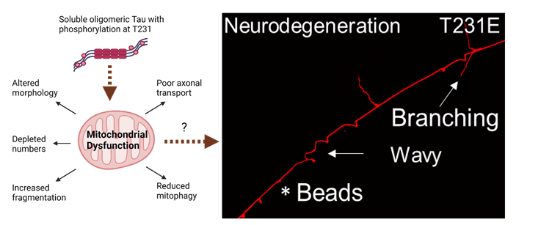

Figure 1: Schematic of how dysfunction of different mitochondrial health parameters might contribute to neurodegeneration in worms expressing phosphomimetic tau (T231E). The neurite shown in red portrays three key features of damage: beading, aberrant branching, and wavy processes.

Recent Publications:
Guha S, Carroll T, Johnson G, Cheng A and Nehrke K. (2021) Drp1 knockout induces severe alteration of mitochondrial network structure, and impairment of mitochondrial trafficking in a tauopathy C. elegans model. (Molecular Cell: pre-submission submitted)

Carroll T, Guha S, Johnson G, and Nehrke K. (2021) Tau Post-Translational Modifications: Potentiators of Selective Vulnerability in Sporadic Alzheimer’s Disease. MDPI Biology (Basel) PMID: 34681146

Guha S, Johnson G and Nehrke K. (2020) The Crosstalk Between Pathological Tau Phosphorylation and Mitochondrial Dysfunction as a Key to Understanding and Treating Alzheimer's Disease. Molecular Neurobiology PMID: 32851560
Guha S, Fishcer S, Johnson G and Nehrke K. (2020) Alzheimer’s disease-relevant tau modifications selectively impact neurodegeneration and mitophagy in a novel C. elegans single-copy transgenic model. Molecular Neurodegeneration PMID: 33168053
Guha S, Fishcer S, Johnson G, Cheng A and Nehrke K. (2020) A T231E Mutant that Mimics Pathologic Phosphorylation of Tau in Alzheimer’s disease Causes Activation of the Mitochondrial Unfolded Protein Response in C. elegans touch neurons. Micropublication Biology PMID: 32939445

 Biography:

Dr. Guha was born and raised in Calcutta, India where he did his undergrad studies. Then in 2008, he moved to California where he completed his Masters. After that he moved to Singapore, where he worked as a research associate at NUS. He then did his Phd in Barcelona, Spain and after completion of that he again moved back to California, where his postdoc was at the Buck Institute, Novato. And now, he is currently as a Staff Scientist at University of Rochester, upstate New York. As a globe trotter, he did his higher studies from 3 different countries, lived in 7 different cities and can speak 5 languages. And today, he will talk about how post-translational modifications of tau selectively impact neurodegeneration and causes mitochondrial dysfunction. This work was published last year at Molecular Neurodegeneration journal, and the corresponding review was at Molecular Neurobiology journal. The follow up paper is in review at Molecular Cell.
Email: sanjibcsu@gmail.com
Twitter: https://twitter.com/SanjibGuha11

