Influence of β-amyloids (Aβ40, Aβ42), tau-protein on the ultra- and nanostructural features of astrocytes in experimental model in vitro

Astashonok AN¹, Kvacheva ²ZB, Poleshchuk NN¹,

¹Republican Research & Practical Centre for Epidemiology & Microbiology, Minsk, Belarus
²Institute of Biophysics and Cell Engineering of National Academy of Sciences, Minsk, Belarus

Keywords: β-amyloid, tau-protein, Alzheimer’s disease, atomic force microscopy

- Abstract
The present study investigated C6 glioma cell line collected from Institute of cytology of the Russian Academy of Science (St. Petersburg) for study ultrastructural features, topography surface and mechanical properties of astrocytes under the influence of tau-protein and pathological β-amyloids which were isolated from brain tissue of patients who had died from Alzheimer's. When making oligomeric forms of Aβ-amyloids (final concentration 0.5 mM) into the cell culture, we documented the destruction the integrity of the cell monolayers, mitochondrial swelling, changes in the rough endoplasmic reticulum and structural modifications of the cell membrane. In atomic force microscopy (AFM) studies, we found the increasing the Young's modulus (from 9.7 to 12.7 kPa) of the cytoplasmic membrane of transforming astrocytes and changes the parameters of mean roughness (Ra) and root mean square roughness (Rq) as comparison with intact cells. Besides, another marker (tau-protein, concentration 0.05 mg/ml) was found to disrupt the cell membrane, not similar to β-amyloids. We revealed more crude morphological changes in astrocytes (protrusions and loss of filopodia, local fragmentation of the cytoplasmic membrane, the releasing of the contents of the cytoplasm into the intercellular space). The obtained results can increase knowledge of the dysregulatory pathological processes associated with the reactivation of astroglia in Alzheimer's.

- Image:

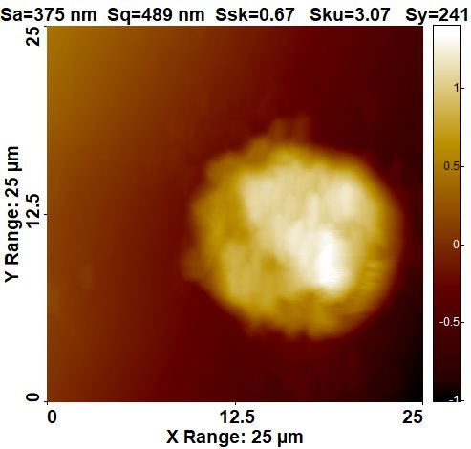
Figure. 1 – AFM astrocyte morphology after exposing with β-amyloids

- Reference:
- Murphy, P. and H. LeVine, 2010. Alzheimer’s Disease and the β-amyloid Peptide. Alzheimers Dis., 19; 1–17
- González-Reyes, R.E., M.O. Nava-Mesa, K. Vargas-Sánchez, D. Ariza-Salamanca and L. Mora-Muñoz, 2017. Involvement of astrocytes in Alzheimer’s disease from a neuroinflammatory and oxidative stress perspective. Front. Mol. Neurosci, 10: 1–20
- Rostagno, A. and J. Ghiso, 2009. Isolation and biochemical characterization of amyloid plaques and paired helical filaments. Curr. Protoc. Cell Biol., 19; 1–31

- Biography:
Andrei Astashonok has completed his PhD at the age of 28 years in 2016 year from Republican Research & Practical Centre for Epidemiology & Microbiology, Minsk, Belarus. He is senior research fellow of Laboratory for diagnosis of bacterial and viral coinfections, a state institution RRPC for Epidemiology and Microbiology (Belarus). He has published more than 20 domestic and foreign publications. He has attended a courses of electron atomic force microscopy techniques in Japan. He is studied the cellular and molecular mechanism of Alzheimer’s disease and prion disease pathogenesis.
V. Presenting author details
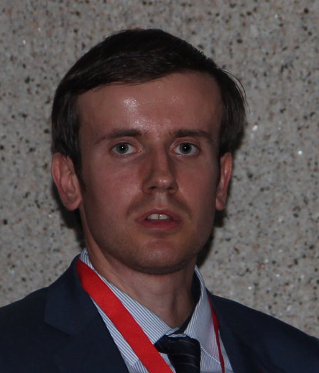
Full Name: Astashonok Andrei Nikolayevich
Contact number: 8(017)-369-91-40; 8(029)-501-50-31
Twitter account: -
Linked In account: -
Session name/ number: 13 (Biomarkers in Alzheimer’s disease)
Category: (Oral presentation/ Poster presentation)
Passport Number: MC2360456

