Assessment of severity of Alzheimer disease by application of easy Z-score imaging systems in brain SPECT study.

Nasreen Sultana¹, Hiroshi Matsuda², Azmal Kabir Sarker³, Sharrmin Quddus¹ ,Tapati Mandal¹ Khokon K Nath¹, Saiful Islam ¹, Md. Rafiqul Islam⁴

- National Institute of Nuclear Medicine and Allied Sciences( NINMAS) , BSMMU campus Dhaka, Bangladesh
- Ex-director , Integrative Brain Imaging Center, National Center of Neurology and Psychiatry, 4-1-1 Ogawa-Higashi, Kodaira, Tokyo 187-8551, Japan
- Institute of Nuclear Medicine and Allied Sciences, Mitford, SSMC campus, Dhaka, 1100, Bangladesh.
- Neurology, BSM Medical University, Dhaka, Bangladesh

Correspondence address: Nasreen Sultana, MBBS, MD, FANMB, Professor, National Institute of Nuclear Medicine and Allied Sciences, BAEC, Shahbag, Dhaka 1000, Bangladesh, Tel. +8801711481442, nasreeninm@yahoo.com

Background
Decreased regional cerebral blood flow (rCBF) in posterior cingulate gyri, pre cunei and parietal lobe on brain perfusion SPECT (BPS) images had long been a qualitative identifier of Alzheimer disease (AD). Aim of this study was to apply easy Z score imaging system (eZIS) on BPS images for quantitative evaluation of perfusion deficit severity (PDS) in patients with clinically suspected AD and find out association of Z score with clinical mini mental state examination (MMSE) scoring.
Methods
Patients were divided into two groups on basis of MMSE score (group A= 20/30 or higher, group B = less than 20/30). All patients underwent BPS with a dual head SPECT camera with IV Tc-99m ethyl cysteinate dimer (ECD). eZIS (Mastuda et al.) was used to quantify and grade PDS.
Results
BPS was performed on 88 patients with clinically suspected AD with mean age of 60.6±9.0 years (45-77) and mean duration since clinical onset of 10.7±5.3 months (6 -24). Mean MMSE and mean severity scores were 23.2±0.63 and 0.99±0.40 in group A (n = 25) while 17.7±0.95 and 2.82±0.45 in group B (n= 63), respectively. Categorically on the basis of eZIS scoring:
- Ten patients were normal (Z score 0-1),
- Twenty patients had slightly decreased perfusion (Z score 1-2)
- Thirty five had moderate disease (Z score 2-3)
- Twenty three had significantly decreased perfusion (Z score >3).
There was strong negative correlation between MMSE and eZIS score (r = 0.96, paired sample t = 21.10, p = 0.000, 95% CI 16.7-20.4)
Conclusions: Quantification PDS with eZIS score correlated well with clinical MMSE scoring in this study group. Perfusion deficit assessment with the application of e-ZIS in functional brain imaging is becoming increasingly important during an era where therapeutic agents are being prescribed.

Image
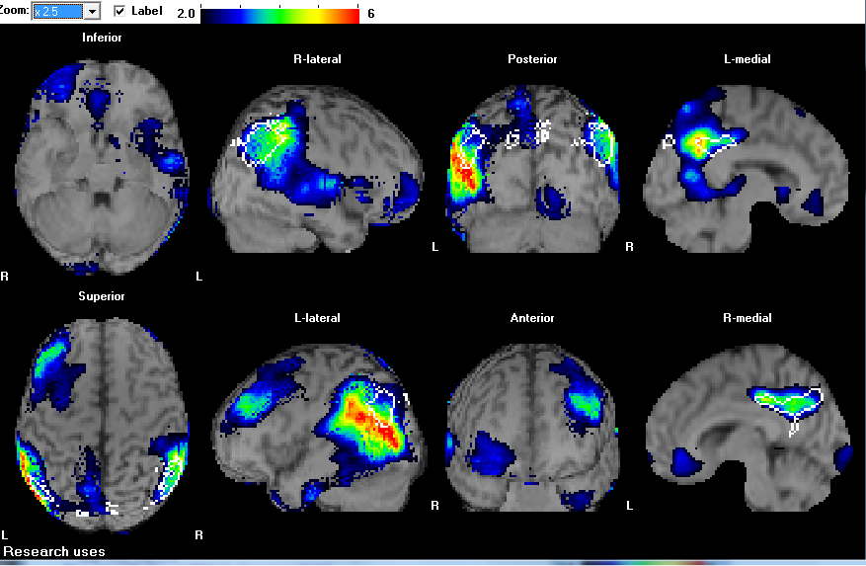
Recent Publications (minimum 5)
- The Journey of Alzheimer’s disease Diagnosis in Bangladesh and Current perspective. Short communication. Nasreen Sultana .EC Neurology 11.6(2019):390-393
- Deterministic Implication of Acetazolamide stress brain perfusion SPECT: A case Report. Azmal Kabir sarker .Nasreen Sultana , Fazle Elahy Miad, and Hiroshi Matsuda .EC Clinical and Medical Case reports 2.3(2019) : 75-80
- Role of Duplex Ultrasound for the Assessment of Malignancy in Breast Tumors. Anindita Rani Paul,Faria Nasreen, Nasreen Sultana January 2019.American Journal of Cancer Research 2019;7(4):143-149DOI: 10.11648/j.crj.20190704.14 .
- Assessment of Agreement Between Peak Systolic Velocity of Inferior Thyroid Artery And Thyroid Scan In Differentiating Diffuse Toxic Goiter And Subacute Thyroiditis. Khaleda Mushtary, Nasreen Sultana and Sharmin Quddus. Bangladesh J. Nucl. Med. 2018 ;21(2):97-101. DOI: 10.3329/bjnm.v21i2.40359
- In Differential Diagnosis of Dementia Application of Easy Z-score Imaging Systemin Single Photon Emission Computed Tomography Brain Perfusion Scan. Nasreen Sultana, Hiroshi Matsuda, Azmal KabirSarker, Jasmine Ara Haque, Rafiqul Islam. American Journal of Psychiatry and Neuroscience. Vol. 7, No. 4, 2019, pp. 100-107. doi: 10.11648/j.ajpn.20190704.14



Biography
Professor Dr. Nasreen Sultana completed her Medical graduation in 1993 from Chittagong University and post graduate course 'Doctor of Medicine' in Nuclear Medicine from BSM Medical University, Bangladesh in 2005. She has been serving as a physician specialist in ultrasound imaging, nuclear neuroimaging and radionuclide therapy at National Institute of Nuclear Medicine and Allied sciences (NINMAS) since 2006. Her scientific papers were awarded by ARCCNM in 2004, 2006 and 2009. She has trainings in Molecular Neuroimaging from Utah University, USA and Osaka Medical University, Japan both in 2017. She has been an academic faculty member of NINMAS (www.ninmas.org) under faculty of medicine of BSMMU, a member in Board of Directors of AOFNMB and a fellow of Asian Nuclear Medicine Board.
Email: nasreeninm@yahoo.com

Notes/Comments:

