

Impact of AIDS upon Oral-Dental Health
Sirma Todorova Angelova, DMD, PhD
Chief Assistant at the Department of Pediatric Dentistry,
Faculty of Dental Medicine,
Medical University-Varna, Varna, Bulgaria

Key words: HIV infection, local and systemic immunity, oral cavity, oral-dental lesions;
Abstract HIV infection transmission is associated to pathological alteration of morphology and functionality of mucosal surfaces. HIV affects a considerable number of human immunity system mechanisms, causing infection, exhaustion and dysregulation of mucosa, related to impingement upon protective mucosal barriers. As a consequence there is established intensive production of microbial metabolomes. HIV infection corresponds to predominance of distribution of oral mucosal infections and disorders of oral microbiota, accompanied by the effect of compromising oral mucosal immunity of HIV-infected individuals. [1] Fluids into oral cavity, taking the role of essential tools of maintenance of homeostasis, serve as medium of specific indicators of mucosal immunity. AIDS subjects and HIV infection carriers are characterized with low concentration of IgA in total unstimulated mixed saliva and parotid gland salivary secretion. [2] Regardless of age, oral candidiasis has been registered as the most frequent HIV-related oral lesion. The disorders of Kaposi’s sarcoma and oral hairy leukoplakia are prevailing among representatives of male gender. Clinical manifestation of these lesions is rare in children. [3] Researchers have put definite accent also upon the pathological state of xerostomia in condition of HIV. [4] Xerostomia is determined as one of the harmful factors for opportunistic infections into oral cavity. Oral opportunistic infections are provoked by exogenous pathogens or resident micro-flora, predominantly initiated and progressing in individuals with suppressed immunity, taking into consideration HIV/AIDS. [5] Opportunistic pathogens can cause infections not only in HIV-infected infants. HIV-exposed but uninfected infants are also vulnerable to opportunistic infections because of transmission from HIV-infected mothers or other members of the family suffering from co-infections. [6]
References:
- Heron S. E., E Shokrollah, HIV Infection and Compromised Mucosal Immunity: Oral Manifestations and Systemic Inflammation. Front Immunol. 2017; 8: 241.
doi: 10.3389/fimmu.2017.00241; PMCID: PMC5339276;
- Challacombe SJ, SP Sweet. Salivary and mucosal immune responses to HIV and its co-pathogens. Oral Dis. 1997 May; 3 Suppl 1:S79-84.
- Sedghizadeh PP, S Mahabady, CM Allen, Opportunistic Oral Infections. Dent Clin North Am. 2017 Apr; 61(2): 389–400. doi: 10.1016/j.cden.2016.12.007;
- Gillespie GM, R Mariño, Oral manifestations of HIV infection: a Panamerican perspective. Journal of Oral Pathology & Medicine. https://doi.org/10.1111/j.1600-0714.1993.tb00110.x;
- Patton LL, JA Phelan, FJ Ramos-Gomez, W Nittayananta, CH Shiboski, TL Mbuguye, Prevalence and classification of HIV-associated oral lesions. Oral Dis. 2002; 8 Suppl 2:98-109.
- Mofenson LM, MT Brady, SP Danner, KL Dominguez, R Hazra, E Handelsman, P Havens, S Nesheim, JS Read, L Serchuck, RV Dyke, Guidelines for the Prevention and Treatment of Opportunistic Infections Among HIV-Exposed and HIV-Infected Children: Recommendations from CDC, the National Institutes of Health, the HIV Medicine Association of the Infectious Diseases Society of America, the Pediatric Infectious Diseases Society, and the American Academy of Pediatrics. MMWR Recomm Rep. 2009 Sep 4; 58(RR-11): 1.

Biography:
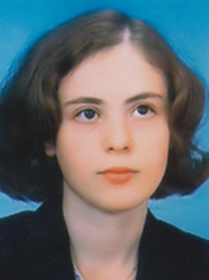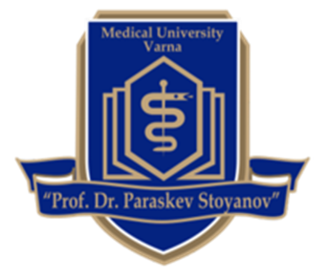

In the year 2005 Dr Sirma Angelova graduated her higher education at the University of Economics in Varna, Bulgaria and gained a Master degree of International Financial Affairs. In the year 2011 Dr Angelova graduated her higher education and gained a Master Degree of Dental Medicine at the Medical University-Varna, Varna, Bulgaria. Since 2011 Sirma Angelova has been working as an Assistant-Professor. Dr Angelova gained a Certificate of Specialization of Pediatric Dentistry in December 2015. In 2017 Sirma Angelova gained a postgraduate degree, PhD, after accomplishment of an independent research on the topic of “Caries Risk Assessment and Prevention in Children Suffering from Some Renal Disorders”. In the year 2018 Dr Sirma Angelova gained an academic degree of Chief-Assistant at the Medical University-Varna. The scientific and research interests of Dr Sirma Angelova are oriented in the scope of: Epigenetics as a cross-point of management of caries risk in children with specific common health problems; interactions between environmental factors, common status of the organism and oral and dental health; prophylactic cares directed towards optimization of the oral and dental health condition in children suffering from common diseases, including renal disorders; evaluation of caries risk level in the context of epigenetic impacts at child’s age; Epigenetics’-related interpretations of assessment of periodontal status at different periods of childhood;
Presenting author details
Full Name: Sirma Todorova Angelova
Contact number: +359 888 147562; +359 895 663317;
E-mail: dsirma_angelova@abv.bg
Session name/ number: Recent Advancement in HIV/AIDS, STDs and STIs; Current Focus in Virology Research;
Category: E-Poster presentation
Copyright © 2016-2018 Meetings Int PTE Ltd, All Rights Reserved.
Meetings International Pte Ltd
28 MAXWELL ROAD, #03-05 RED DOT TRAFFIC, SINGAPORE (069120)
Contact Number65-310-80483 (SINGAPORE)
Email Id: aids@insightsummits.com
URL: https://www.meetingsint.com/conferences/aids

