Title: βc1 proteins restore the expression of an in-house developed silenced GFP transgene in Nicotiana tabacum and Targets the host cell nucleus
Anurag Kumar Sahu and Neeti Sanan-Mishra
Plant RNAi Biology Group,
International Centre for Genetic Engineering and Biotechnology,
New Delhi, India.

Keywords: ChiLcuβ, transgenic tobacco lines, PTGS,
GFP expression, Confocal analysis

- Abstract: Some geminiviruses have acquired a betasatellite called DNA β. This study presents evidence that suppression of PTGS by the sole betasatellite-encoded protein, βC1 is crucial to the association of chili leaf curl virus (ChiLCuV) with its betasatellite (ChiLcuβ). The ability of the ChiLCuβ encoded βc1 proteins to suppress PTGS was investigated by using in-house developed short hairpin GFP Nicotiana tabacum line (_{SH}GFP) harbouring a silenced green fluorescent protein (GFP) transgene. Inoculation of _{SH}GFP plants with a recombinant pCAMBIA1302-βc1 resulted in restoration of GFP expression. RT-PCR analysis confirmed that the observed GFP fluorescence was associated with GFP mRNA transcript accumulation. Inoculation with recombinant pCAMBIA1302 vectors harbouring a βc1 proteins in naturally GFP Silent (G14 lines) were similarly shown to result in G14 plants with restored GFP expression. These results indicate that the beatsatellite-encoded βc1 can restore the expression of a silenced GFP transgene in N. tabacum, indicating that betasatellites are involved in overcoming host defence. A yeast two-hybrid screen of candidate βC1 proteins interact with ChiLCuV-CP followed by subcellular localization through Confocal analysis, revealed that when βC1 fused with GFP and expressed in planta under CAMV 35S promoter, GFP fluorescence was localized in the nucleus indicating the targeting of βC1 to host cell nucleus. | - Reference:  - Sunitha S, Shanmugapriya G, Balamani V. Veluthambi K.(2013) Mungbean yellow mosaic virus (MYMV) AC4 suppresses posttranscriptional gene silencing and an AC4 hairpin RNA gene reduces MYMV DNA accumulation in transgenic tobacco. Virus Genes. 46:496–504.  - Jian Ye, Jing Qu, Hui-Zhu Mao, Zhi-Gang Ma, Nur Estya Binte Rahman, Chao Bai, Wen Chen, Shu-Ye Jiang, Srinivasan Ramachandran and Nam-Hai Chua (2014) Engineering geminivirus resistance in Jatropha curcus Biotechnology for Biofuels 47:149  - Poonam Roshan, Aditya Kulshreshtha, Vipin Hallan (2017) Identification of host cellular targets of AC4 and AV2 proteins of tomato leaf curl palampur virus and their sub-cellular localization studies Virus Dis. 2017 28(4):390–400  Biography:  I Anurag, PhD Biotechnology (Major Plant molecular virology), currently I am working as a DBT-Research Associate at International Centre for Genetic Engineering & Biotechnology, New Delhi, India. Here we involve in plant biotic stress biology and plant virus inetraction study. Crop improvement and biotic stress matters are of interest because as pathogen infection (viral & Fungal) causes serious economic damages in agricultural and environmental fields in India, therefore research to understand the molecular mechanism of interaction between host plant and pathogen is significant, and also fruitful in development of strategies to increase broad spectrum resistance to viruses through the use of pathogen derived resistance and silencing approach.
- Image:  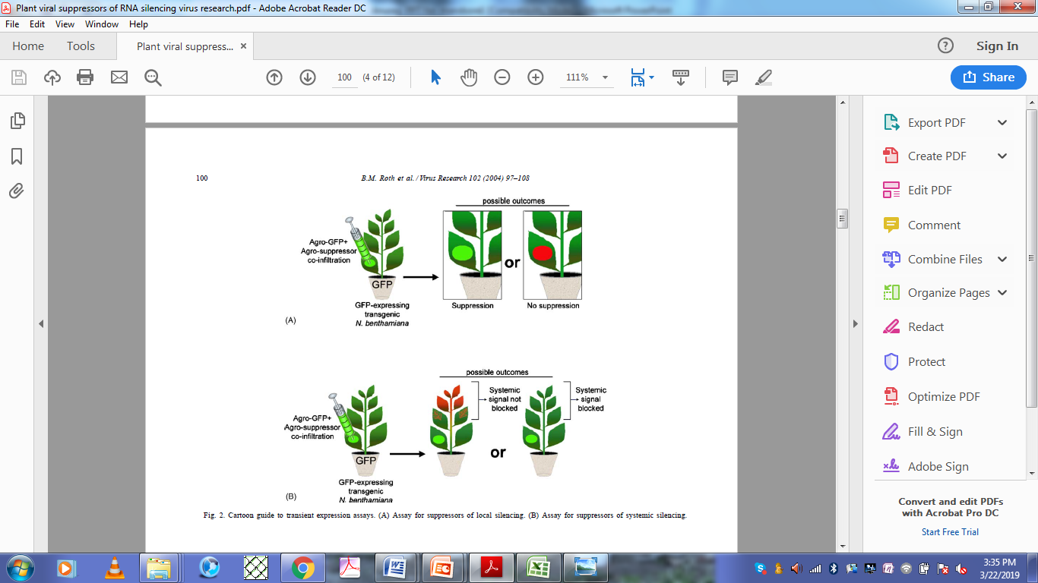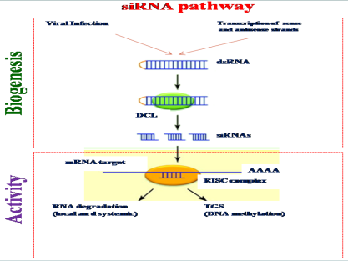 | - Presenting author details
   | Full Name: Anurag Kumar Sahu  Contact number:+91-8840351348  Twitter account: @anuragsahhu  Linked In account: anurag22sahu  Session name/ number: Crop protection  Category: (Oral presentation/ Poster presentation): Oral  Passport Number: R8874902

