Title: EFFECTS OF PIG SLURRY APPLICATION ON GROWTH AND YIELD OF MAIZE CROP

GONZALEZ-TORRES I¹, BARRIO JC¹, GONZALEZ P^{1,}, VAZQUEZ L^{1,}, GARCÍA L^{1,}
¹Department of Agronomy, Meat Technology Centre, Galicia, Spain

Keywords: pig slurry, maize, organic fertilization

- Abstract Body:
The management of pig manure is a problem of crucial environmental and economic interest, especially in Mediterranean countries, like Spain, where a dense concentrations of intensive fattening pigs. The aim of this study was to evaluate the use of pig slurry (PS), liquid fraction previously separated, as a substitute of mineral fertilizer in the maize crop in the experimental parcel situated in the district of A Limia (Galicia, NW Spain). This study was carried out with 2 replications and 20 parcels according to randomized complete blocks trial design between 2017 and 2018 as two separate experiments. The treatments consisted of using mineral fertilization recommended for the maize crop (200 kg ha⁻¹), without fertilization, and PS doses (7, 13 and 20 l m⁻² in 3 irrigations). Additionally, all plants received 750 kg∙of 8-24-16 ha⁻¹ at planting time. Maize yield was evaluated. The high application rate of the organic fertilizer raised a production to 45,230 kg ha⁻¹, followed by mineral trial with 44,409 kg ha⁻¹. Lesser differences among the rest of the treatments were found, obtained 40,757 kg ha⁻¹ without slurry added, 40,735 and 40,256 kg ha⁻¹ with medium and low pig manure respectively. The mineral fertilization in maize can be replaced by high pig slurry doses (20 l slurry m⁻² and 30 l water m⁻²) with no loss of yield components.
Height and weight of corn were determined. Regarding the weight of 10 corn, the medium PS was the best result. Results indicated a positive and significant effect of nitrogen fertilization over productivity parameters.
- Image:

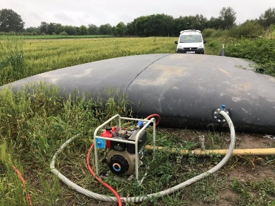 | 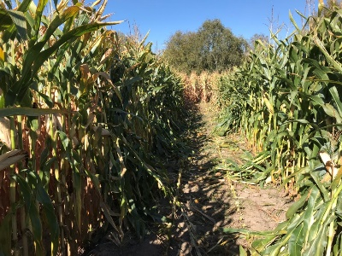

- Reference:
- Menezes, J.F.S., da Silva, M.P., Caetano, J.O., Cantão, V.C.G., De Benites, V.M. (2017). Maize yield after long-term application of pig slurry. Revista Brasileira de Engenharia Agricola e Ambiental 21(10), pp. 686-690.
- Basso, C.J., Pinto, M.A.B., Santi, A.L., da Silva, R.F., da Silva, D.R.O. (2016). Pig slurry as a nutrient source in wheat/corn succession. Revista Ceres, 63 (3), pp. 412-418.
- Carneiro, J.P., Coutinho, J., Trindade, H. (2012) Nitrate leaching from a maize×oats double-cropping forage system fertilized with organic residues under Mediterranean conditions Agriculture, Ecosystems and Environment, 160, pp. 29-39.
- Biography:
Inmaculada González is agronomist engineer and currently works in the Project Office of the Meat Technology Center since 2009, developing researched and developed projects and transfer and dissemination management tasks. She has participated in more than 80 RDi projects along with others for tax deduction, has published a book of dissemination and various communications to congresses. She is currently studying her PhD in Food Science and Technology at the University of Vigo.

- Presenting author details

Full Name: Inmaculada González Torres
Contact number: +34988548277
Linked In account: linkedin.com/in/inmaculada-gonzález-42146b144
Category: EPoster presentation
Passport Number: 34994171Q

