Title: EFFECTS OF ORGANIC AND MINERAL FERTILIZERS ON THE YIELD OF POTATO

GONZALEZ-TORRES I¹, BARRIO JC¹, GONZALEZ P^{1,}, VAZQUEZ L¹, GARCÍA L^{1,}
¹Department of Agronomy, Meat Technology Centre, Galicia, Spain

Keywords: Poultry manure, pig slurry, potato, organic fertilization, tuber yield production.

- Abstract Body
Experiments at the testing field of Meat Technology Centre situated in Laguna de Antela, Ourense, Spain (42° 6′ N, 7° 42′ W) during 2017-2018 evaluated poultry manure (PM) and solid fraction of pig slurry (PS) as a fertilizer. Tree levels of SFPS fertilization, using different mixtures of solid pig slurry (20, 30 and 40 m³) and poultry manure (25m³) were compared with a mineral fertilizer (N 26%) control. The fertilization treatments were repeated each year on the same plots. 20 parcels were sown with Agria variety, highly adapted to this region. The two central grooves from each parcel were collected l and the quality analysis and crop yield were done.
All the crops tested responded markedly fertilization, giving the following production data (expressed as kilogram per hectare): 76,595 kg ha⁻¹ C, 69,290 kg ha⁻¹ PM, 64,194 kg ha⁻¹ high PS, 62,606 kg/ha low PS and 62,006 kg ha⁻¹ medium PS.
if we pay attention to commercial production, the most effective fertilization formula was chemical and poultry manure. In the case of high PS, a pronounced descent between gross production (64,194 kg ha⁻¹) and commercial (48,408 kg ha⁻¹) was observed.
Among the treatments with different amount of pig manure, it can be concluded that the increase of this only slightly raises the commercial production for a medium dose application. With this type of organic fertilizer, the productions are lower than those obtained with the controls. This suggests that a mixture of organic fertilizer from the solid fraction of pig manure and remains of chicken beds can be very suitable for potato fertilization.

- Image:

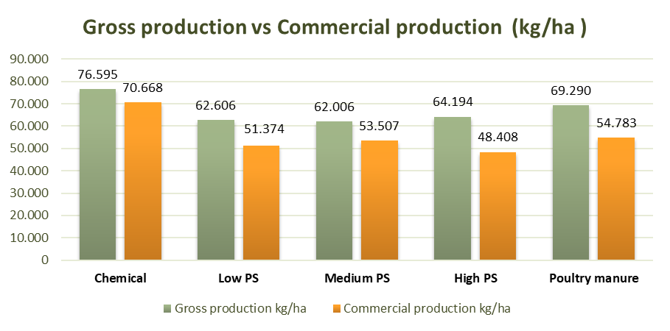

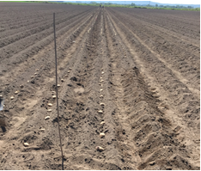 | 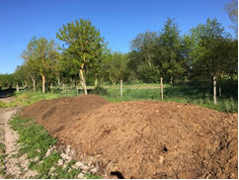
- Reference:
- Garmendia A, Raigón MD, Marques O, Ferriol M, Royo J, Merle H. 2018. Effects of nettle slurry (Urtica dioica L.) used as foliar fertilizer on potato (Solanum tuberosum L.) yield and plant growth. PeerJ 6:e4729
https://doi.org/10.7717/peerj.4729
- Rigby, H. & Smith, S.R. Nutr Cycl Agroecosyst (2014) 98: 137. https://doi.org/10.1007/s10705-014-9602-4
- Pirkko Roinila, Jaana Väisänen, Artur Granstedt & Susanna Kunttu (2003) Effects of Different Organic Fertilization Practices and Mineral Fertilization on Potato Quality, Biological Agriculture & Horticulture, 21:2, 165-194
- Biography:
Inmaculada González is agronomist engineer and currently works in the Project Office of the Meat Technology Center since 2009, developing researched and developed projects and transfer and dissemination management tasks. She has participated in more than 80 RDi projects along with others for tax deduction, has published a book of dissemination and various communications to congresses. She is currently doing her PhD in Food Science and Technology at the University of Vigo.
- Presenting author details

Full Name: Inmaculada González Torres
Contact number: +34988548277
Linked In account: linkedin.com/in/inmaculada-gonzález-42146b144
Category: EPoster presentation
Passport Number: 34994171Q

