New indicators of vulnerability and resilience of agroforestry systems to climate change in West Africa

Gnonlonfoun I^{1, 2}, Assogbadjo AE², Gnanglè CP^{1,3}, Glèlè Kakaï RL¹

¹ Laboratory of Biomathematics and Forest Estimations (LABEF), Faculty of Agronomic Sciences, University of Abomey-Calavi, 04 BP 1525 Cotonou Benin.
² Laboratory of Applied Ecology (LEA), Faculty of Agronomic Sciences, University of Abomey-Calavi, 03 BP 1974 Cotonou Benin
³National Institute of Agricultural Research of Benin, Cotonou, Benin

Keywords: Agroforestry systems, Climate change, Traditional ecological knowledge, Ecosystem services, Food security

- Abstract Body (up to 250 words)

Climate change threatens ecosystems, including traditional agroforestry parklands. Assessing the level of vulnerability and resilience of any ecosystem to climate change is important for designing sustainable adaptation strategies. This study assessed: (i) the effect of changes in climatic conditions on agroforestry systems, (ii) the endogenous indicators of vulnerability of agroforestry systems and (iii) analyzed agroforestry and cropping systems’ resilience to climate change. A total of 233 household heads were surveyed, and seven agroforestry systems were assessed. Data collected included components, indicators of vulnerability, and the level of resilience of agroforestry systems. We characterized the agroforestry systems using a proportion of each woody tree species and density of tree. We differentiated the agroforestry systems with regard to vulnerability indicators using canonical factorial discriminant analysis. The resilience of agroforestry and cropping systems was evaluated on a scale of 0 to 3 (0 — not resilient to 3 — most resilient). The number of components damaged in the system was the main indicator of the vulnerability of Anacardium occidentale and Citrus sinensis parks to climate change effects. Local people perceived age and density of Vitellaria paradoxa parks and mixed parks (Vitellaria paradoxa – Parkia biglobosa) as factors determining the vulnerability of these agroforestry systems to the effects of climate change. All agroforestry systems were perceived to be resilient to climate change but in different degrees. Manihot esculenta was reported as the most resilient crop to climate damage. Specific endogenous indicators of the vulnerability of agroforestry systems to climate change identified are important for better adaptation strategies.

- Image:

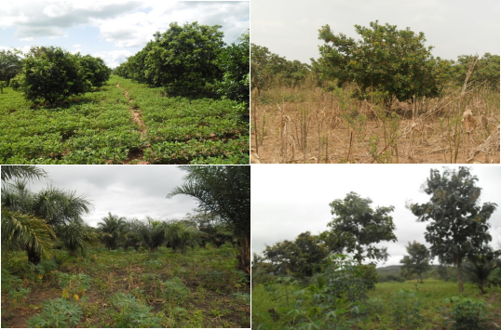

- Reference:
- Collier, P., G. Conway and T. Venables, 2008. Climate change and Africa. Oxf. Rev. Econ. Policy., 24(2):337 – 353.
- Coulibaly, Y.N., R. Mulia, J. Sanou, G. Zombré, J. Bayala, A. Kalinganire and M. van Noordwijk, 2014. Crop production under different rainfall and management conditions in agroforestry parkland systems in Burkina Faso: observations and simulation with WaNuLCAS model. Agrofor. Syst., 88:3-28.
- Luedeling, E., N.I. Huth, R. Kindt and K. König, 2014. Agroforestry systems in a changing climate -challenges in projecting future performance. Curr. Opin. Environ. Sustain., 6 :1 – 7.
- Biography:
Isidore GNONLONFOUN is a PhD candidate at the age of 32 years from University of Abomey-Calavi, Benin, west Africa. He is a research assistant at the faculty of agronomic sciences. Isidore GNONLONFOUN has expertise in agriculture and forest sciences, evolutionary ecology, wildlife management and conservation ecology. He is addressing right now the evolutionary processes between elephants and woody trees communities in Pendjari Biosphere Reserve in West Africa. He has published 3 papers in reputed impact factor journals and has two other papers under review and three others in preparation.
- Presenting author details


Full Name: Isidore GNONLONFOUN
Contact number: +229 97330045
Twitter account: https://twitter.com/isidorstar2
Linked In account: https://www.linkedin.com/in/isidore-gnonlonfoun-248a3856/
Session name/ number: Agroforestry and Landscaping
Category: (Oral presentation)
Passport Number: B0697314

