Title: Nitrogen uptake and utilization efficiency of malting barley as influenced by variety and nitrogen level

Meharie Kassie ^{1*}, Kindie Tesfaye ²

¹ Arsi University, College of Agriculture and Environmental Sciences, P O Box 193, Asella, Ethiopia
² International Wheat and Maize improvement Center (CIMMYT), Addis Aababa, Ethiopia

Keywords: Barley, Grain yield, Nitrogen fertilizer, Train relationship
I. Abstract Body
Nitrogen (N) is the primary driver of crop production and it is heavily used in modern agriculture to maximize yield. However, the effectiveness with which N is used by cereals has become increasingly important because of both financial and environmental costs to N fertilization. The aims of this study were to determine the effects of N fertilization rate, variety and growing season on grain yield, N uptake and N efficiency traits of malting barley at Bekoji, south eastern Ethiopia. The treatments studied were five N levels (0, 23, 46, 69 and 92 kg ha⁻¹) and two malting barley varieties (Miscal-21 and Holker) over three seasons (2012, 2013 and 2014). The results showed that as N rates increased, malting barley grain yield, grain, straw and total N uptakes increased, but N-harvest index, N-use efficiency, N-recovery efficiency and N-utilization efficiency decreased. Grain yield, grain and total N uptake, N-harvest index, N-use efficiency, N-recovery efficiency and N-utilization efficiency were greater in Miscal-21, whilst straw N uptakes were greater in Holker. Grain yield, grain, straw and total N uptake, N-recovery efficiency and N-harvest index were greater in 2012 than in 2013 and 2014, but growing season had no effect on N-use efficiency and N-utilization efficiency. Grain yield was positively correlated with N-efficiency traits, but the role of N-recovery efficiency in enhancing grain yield was larger than the role of N-utilization efficiency. In conclusion, future studies should focus in developing varieties with increased efficiency to capture and utilize the applied N fertilizer, and more efficient N management strategies are of interest.

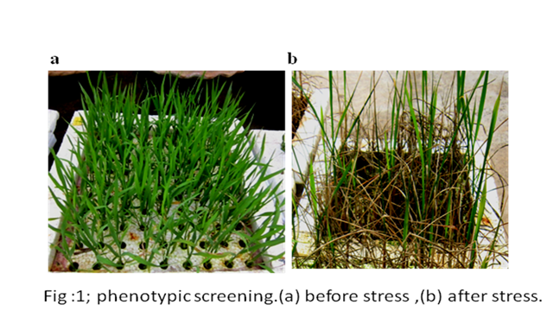
- Image:

III. Reference:
- Anbessa Y, Juskiw P, Good A, Nyachiro J, Helm J. 2009. Genetic variability in nitrogen use efficiency of spring barley. Crop Sci. 49: 1259 -1269
- Beatty PH, Anbessa Y, Juskiw P, Carroll RT, Wang J, Good AG. 2010. Nitrogen use efficiencies of spring barley grown under varying nitrogen conditions in the field and growth chamber. Ann. Bot. 105: 661-676
- O’Donovan JT, Turkington TK, Edney MJ, Clayton GW, McKenzie RH et al. 2011. Seeding rate, nitrogen rate and cultivar effects on malting barley production. Agron. J. 103: 709-716
IV. Biography:
Meharie Kassie has completed his MSc at the age of 27 years from Haramaya University, Ethiopia. He is lecturer and researcher in Arsi University, College of Agriculture and Environmental Sciences. He has published 3 papers in reputed journals.
V. Presenting author details


Full Name: Meharie Kassie
Contact number: +251911749072
Twitter account:
Linked In account:
Session name/ number: Agronomy and Crop Science
Category: Oral presentation
Passport Number: EP4315286

