EFFECT OF CLIMATE CHANGE ON VEGETABLE PRODUCTION
¹Ozumba, G. I., ²Pam, V. A., ²Adejoh, V. A. and ²Odey, S. A.
¹Federal Polytechnic Ilaro, Ogun State, Nigeria
²Department of Zoology, Faculty of Sciences, Federal University Lafia
Corresponding email: ozumbagodwinifedi@gmail.com
- Abstract
Vegetables are one of the good sources of vitamins and minerals and play an important role in ensuring food and nutritional security. Vegetables are highly perishable and very sensitive to unpredictable climatic changes. Intergovernmental Panel on Climate Change (IPCC) reported that the global mean temperature had risen for the 20th century at the rate of 0.74ºC per 100 years due to increasing greenhouse gas. Climate change such as temperature, precipitation and tropical cyclone activity has been strongly related to agricultural production, water resource, and species diversity. Environmental stresses like increasing temperature, reduced irrigation water availability, flooding and salinity are thought to be the major limiting factors in enhancing vegetable productivity. Though the climate vagaries are beyond human control, its intensity and extreme impact of environmental stress on vegetable crops can be reduced to some extent and enhance the production as well, if the integrated approaches like cultural management practices including nutrient and tillage residue management, water management, mulching, improved pest management, and breeding approaches like development of genotypes tolerant to high temperature, salinity, moisture stress are resorted.
Keywords: Climate Change, Crop, Environment, Vegetable.
- Reference
- Abdalla, A.A., and Verderk, K. 1968. Growth, flowering and fruit set of tomato at high temperature. The Neth J Agric Sci.16:71- 76.
- Arora, S.K., Partap, P.S., Pandita, M.L. and Jalal, I. 1987. Production problems and their possible remedies in vegetable crops. Indian Horticulture. 32(2): 2-8.
- Yamane, S. and K.Shibayama (2006): Effects of trunk girdling and crop load levels on fruit quality an root elongation in ‘Aki Queen’ grape berries. J. Japan, Soc. Hort.Sci. 75:458-462.
- Sugiura, T. (2009): What become of ‘Agriculture’ and ‘Food’ by Global Warming? Gijyutuhyoronsya, Tokyo, Japan.

- Image
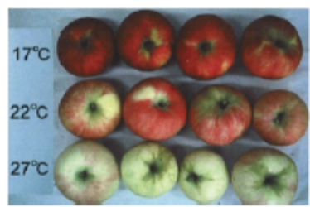
Plate 1: Skin color disorder of apples due to high temperature (Sugiura 2009)
- Biography
Mr. Ozumba Godwin Ifedi got his B. Sc. From the prestigious University of Jos where he studied Zoology. He holds a Higher National Diploma in Animal Husbandry and he is currently the Senior Technical Officer (CTO) of the Rectory Unit of the Federal Polytechnic Ilaro, Ogun State, Nigeria.

- Presenting Authors Details

Full Name: Ozumba, Godwin Ifedi
Contact Number: +234706 271 9042
Email: ozumbagodwinifedi@gmail.com
Category: Oral Presenting

