Title: Micropropagation of Grapevine (Vitis vinifera L.) cv. Red Globe through direct organogenesis
*¹Ruma Debbarma and ² J. Suresh
¹Department of Fruit Crops, Horticultural College and Research Institute, Coimbatore-641003, Tamil Nadu Agricultural University, Coimbatore, Tamil Nadu, India
² Department of Spices and Plantation Crops, Horticultural College and Research Institute, Coimbatore-641003, Tamil Nadu Agricultural University, Coimbatore, Tamil Nadu, India
Key words: Vitis vinifera, micropropagation, Red Globe, Axillary Bud, BAP
I. Abstract Body:
Grapevine (Vitis vinifera L.) is one of the most important perennial deciduous woody vine and delicious refreshing sub-tropical fruits of the world (Winkler et al., 1974). It is vegetatively propagated through hardwood stem cuttings and may carry plant pathogens, leading to reduced vigour and yield and they do not ensure the production of virus and disease free elite plant material. Micropropagation technique can be a potential alternative to overcome these constraints. Earlier nodal cuttings/axillary buds and shoot tips explants have popularly used by many scientists in grapevine (Chee et al.,1984; Heloir et al., 1997; Mhatre et al., 2000; Alizadeh et al., 2010 and Abido et al., 2013). Based on that, 2wo types of explants viz., axillary buds and shoot tips were used in a study taken up to standardize micropropagation protocol. Axillary buds registered higher response for shoot proliferation (86.00%) compared to shoot tips (56.66%) and were found to be the most suitable explants for micropropagation. Full strength MS medium supplemented with BAP 2.0 mg l⁻¹ gave best result for axillary bud in respect to the least time for bud break (16.32 days), shoot proliferation (86.00%), average length of shoots (6.80 cm) and days taken for multiple shoot induction (30.00 days). Efficient rooting (78.80%) of the in vitro regenerated micro shoots were achieved with half MS medium fortified with IBA 2.0 mg l⁻¹ and activated charcoal 500 mg l⁻¹. Rooted plantlets of Red Globe were hardened with various media among which a mixture of coco peat: sand: soil (1:1:1) resulted in the highest ex vitro survival rate (75.00%).

II. Image:
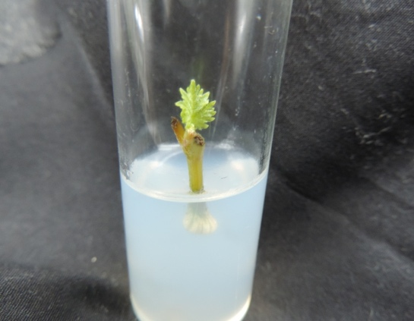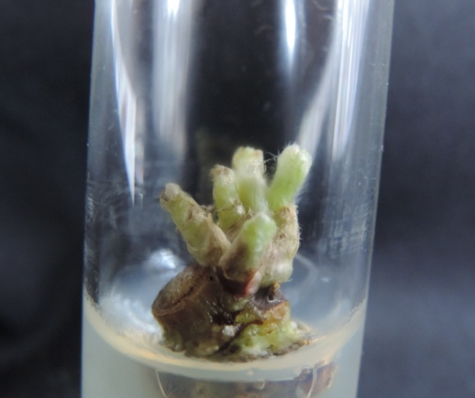

- Shoot tip explant b. Axillary buds explant

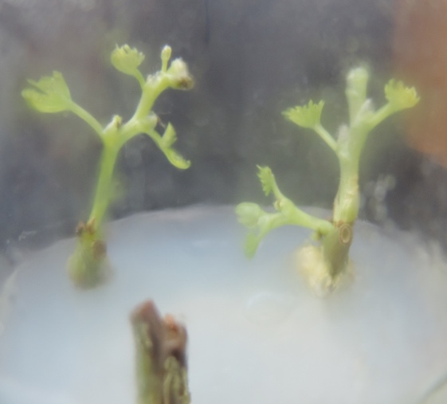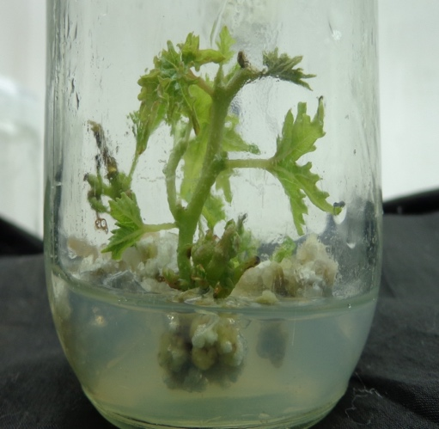

- Shoot Proliferation of Red Globe

III. Reference:
Abido, A.I.A., M.A.M. Aly, S.A. Hassanen and G.A. Rayan. 2013. In vitro Propagation of Grapevine (Vitis vinifera L.) Muscat of Alexandria cv. for conservation of Endangerment. Middle-East J. of Scientific Research, 13 (3): 328-337.
Alizadeh, M., S.K. Singh and V.B. Patel. 2010. Comparative performance of in vitro multiplication in four grape (Vitis spp.) rootstock genotypes. Int. J. Plant Prod., 4(1): 41-50.
Chee, R., R.M. Pool and D. Bucher. 1984. A method for large scale in vitro propagation of Vitis. In: New York’s Food and Life Sci. Bul. 109: 1-9.
Heloir, M. C., J. C. Fournioux, L. Oziol and R. Bessis. 1997. An improved procedure for the propagation in vitro of grapevine (Vitis vinifera cv. Pinot Noir) using axillary bud micro-cuttings. Pl. Cel. Tis. Org. cult., 49: 223-225.
Mhatre, M., C.K. Salunkhe and P.S. Rao. 2000. Micropropagation of Vitis vinifera L. Towards an improved protocol. Sci. Hort., 84: 357-363.
Winkler, A.J., 1974. General viticulture. University of California Press, Berkeley.
IV. Biography:
RUMA DEBBARMA has completed M.Sc. Fruit Science and currently final year of Ph. D in Fruit Science from Tamil Nadu Agricultural University, Department of Plant Biotechnology, CPMB &B, Coimbatore, India.
V. Presenting author details

Full Name: RUMA DEBBARMA
Contact number: 8015649028

