Effect of foliar application of bio-stimulants on growth, yield and flower quality of chrysanthemum (Dendranthema grandiflora Tzvelev.)
Dr B Hemla Naik ¹; Bhargavi S P ²; Dr S Y Chandrashekhar ³; Dr. Y. Kantharaj ⁴and Dr. Ganapathi, M⁵.
¹Associate Director of Research (HQ) cum Professor and University Head, Department of Horticulture, UAHS,
Shivamogga, Karnataka (India)
²M Sc (Hort.) Graduate, Department of Floriculture and Landscape Architecture, UAHS Shivamogga
³Assistant Professor, Department of Floriculture and Landscape Architecture, College of Horticulture, Mudigere
⁴Assistant Professor, Department of Post-Harvest Technology, College of Horticulture, Mudigere
⁵Assistant Professor, Department Crop physiology, College of Horticulture, Mudigere

Keywords: chrysanthemum, Dendranthema grandiflora, biovita, humic acid, spic cytozyme recharge vipul boron

I. Abstract

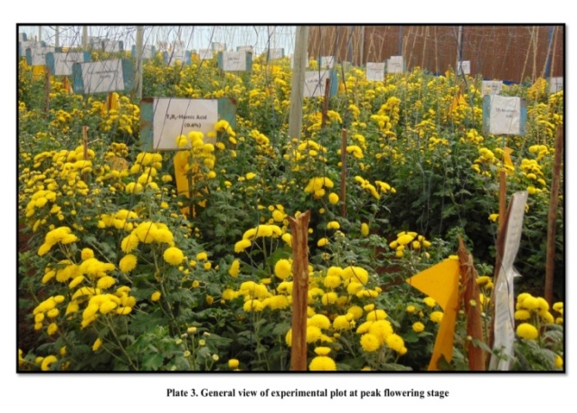
An experiment was conducted to study the effect of bio-stimulants on growth, flowering, yield, quality and economics of chrysanthemum under fan and pad greenhouse at Department of Horticulture, College of Agriculture, Shivamogga during 2017-18.The experiment was laid out in RCBD with thirteen treatments viz., T₁-Humic acid 0.5%, T₂-Humic acid 0.6%, T₃-Biovita 0.5%,T₄-Biovita 0.6%, T₅-Recharge 0.5%, T₆-Recharge 0.6%, T₇- Spic cytozyme 0.2%, T₈-Spic cytozyme 0.4%, T₉-Vipul 0.2%, T₁₀-Vipul 0.4%, T₁₁-Boron 0.1%, T₁₂-Boron 0.2% and T₁₃-Control replicated thrice. Among the different bio-stimulants treatments application of Spic cytozyme @ 0.4% at 30, 60, 90,120 and 150 days after transplanting resulted in significantly higher plant height (89.04 cm) and internodal length (2.44 cm), while biovita at 0.6% recorded maximum number of leaves (143.43), stem girth (8.18 mm), number of primary branches (11.47), number of secondary branches(24.98), leaf area (5245.33 cm²/plant), leaf area index(5.80), leaf area duration (122.60), stem dry weight (15.06 g/plant), leaf dry weight (24.84 g/plant), flower dry weight (6.16 g/plant), total dry matter accumulation (45.37 g/plant), crop growth rate(0.000897 g/m²/day), relative growth rate(0.009760 g/g/day) and net assimilation rate (0.0129800 g/dm²/day), minimum number of days for first flowering (100.00), 50 per cent flowering (112.33) and maximum duration of flowering (65.82), maximum number of flowers per plant (95.57),flower yield per plant (511.93 g), flower yield per square meter (5.63kg), flower yield per hectare (56.30 t/ha), sucker yield per plant (9.99), individual flower weight(7.87 g), flower diameter (6.92 cm), stem length (46.89 cm), vase life (22.99 days), shelf life (11.07 days) and benefit to cost ratio (3.92).
II. Image

- Reference:

- Ahmad, I., Saqub, R.U., Qasim, M., Salee, M., Khan, S. A. and Yaseen, M., 2013. Humic acid and cultivar effects on growth, yield, vase life, and corm characteristics of gladiolus. Chilean. J. Agri. Res., 73(4): 339-344.
- Khandelwal, S., Jain, N. and Singh, P., 2003, Effect of biozymes and pinching on growth and yield of African marigold (Tagetes erecta L.). J. Ornam. Hort., 6(3): 271-273.

- Pruthvi, P. Hegde., B. Hemla Naik., M. Shivaprasad and Beeralingappa., 2017, Effect of biostimulants on morphology, flowering and yield of Chrysanthemum (Dendranthema grandifloraTzvelve) Cv. Kolar Local under naturally ventilated polyhouse. The bioscan., 12(1): 273-276.

- Biography:
Professor B Hemla Naik, has his expertise in Floriculture and Landscaping for 24 years. Developed technologies on planting densities, organic and inorganic nutrition including bioagents and bio-stimulants, INM, for tomato, chili, bhendi, onion and garlic, fertigation, INM for rose, gerbera, carnation, lilies, chrysanthemums, China Aster, Marigold for xanthophylls, Gladiolus, etc. He completed his PhD at the age of 38 years on xanthophyll from Tagetes. Guided 25 MSc’s and 04 PhD’s as a Chairman. Developed e- contents for 51 courses of B Sc (Hort.) Involved in UG and PG teaching (24 Yrs). Served as Dean (Hort.), Nodal Officer (PME), Associate Director of Extension, Professor & University Head (Horticulture, Food and Nutrition, Floriculture and Landscape Architecture, Post Harvest Technology) Member of Academic, Research and Extension Council at SAUs. He has published 85 research papers in National and International reputed journals and has been serving as an editorial board member of reputed Journals. He visited University of Jerusalem, Rehovot campus, Cornel University Ithaca, and presented research papers, Served as Chairman in many National and International Workshops, Conference, Symposia et,. Recipient of 08 National and International awards for excel in Academic and Research.

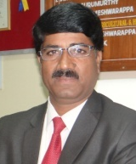
- Presenting Author
Full Name : DR B HEMLA NAIK
Contact number : +91 9448862225
Linked In account:
Session name/ number: Track 4: Horticulture Therapy; Track 4-3: Floriculture
Category : Oral presentation
Passport Number : H8025218

