COMPARISON OF HYDROPONIC AND IN VITRO TECHNIQUES FOR THE SCREENING OF DROUGHT TOLERANT ACCESSIONS IN BRASSICA NAPUS L.
*Bareera Nasir¹, Humera Razzaq¹, M. Hammad Nadeem Tahir¹ and Fatima Usman²
¹ Department of Plant Breeding and Genetics, University of Agriculture, Faisalabad-38040, Pakistan
² Institute of Horticultural Sciences, University of Agriculture, Faisalabad-38040, Pakistan
*Corresponding author= bareeranasir64gmail.com
Keywords: Brassica napus accessions, Drought stress, Hydroponic culture, In vitro culture, Polyethylene glycol (PEG-6000), Seedling traits
ABSTRACT
The present study was focused on comparison of hydroponic and in vitro techniques for the screening of drought tolerant accessions in Brassica napus. Seeds of ten accessions were grown in polythene bags with triplicate Completely Randomized Design by using factorial structured treatments. Fifteen days after sowing, seedlings were transplanted to the hydroponics at three drought stress levels T₀= 0 (control), T₁= 9% and T₂= 18% of polyethylene glycol 6000. Data were recorded on seedling height, root length, shoot length, fresh and dry root and weights after 15 days of transplantation. In in vitro culture seeds were grown in MS zero media and explants were used for callus culture. Three drought stress levels T₀= 0 (control), T₁= 9% and T₂= 18% of PEG were applied. Relative fresh weight of callus, electrolyte membrane leakage, proline content, glycine betaine and total soluble sugar contents were recorded after 21 days of callus formation. Recorded data of both experiments were subjected to analysis of variance and multiple comparison test. Hydroponics showed better results due to high germination % of accessions, genetic variability for many traits. It may also be very helpful for the study of root and its extensions under drought stress conditions.
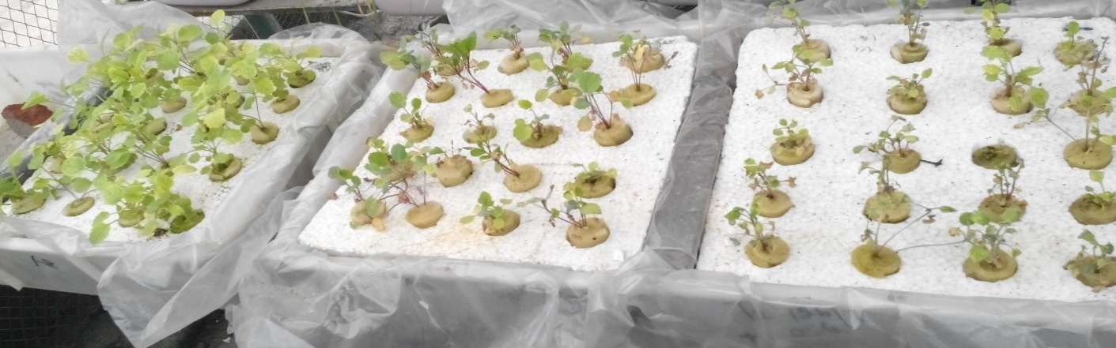
T₂
T₀
T₁
Figure 1. Seedlings in hydroponic tubs after 15 days of stress application
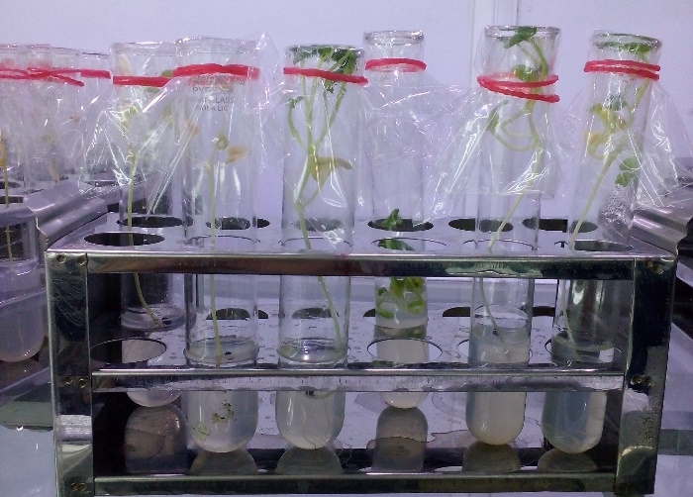 | 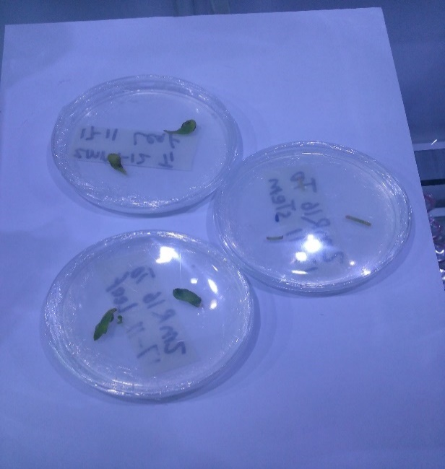
Figure 2. Callus culture of leaves of Brassica napus seedlings
Recent Publications
Hadi, F., Ayaz, M., Ali, S., Shafiq, M., Ullah, R., Jan, A. U. 2014. Comparative effect of polyethylene glycol and mannitol induced drought on growth (in vitro) of canola (Brassica napus), cauliflower (Brassica oleracea) and tomato (Lycopersicon esculentum) seedlings. Int. J. Biosci. 4, 34-41.
Husen, A., Iqbal, M. 2014. Growth, water status, and leaf characteristics of Brassica carinata under drought and rehydration conditions. Braz. J. Bot. 37, 217-227.
Nosrati, S., Zanjan, M. G., Asli, D. E. 2014. Fluctuations of proline concentration and soluble sugars content affected drought stress in canola (Brassica napus L.) seedlings. J. Applied Sci. Agri. 9, 497-502.
Viscardi, S., Ventorino, V., Duran, P., Maggio, A., De Pascale, S., Mora, M. L., Pepe, O. 2016. Assessment of plant growth promoting activities and abiotic stress tolerance of Azotobacter chroococcum strains for a potential use in sustainable agriculture. J. Soil Sci. Plant Nutrition. 16, 848-863.
Tian, F. P., Zhi, N. Z., Xiao, F. C., Lei, Sun, Xue, H. W., Gao, L. W. 2016. Effects of biotic and abiotic factors on soil organic carbon in semi-arid grassland. J. Soil Sci. Plant Nutrition. 16, 1087-1096.

Biography
Bareera Nasir has completed her Msc. (hons) Plant breeding and genetics from University of Agricultural, Faisalabad, Pakistan at the age of 23 years. She is currently a student of PhD. in university of agriculture, Faisalabad.

Contact number: +923425820693
bareeranasir64@gmail.com

https://www.omicsonline.org/agri-food-aqua-conferences.php

