Abstract

Title: Strategy for protection and management of traditional agricultural landscape (on the example from Slovakia)

Jana Špulerová¹, Marta Dobrovodská¹, Dagmar Štefunková¹, Juraj Lieskovský², Peter Bezák², Zita Izakovičová¹
¹ Institute of Landscape Ecology, Slovak Academy of Sciences, Bratislava, Slovakia
² Institute of Landscape Ecology, Slovak Academy of Sciences, Nitra, Slovakia

Keywords: traditional agriculture, biodiversity, cultural diversity, High Nature Value farmland

- Abstract Body (up to 250 words)
Within the agricultural landscape of Slovakia, which covers almost half of the area, the remnants of traditional agricultural landscapes (TAL) can still be found (Lieskovský et al., 2014). Facing their disappearance, the aim of this study is to (1) point to diversity of TAL and their biocultural value, (2) analyse the geographical preconditions of abandonment (slope, soil fertility, accessibility, isolation) and thus (3) to propose measures for protection and management of TAL in accordance with sustainable development.
The strategy was elaborated on the basis of country-wide mapping of TAL in Slovakia (Špulerová et al., 2011) and results of interdisciplinary research of biodiversity and ecological conditions performed in case-study areas. The results from the country-wide mapping shows that main threats of TAL is abandonment that occurs most intensively on steep slopes and on less fertile soils. Interviews at the case study level showed that financial profit is the main factor, which would motivate the local people to farm the TAL. The Strategy for protection and management of TAL is oriented to optimal multifunctional utilization and management of investigated landscapes in relation to sustainable development of TAL and maintaining the biodiversity of landscape, by application of agro-environmental scheme as well as support to multi-functional farming. The proposal of ecological management brings about not only protection of valuable habitats, but it should have positive impact on environment and human wellbeing. The proposal for support from agri-environmental scheme was developed on the basis of knowledge about High Nature Value farmland support in other European countries (Špulerová et al., 2017).

- Image:

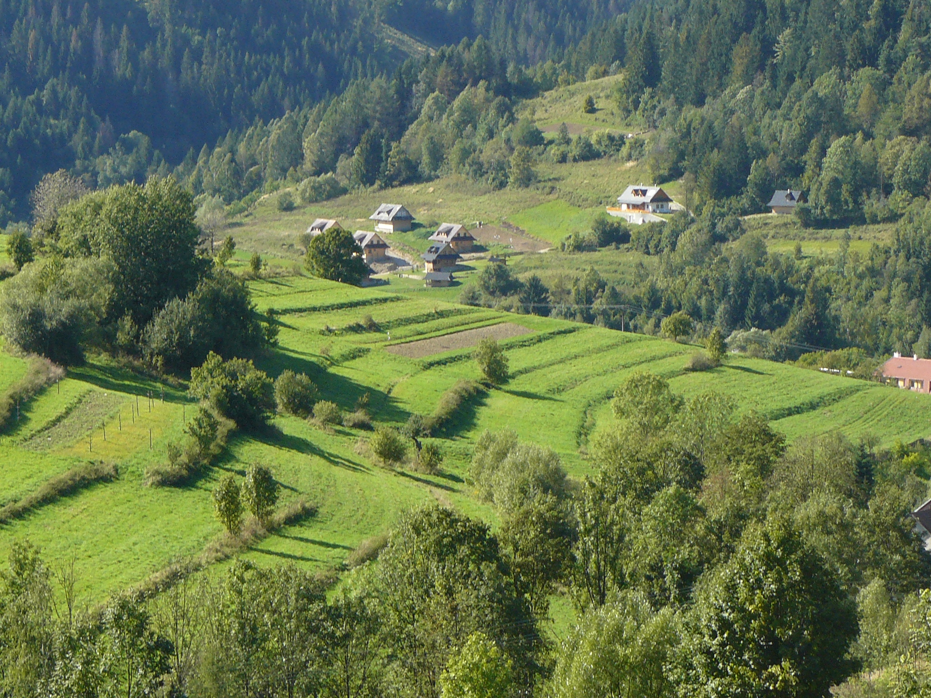

- Reference:
- Lieskovský, J., Kenderessy, P., Špulerová, J., Lieskovský, T., Koleda, P., Kienast, F., Gimmi, U., 2014. Factors affecting the persistence of traditional agricultural landscapes in Slovakia during the collectivization of agriculture. Landsc. Ecol. 29, 867–877. https://doi.org/10.1007/s10980-014-0023-1
- Špulerová, J., Bezák, P., Dobrovodská, M., Lieskovský, J., Štefunková, D., 2017. Traditional agricultural landscapes in Slovakia: why should we preserve them? Landsc. Res. 42, 891–903. https://doi.org/10.1080/01426397.2017.1385749
- Špulerová, J., Dobrovodska, M., Lieskovský, J., Bača, A., Halabuk, A., Kohút, F., Mojses, M., Kenderessy, P., Piscová, V., Barančok, P., 2011. Inventory and classification of historical structures of the agricultural landscape in Slovakia. Ekológia (Bratislava) 30, 157–170. https://doi.org/10.4149/ekol_2011_02_157
- Biography:
Jana Spulerova has completed her PhD at the age of 29 years from 1993-1998 Technical University in Zvolen, School of Ecology and Environmental Sciences and Postdoctoral Studies from Technical University in Zvolen, Institute of Landscape Ecology, Slovak Academy of Sciences, Bratislava, Slovakia. She is a senior researcher and head of Scientific board at the Institute of Landscape Ecology of the Slovak Academy of Sciences. She has published more than 15 papers in reputed journals and has been serving as an editorial board member of Ekologia (Bratislava) journal.
- Presenting author details


Full Name: Jana Spulerova
Contact number:
Twitter account:
Linked In account:
Session name/ number:
Category: Oral presentation
Passport Number:

