Impact of Climate Change on Phenological Stages of Citrus in Pakistan
Rab Nawaz and Prof. Dr. Nadeem Akhtar Abbasi,
Pir Mehr Ali Shah- Arid Agriculture University Rawalpindi, Pakistan

Abstract
Citrus fruits are prominent cultivar of tropical and sub-tropical region and require suitable climate and growing conditions for good quality production. Different environmental conditions influence Citrus fruit physico-chemical quality. Perennial crops like citrus fruits are long –lived and change slowly than annual crops and are at higher risk due to climate change. The present study was designed to develop a phenological model of Citrus fruit in three main citrus groves and evaluated potential impact on climate change on different phenological stages and reduction in yield and deterioration of fruit quality. Due to global warming, a paradigm shift in climate of the region which resulted in rise of temperature, change in rainfall pattern and squeeze of winter period and prolong summer that has adversely affected citrus fruits. Heat wave in the months of April-May has led to more fruit drop and rise of temperature in October-November has deteriorated fruits quality and resulted in more incidences of diseases .Similarly vegetative flushes of citrus are more at risk to pest infestation in period of rise in temperature and change in rainfall. A recent phenomenon of fog in the month of November has increased fruit drop at maturity stage and led to shortened period of fruit harvesting and marketing. Both fruits physical and chemical qualities are deteriorated in era of temperature rise. Resultantly inputs cost increased while citrus production decreased with lower prices. In order to mitigate the challenges of climate change, a long term planning is direly needed to evolve new cultivars and resistant rootstocks while timely management practices are somewhat workable in short term to avoid major disaster.

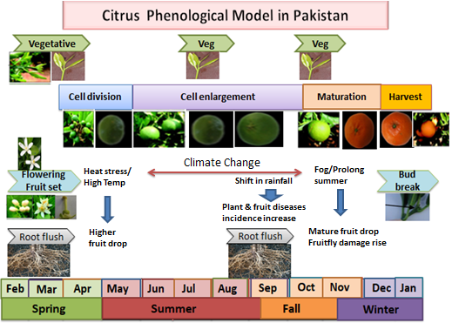
Recent Publications
- Tejero, I.G et.al (2010) Response of citrus trees to deficit irrigation during different phenological periods in relation to yield, fruit quality, and water productivity. Agricultural Water Management 97: 689–699.
- Dalal, R.P.S et.al (2013) Seasonal Variation in Growth, Leaf Physiology and Fruit Development in Kinnow, a Mandarin Hybrid. Journal of Plant Studies:10.5539/jps.v2n1p72.
- Isma-ae Chelong and Sayan Sdoodee (2013) Effect of Climate Variability and Degree-Day on Development, Yield and Quality of Shogun (Citrus reticulata Blanco) in Southern Thailand. Kasetsart J. (Nat. Sci.) 47 : 333 – 341.
- Farooq et.al (2011) Fruit Growth And Development In Three Cultivars Of Citrus: Orange, Kinnow And Feutrall’s Early FUUAST J. BIOL., 1(2): 145-147
- Hafeez-ur-Rahman et.al (2012) Growth and yield of Kinnow (Citrus reticulate Blanco) and soil physical properties as affected by orchard floor management practices in Punjab, Pakistan. Soil Environ. 31(2): 163-170.



Biography
Rab Nawaz has worked in citrus growing area and disseminated production technology and knowledge to growers. He worked on citrus agro-ecological system analysis since 2006 to now. Presentably he is conducting his research on physiological and fruit quality assessment of Kinnow mandarin under varying environmental conditions. The main focus of his study area is impact of climate change on citrus crop. His study based on phenological events of citrus with reference to climate change and its adverse effect on fruit quality. He is doing PhD under the supervision of Prof.Dr. Nadeem Akhtar Abbasi, Dean Faculty of Crops & Food Sciences, PMAS-Arid Agriculture University, Rawalpindi Pakistan.

Email: rnkahut@yahoo.com

