Novel Insight into Transcriptional Regulation of Key Genes of Citrulline Biosynthetic Pathway Mediated By Rootstock
Aslam Ali, Chinese Academy of Agricultural Sciences, Zhengzhou Fruit Research institute, Zhengzhou, China.

Abstract
Watermelon is considered to be a largest natural source of citrulline. Trabscriptional regulation of citrulline biosynthetic pathway genes and quantification of citrulline at different developmental stages of fruit was studied in homografted, hetero grafted and non grafted watermelon. Citrulline content continues to increase until ripe stage in grafted and no grafted plants with highest content was observed in heterografted followed by homografted and non grafted watermelon. High transcript level for GAT, NAG and NAGK can be related to high citrulline amount in hetero grafted and among downstream stream genes, ASS gene family interact synergistically while ASL gene family work antagonistically resulted in low degradation of citrulline in hetero grafted. Experiment was laid out according to Randomized Complete Block Design (RCBD) and three biological replicates were used for analysis. The significant differences between expression values were statistically evaluated by standard deviation. Two way ANOVA for citrulline quantity was performed and tested for statistical significance using Statistics 8.1.

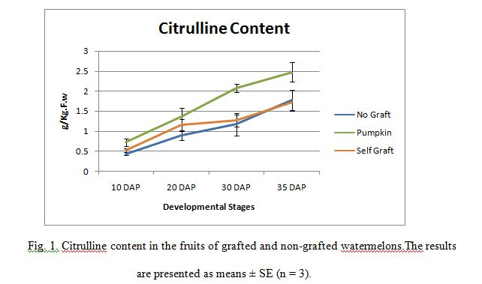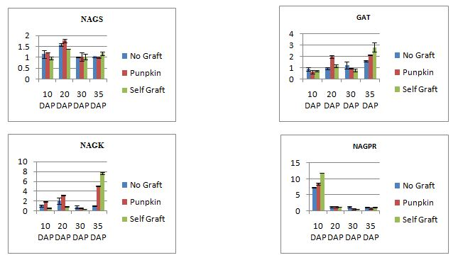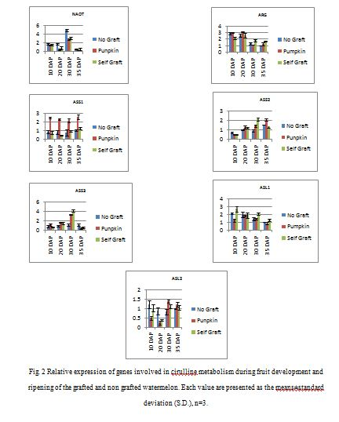



Ali Aslam is Phd Scholar in Zhengzhou Fruit Research Institute Henan, China. His major subject is vegetable breeding. He has published several papers locally and internationally. He has expertise in Polyploidy breeding, Molecular genetics, Plant metabolism and Grafting

Email mianaliaslam538@gmail.com

- Kyriacou M C, Soteriou G A, Rouphael Y, et al. Configuration of watermelon fruit quality in response to rootstock‐mediated harvest maturity and postharvest storage[J]. Journal of the Science of Food and Agriculture, 2015.
- Guo S, Zhang J, Sun H, et al. The draft genome of watermelon (Citrullus lanatus) and resequencing of 20 diverse accessions[J]. Nature genetics, 2013, 45(1): 51-58.
- Fallik E, Ilic Z. Grafted vegetables–the influence of rootstock and scion on postharvest quality[J]. Folia Horticulturae, 2014, 26(2): 79-90.
- Cookson S J, Moreno M J C, Hevin C, et al. Graft union formation in grapevine induces transcriptional changes related to cell wall modification, wounding, hormone signalling, and secondary metabolism[J]. Journal of experimental botany, 2013: ert144.
5. Aloni B, Cohen R, Karni L, et al. Hormonal signaling in rootstock–scion interactions[J]. Scientia Horticulturae, 2010, 127(2): 119-126.

