U In vitro propagation of UCB-1 (Pistacia integrima × P. atlantica) to unravel main limiting factors
Nezami SR, M.Sc, Tarbiat Modares University, Iran
Yadollahi A, Ph.D, Tarbiat Modares University, Iran
Hokmabadi H, Ph.D, Agricultural Research,Education and Extension Organization, Iran
Eftekhari M, Ph.D, Tarbiat Modares University, Iran

Abstract
Statement of the Problem: Pistachio is a perennial, deciduous and subtropical. Considering the prevalence of using seedlings as rootstock, there is an irregularity in pistachio orchards and it is necessary to use vegetative methods in propagation of rootstocks. ‘Badami’ and ‘Ghazvini’ are the most common used rootstocks in Iran. Recently, UCB-1 has been also considered as an appropriate one due to its noble features. Now, because of the limitation of importing its seeds to Iran, the only way of its propagation is by tissue culture. But pistachio micropropagation is problematic due to the phenol exudation and bacterial contamination problems in establishment phase, shoot tip necrosis in proliferation, low proliferation rate and especially being hard to root. In order to in vitro propagation of this valuable rootstock, we carried out an experiment. Methodology & Theoretical Orientation: To overcome the contamination problem, we used different concentrations and immersion times of mercury chloride, sodium hypochlorite and chloramphenicol. Antioxidants, active charcoal, darkness and decreasing macro-nutrients concentration treatments were applied as controlling agents of phenol exudation. Modifying macro- and micro-elements᾽ concentration was applied to IMPROVE proliferation and controlling shoot tip necrosis. In rooting stage, we used treatments of Fe-sequesteron, putrescine, modifying different nutrients᾽ concentrations and using various types of auxins. Finally, darkening mother plant for 2 weeks with decreasing macro-nutrients᾽ concentration and immersing explants in 150 Mm ascorbic acid for 120 min and 60 min respectively before and after sterilization process showed the highest rate (100 percent regeneration) of controlling phenol exudation (100 percent explant without phenol). Findings: The highest rooting was achieved in the half strength macro-nutrients of DKW (1/2 DKW) culture medium and 2 mg/l IBA, 150 mg/l fe-sequestron and 100 mg/l putrescine. Finally, rooted shoots (> 2 cm) were acclimatized in the mixture of perlite and peat-moss (1:1).

Image
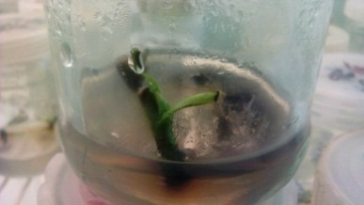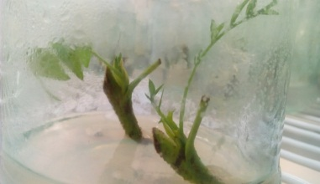
Figure 1. Effect of CAS on in vitro establishment of UCB-1 rootstock, right: control medium lacking ACH and CAS and left: CAS
Recent Publications
- Ananthakrishnan G, Ravikumar R, Anand PR, Vengadesan G (1999) Induction of somatic embryogenesis from nucellarderived callus of Anacardium occidentale L.. Scientia Horticulture 79:91–99.
- Bairu MW, Wendy A, Stirk J, Van Staden (2009) Factors contributing to in vitro shoot-tip necrosis and their physiological interactions. Plant Cell Tissue and Organ culture 98:239-248.
- Benmahioul B, Dorion N, Kaid-Harche M, Daguin, F (2012) Micropropagation and ex vitro rooting of pistachio (Pistacia vera L.). Plant Cell Tissue and Organ culture 108:353-358.
- Dias MA, Costa MM (1983) Effect of low salt concentrations on nitrate reductase and peroxidase of sugar beet leaves. Journal of Experimental Botany 34:537-543.
- Fujita Y, Hara Y, Suga C, Morimoto T (1981) Production of shikonin derivatives by cell suspension cultures of Lithospermum erythrorhizon. Plant Cell Report 1:61-63.

Biography
Abbas Yadollahi has his expertise in Fruit Physiology and Breeding. He has about 10 years of experience in plant tissue culture both scientifically and commercially. And has lots of publications in this issue which are mostly on micropropagation of important fruit tree rootstocks.
Email: yadollah@modares.ac.ir

