A way forward to eco-efficient farming practices

Khurram Shahzad PhD, King Abdulaziz University KSA
Stephan Maier PhD, Graz University of Technology, Austria.

Abstract

The cultivation of energy crops to fulfil clean energy demand has resulted in land use competition between food and energy. Similarly, continuous monoculture cropping system results in extra pressure on soil and surrounding environment. The cropping potential of arable land can be increased by applying alternate cropping practices. One of the main challenges in current bio resource management is economically feasible food production while sustaining intact arable land. The improvement of conventional farming practices can help to attain eco-economic benefits and overcome prevailing challenges.

The ecological evaluation methodologies exhibits diverse levels of comprehensiveness based on normative behind their development to assess ecological impact of anthropogenic activities on natural resources as well as biogeochemical cycles. This study deals with design and development of eco-efficient integrated biomass production system. The ecological evaluation is carried out using life cycle assessment based methodology known as Sustainable Process Index (SPI). This methodology considers resources availability from natural income, their life cycle chains and emissions to their relevant compartments (air, soil, water) on the earth sphere. Overall footprint of a process, product or service unit is given as single number in m2 area. This value is the sum of ecological pressure exerted by resource and energy consumption as well as emissions during the life cycle of a process chain.

The analysis highlights the ecological hotspots in the process chain. These ecological hotspots in the conventional farming practices includes monoculture cropping system, use of mineral fertilizers, pesticides, herbicides and consumption of fossil fuel to fulfil energy demand. The shift from business as usual farming practice to organic farming practise using manure as fertilizer while biogas as renewable fuel instead of fossil fuel showed an ecological footprint reduction potential ranging from 22% to 57%. The evaluation outcomes are very promising and depicts that shift to modern farming practices equipped with alternate renewable energy provision systems have huge potential to attain sustainability in agriculture sector.
Image
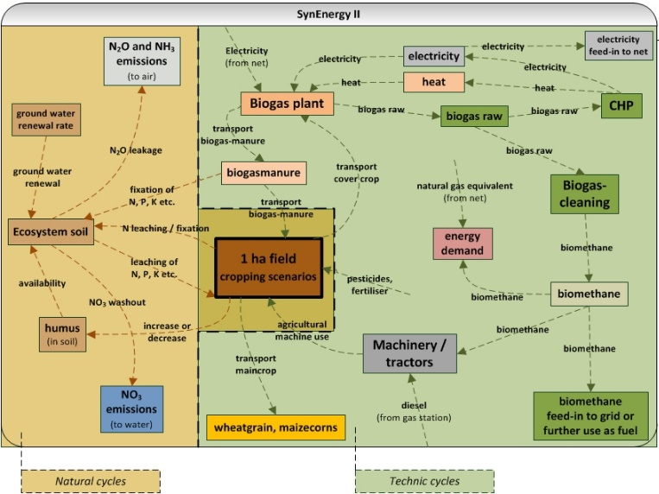
Figure 1:Maximum cultivation, emission cycle and energy network of considered scenarios
Recent Publications (minimum 5)

S Maier, M Szerencsits, M Narodoslawsky, Ismail IMI, K Shahzad. 2017. Current potential of more sustainable biomass production using eco-efficient farming practices in Austria. Journal of Cleaner Productions. 155 (2017) 23-27. doi: 10.1016/j.jclepro.2016.09.037. (IF: 5.715)

K Shahzad, L Čuček, M Sagir M, N Ali, MI Rashid, R Nazir, AS Nizami, HA Al-Turaif, IMI Ismail. 2018. An ecological feasibility study for developing sustainable street lighting system. Journal of Cleaner Productions. 175-683-695. doi:10.1016/j.jclepro.2017.12.057. (ISI Impact Factor: 5.715)

K Shahzad, M Narodoslawsky, M Sagir, N Ali, S Ali, MI Rashid, IMI Ismail, N Koller. 2017. Techno-economic feasibility of waste biorefinery: Using slaughtering waste streams as starting material for biopolyester production. Waste Management. 67 (2017) 73–85. doi: 10.1016/j.wasman.2017.05.047. (IF: 4.030).

J Sadaf; GA Shah; K Shahzad; N Ali; M Shahid; S Ali; A Hussain; ZI Ahmed; B Traore, MI Rashid. 2017. Improvements in wheat productivity and soil quality can accomplish by co-application of biochars and chemical fertilizers. Sci Total Environ. 607-608:715-724. doi: 10.1016/j.scitotenv.2017.06.178. (IF: 4.9)


The Author is working as Assistant Professor in the Center of Excellence in Environmental Studies (CEES), King Abdulaziz University, Jeddah, KSA. He is a Life Cycle Assessment (LCA) expert with a background in chemical engineering and environmental sciences. He has more than 8 years of international experience and cross sector exposure. He has around 50 journal and peer reviewed conference papers. He is passionate about sustainability and dedicated to sustainable development that can positively contribute to economic, social and environmental impacts of the society.
Email: shahzadkhu@gmail.com

