Sustainable improvement in agricultural productivity through algae (seaweeds) based fertilizers and mechanistic understanding thereof of their biostimulant activity
Dr. Arup Ghosh, Ph.D, CSIR-CSMCRI, Bhavnagar, India

Abstract (300 word limit)

Statement of the Problem: Use of chemicals fertilizers have serious repercussions to the environment. In this context, organic liquid seaweed fertilizers from macroalgae (seaweeds) offers great potential for enhancing crop productivity under normal and drought stress conditions. However, their mechanism of action is still elusive as are the identity of the active constituents in them. Equally important is to quantify such organic products in terms of sustainability. Besides evaluating their efficacy across varied agro-ecological conditions, their effect on soil microbial flora ought to be simultaneously studied. Methodology & Theoretical Orientation: Cultivation technologies for several macroalgae like Gracilaria, Kappaphycus, etc., have been developed at CSIR-CSMCRI, Bhavnagar in India. A process to obtain liquid seaweed fertilizers (LSF) was developed from red seaweed, Kapppahycus alvarezii (US Patent No. 6,893,479). To demonstrate and validate its efficacy as biostimulant, over 170 agronomic and large scale demonstration trials were carried out on cereals, pulses, oilseeds, sugar, fodder and vegetables in varied agro-ecological zones across 20 states in India in coordination with CSIR-CSMCRI, State agricultural universities & ICAR Institutes. Selective elimination of the specific constituents enabled identifying of the active constituents in the LSF responsible for its bioefficacy. Physiological, biochemical and transcriptome studies helped gain an insight into the mechanistic aspects of their action on crops, while 16s metagenome analysis revealed their effect on soil microbial community. Life cycle impact assessment (LCA) was carried out to quantify their sustainability. Findings: KSWE proved an effective bio-stimulant that enhanced crop yields by 13-37 percent over and above the recommended chemical fertilizers dosages (control) and in several cases their quality. KSWE was computed to have low carbon foot print of 118.6 kg CO2 equivalent per kilo litre and its use was found to offset the impact across several environmental categories, including global warming potential, per unit of agricultural production. Elimination of Gibberellic acid was found to be beneficial towards improving corn stover as well as grain yield by suppressing of crosstalk between cytokinins and GA3, while glycine betaine imparted drought tolerance and

improved photosynthetic efficiency. Several key genes related to N metabolism, antioxidants cell cycle and cell repair, hormonal regulation were found to be upregulated by KSWE. In soil, bacterial genera influencing Nitrogen cycle (Nitrosomonas, Nitrospira, etc.) responded beneficially.

Image
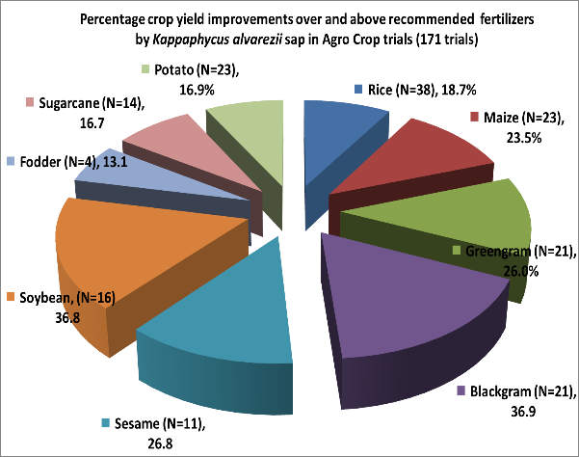

Recent Publications
- Anand et al. and Ghosh (2018) Life cycle impact assessment of a seaweed product obtained from Gracilaria edulis - a potent plant biostimulant. Journal of Cleaner Production 170: 1621-1627. Alcohol Alcohol 44:136-140.
- Trivedi et al. and Ghosh (2017) Drought alleviatory potential of Kappaphycus seaweed extract and the role of the quaternary ammonium compounds as its constituents towards imparting drought tolerance in Zea mays L. Journal of Applied Phycology. [doi: 10.1007/s10811-017-1375-0]
- Trivedi et al. and Ghosh (2017) Crop stage selection is vital to elicit optimal response of maize to seaweed bio-stimulant application." Journal of Applied Phycology: 1-10. DOI: 10.1007/s10811-017-1118-2
- Sharma et al. and Ghosh (2017) Sustainable agro-technology for enhancement of rice production in the red and lateritic soils using seaweed based biostimulants." Journal of Cleaner Production 149: 968-975
- Singh et al. and Ghosh (2016) Sustainable enhancement in yield and quality of rain-fed maize through Gracilaria edulis and Kappaphycus alvarezii seaweed sap." Journal of Applied Phycology 28: 2099-2112.
- Ghosh et al. (2015) Life cycle impact assessment of seaweed based biostimulant production from onshore cultivated Kappaphycus alvarezii (Doty) Doty ex Silva—Is it environmentally sustainable?." Algal Research 12: 513-521.


Biography (150 word limit)

Dr. Arup Ghosh, Senior Scientist & Head, Agronomy and Fertilizer Group, Biotechnology and Phycology Division in a top CSIR laboratory has his expertise in development and evaluation of crop biostimulants developed from marine seaweeds (macroalgae). He has the passion for improving the livelihood opportunities and profitability of farmers through innovative products. His research findings through agronomic trials and molecular tools have helped opened new insights regarding the use of seaweed biostimulants enabling the entrepreneurs to commercialize and take these products to the farming community in a big way. He has years of experience in research, evaluation, teaching and administration and has executed several national and International projects. He has to his credit many book chapters, popular articles and more than 80 peer reviewed articles in Journals of repute. His research approach is based on the felt needs of the stakeholders and has won accolades to the Institute he is associated with.
Email: arupghosh@csmcri.res.in

Notes/Comments:

Work on several other fertilizers, for example potassic fertilizers (Schoenite, potassium nitrate) from seabittern, microalgal organic fertilizers (Chlorella and Lyngbya deoiled cake) and effect of organic manure (Jatropha cake) on soil and plants would also be touched upon during the presentation.

