Sdg’s4Business: how to create value with Sdg’s
Raffaele M. Maiorano, chairman of Gfar, Global forum on agricultural resear; responsible for Sdg’s at Confagricoltura

Abstract (300 word limit)

We are in UN decade for Sdg’s. From 2015, when UN countries met in NYC and decided to achieve the Sdg’s, many things has been done, but companies and private sector are still wondering how to create value with them. Sdgs Competitive model has been implemented to help agribusiness companies to measure their investment with the Sdg’s and create a systemic progressive positive mechanism. To become more sustainable, we need to follow 5 actions:

Change of paradigm: sustainability is an «engine for value» for companies, clients and Society (stakeholder). It’s not an imposition

Semplify target and global challenges in concrete actions, measurable e consistent with the company business;

Work on the innovation of process and product tranforming the existing model in a more sustainable way (key SDG,s). Start with the innovation of thought.

Create a business model able to generate value, incrementally (virtuosity)

Establish compliant targets coherent with business targets

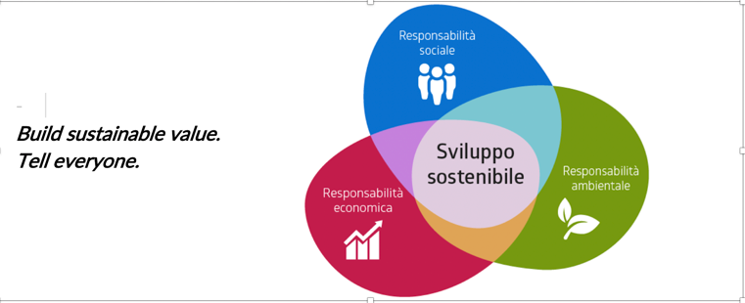

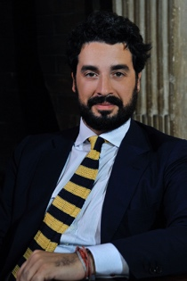

Biography (150 word limit)
Raffaele M. Maiorano, is an entrepreneur in agriculture and runs two farms in southern and central Italy, producing Pecorino Crotonese DOP cheese, organic olive oil, cereals, oranges and fresh vegetables. He was president of the Italian young farmers for six years and now he's in charge for Sdg's and sustainability programs at Confagricoltura, the oldest farmers organization in Italy and Europe. He's a freelance journalist who worked for many political agencies and national newspapers. He's the chairman of Gfar, the Global forum on agricultural research and innovation at FAO. He's a professor of agribusiness management at Camerino University, designed and runs the Agribusiness management's master at Rome Business School. He was in the advisory board of Carrefour, works with Gambero Rosso and he's a consultant for startups and agribusiness companies.

Email: raffaelemaiorano@gmail.com

Notes/Comments:

