Integrated Crop-Livestock-Forestry: is it the new Brazilian green revolution?
Mariana de Aragão Pereira, PhD, Embrapa Beef Cattle, Brazil

Abstract (300 word limit)
Statement of the Problem: Climate change is a world concern and reducing agriculture environmental impacts has become a major challenge, given the ever growing food and energy demands. Integrated farming systems (IFS), combining crops (C), livestock (L) and/or forestry (F), reached over 12 million hectares in Brazil, in 2016, becoming a sustainable alternative to large monoculture. IFS involves intercropping, rotation and/or succession, enabling the production of food, fiber and energy on the same area (Fig. 1). “How promising are IFSs to promote production increase while reducing the environmental impact of agriculture, under climate change conditions” is the subject matter of this exploratory paper. Methodology: a literature review was carried out considering, particularly, the Brazilian context. It explored the research question, critically analyzing IFS benefits and challenges. Findings: Research has shown several benefits of IFS in Brazil, under different edaphic and climate conditions, arrangements, and others. In general, the synergisms occurring in IFS lead to greater production of biomass, improving soils conditions, which, in turn, results in better pasture and animal performance, and less weeds. Cover or cash crops lend pasture some residual fertilization, and receive back better physical and biological soil conditions that result in yield increase. The introduction of trees can represent additional source of farm income, while promoting animal welfare and ecological services, like carbon emissions mitigation. Additionally, IFS allows for good economic returns and reduced income risks. Brazilian government has been incentivizing IFS through specific credit program, but the adoption of such systems remains limited because of cultural aspects, lack of holistic understanding of IFS and structural and market constraints. Conclusions: To increase the uptake of IFS and consolidate it as the “new green revolution” further fostering of agriculture and energy supply chains is necessary, along with government

spending on infrastructure. Farmers’ training should also be addressed.
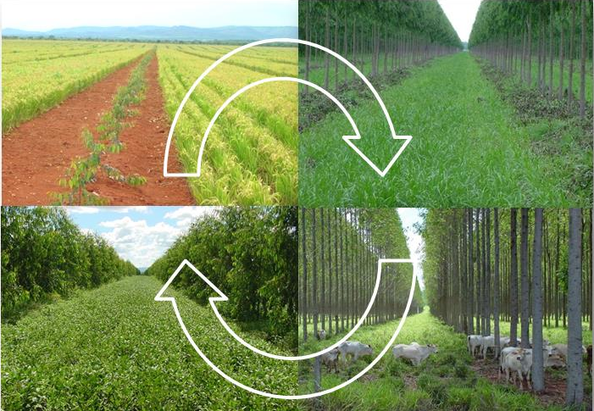
Figure 1 – Illustration of integrated crop-livestock-forestry, Brazil.

Recent Publications
- Esteves, E.M.M, Esteves, V.P.P., Bungenstab, D.J., Araújo, O.Q.F. et al. (2018). Greenhouse gas emissions related to biodiesel from traditional soybean farming compared to integrated crop-livestock systems. J. Clean. Prod., 179, 81-92. https://doi.org/ 10.1016/ j.jclepro.2017.12.262
- da Conceição, M.C.G., Matos, E.S., Bidone, E.D., et al. (2017) Changes in Soil Carbon Stocks under Integrated Crop-Livestock-Forest System in the Brazilian Amazon Region. Agric. Sci., 8, 904-913. https://doi.org/10.4236/as.2017.89066
- Magalhães, C.A.S., Pedreira, B. C., Tonini, H. and Farias Neto, A. L. Crop, livestock and forestry performance assessment under different production systems in the north of Mato Grosso, Brazil. Agroforest. Syst., 93, 2085–2096. https://doi.org/10.1007/ s10457-018-0311-x
- MAPA, MDA (2012) Sector plan for mitigation and adaptation to climate change for the consolidation of an economy of low carbon emission agriculture. ‘‘LCA Plan’’ (Low Carbon Agriculture). Ministério da Agricultura, Pecuária e Abastecimento/Ministério do Desenvolvimento Agrário, Brasília. Available at: http://www.agricultura.gov.br/desenvolvimento-sustentavel/plano-abc. Accessed 14 December 2019.
- Pereira, M.A., Almeida, R.G., Laura, V.A., Costa, F.P. et al. (2019). Carbon Neutral Brazilian Beef: an analysis of its economic viability for livestock sustainable intensification. In: International Farm Management Association, 22, Launceston, Australia. Proceedings…IFMA: Launceston, 2019.
- Schuster, M.Z., Lustosa, S.B.C., Pelissari, A., Harrison, S.K. et al. (2019). Optimizing forage allowance for productivity and weed management in integrated crop-livestock systems. Agron. Sustain. Dev. 39, 18. https://doi.org/10.1007/s13593-019-0564-4
- Deniz, M., Schmitt Filho, A.L., Farley, J., Quadros, S.F. (2019). High biodiversity silvopastoral system as an alternative to improve the thermal environment in the dairy farms. Int. J. Biometeorol, 63, 83–92. https://doi.org/10.1007/ s00484-018-1638-8

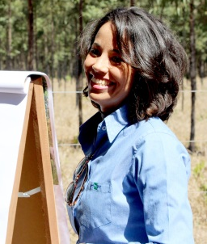 Biography (150 word limit)
Dr. Mariana de Aragão Pereira
Bachelor in Animal Sciences (1999) and master’s in Applied Economics (2001), both at Viçosa Federal University/Brazil. PhD on Agricultural Management at Lincoln University, New Zealand (2011). Since 2001, she joined the Brazilian Agricultural Research Corporation – EMBRAPA, as a researcher, initially, working at the Strategic Management Secretary (SGE) and, from 2004, working at Embrapa Beef Cattle research unit. She also worked as a research assistant at the Agribusiness and Economics Research Unit (AERU), Lincoln University from 2007 to 2008, and is currently the representative of South America at the International Farm Management Association Council. Her major areas of expertise are Rural Economics and Farm Management, with emphasis on beef cattle systems and production costs, farm management and technology adoption. She is a member of two Management Committee for Environmental Protected Areas in Campo Grande, Mato Grosso do Sul state and is an ad hoc reviewer for several Brazilian and international journals.
Email: mariana.pereira@embrapa.br

Notes/Comments:
This study is part of Research Projects sponsored by Embrapa under the grant numbers: 02.13.11.003.00.03; 03.13.11.004.00.07.001 and 04.13.11.001.08.04.010

