Effect of Land Use on Soil Phosphorous Sorption Characteristics and Physicochemical Properties of Assosa District, of North Western Ethiopia.

Dessalegn Tamene, Junior Researcher at EIAR, Ethiopia

Abstract
This study investigated effect of land use on soil phosphorous sorption characteristics and physicochemical properties of surface soils of cultivated, grazing, homestead, natural forest and eucalyptus plantation lands in the Assosa District of North Western Ethiopia. The objectives of this study were to evaluate P-sorption characteristics and to see effect of different land use types on the P sorption and on soil properties. Composite surface (0-20 cm) soil samples from 15 sites of Assosa district were collected arranged for analysis. Soil P sorption was measured in the laboratory by batch experiment. From each land use type, physic chemical properties of soils were evaluated using different extractants and P sorption isotherms were described by Langmuir and Freindulich equations provided a good fit for Langmuir equation for the equilibrium P concentration. Values of the P sorption maximum of the soils ranged from 97.09 to 243.90 mg kg-1 and the distribution coefficient (Kf) values of soils ranged from 0.04-0.18 mg P Kg-1 based on Freundlich model. Soils of the cultivated land with high clay and exchangeable cation contents had high degree of P sorption than the remaining land use systems. Soils physicochemical properties and their relationships with P-adsorption data were determined by correlation analysis method. The results revealed that the P-sorption data were fitted well with both Langmuir and Freundlich models with R² values of 0.72 and 0.96 respectively. But the former model was found to better in describing P-sorption data than the later model. Bonding energy constant (K) of Langmuir model and Freundlich constant (b) ranged from 0.107-0.220 L/mg and 0.83-0.95 respectively. Among the various soil properties which correlated with P sorption maxima of significance was PH (R² = 0.92) and CEC (R² = 0.78) was significantly correlated. The study illustrated that P sorption isotherm in relation to soil properties can be used as a tool of P management in sustainable crop production. It was concluded that P-sorption models can effectively be used to discriminate soils based on P-fixation ability.


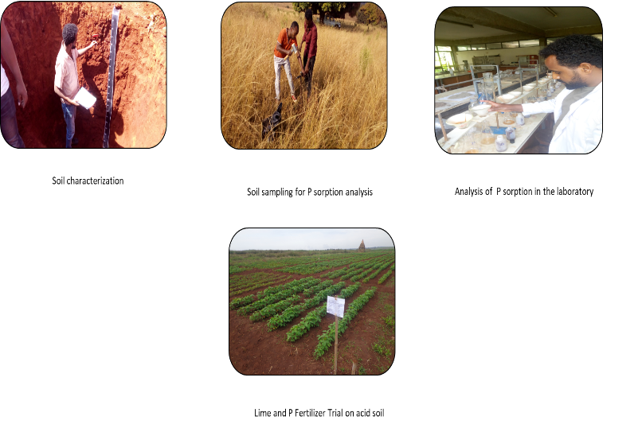
Recent Publications
- Tamene D, Anbessa B, Legesse TA, Dereje G (2018) Refining Fertilizer Rate Recommendation for Maize Production Systems in Assosa, North Western Ethiopia.
- Tamene D, Anbessa B, Adisu T (2017) Influence of Lime and Phosphorus Fertilizer on the Acid Properties of Soils and Soybean (Glycine max L.) Crops Grown in Benshangul-Gumuze Regional State Assosa Area.
- Tamene D, Bekele A, Getahun D and Bogale W (2018) Response of Sorghum and Soybean to Split Application of Lime, Proceeding.
- Getahun D, Dessalegn T, Bekele A, and Bogale W (2018) Response of Sorghum and Soybean to Lime and Phosphorus, Application and its Subsequent Effect on Acidity of Soils in Assosa Area, Proceeding.
- Bekele A, Getahun D, Dessalegn T, and Bogale W (2018) Response of Sorghum and Soybean to Furrow Application of Lime and its Effect on the Acidity of Soils, Proceeding.

Biography
Presently I am working at Ethiopian Institute of Agricultural Research (EIAR), Assosa Agricultural Research Center as junior researcher. I am working as junior researcher in soil research process and I am a leader of acid soil management case team. I am undertaking different research activities concerning soil and plant nutrients in addition to my previous responsibilities in the research department. From this range of experiences and in performing my responsibilities immediately related to my specialty, I devoted a great deal of energy. The most important thing is that those opportunities of directly experiencing the realities of Ethiopian’s research institute have made me soberly aware of the difficulties that they face and their serious gaps from advanced western technologies. In particular, Ethiopian research institutes lack sufficient research and development input, resulting partly from lack of research funds and partly from the lack of well-trained soil scientists.
Email: dessalegnt12@gmail.com

Notes/Comments: It is my pleasure if was participated as a speaker rather than a Dedicate.

