Genetic dissection of seedling vigor in a diverse panel from the 3,000 Rice (Oryza sativa L.) Genome project
Jianlong Xu, Institute of Crop Sciences, Chinese Academy of Agricultural Sciences, Beijing, China

Abstract
With economic and social development, cultivating systems for rice (Oryza sativa L.) production have changed. Direct seeding rice (DSR) has been widely adopted by farmers due to large saving of production costs in China. Thus, seedling vigor (SV), especially early SV, which refers to the SV for seedlings less than 28 d old, is imperative for crop stand establishment and weed competitiveness for upland direct seeding which is absent standing water layer to suppress weeds. Although the control of weeds is much easier owing to the standing water layer, the late SV, 28 d after sowing is more important for the population type and final grain yield for paddy direct seeding. So, SV is important for DSR for both upland- and paddy-direct seeding systems, but the genetic mechanisms behind the related traits remain largely unknown. Here, we used 744 germplasms, having at least two subsets, for the detection of quantitative trait loci (QTLs) affecting the SV-related traits tiller number, plant height, and aboveground dry weight at three sampling stages, 27, 34, and 41 d after sowing. A joint map based on GAPIT and mrMLM produced a satisfying balance between type I and II errors. In total, 42 QTL regions, containing 18 (42.9%) previously reported overlapping QTL regions and 24 new ones, responsible for SV were detected throughout the genome. Four QTL regions, qSV1a, qSV3e, qSV4c, and qSV7c, were delimited and harbored QTL that are responsible for SV-related traits. Favorable haplotype mining for the candidate genes within these four regions, as well as the early SV gene OsGA20ox1, was performed, and the favorable haplotypes were presented with donors from the 3,000 Rice Genome Project. This work provides new information and materials for the future molecular breeding of DSR, especially in paddy-direct seeding cultivation systems.

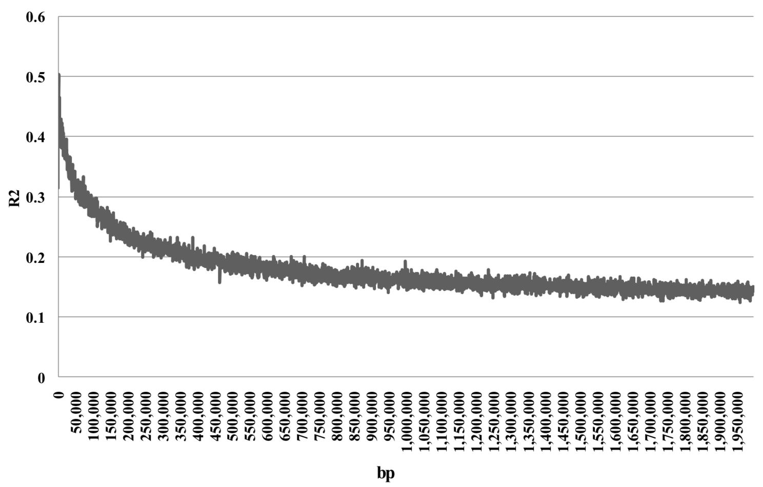

Figure 1. LD decays throughout the genome in the 744 germplasm set
References
1 Chen K, Q Zhang, CC Wang, ZX Liu, YJ Jiang, LY Zhai, TQ Zheng, JL Xu, ZK Li (2019) Genetic dissection of seedling vigour in a diverse panel from the 3,000 Rice (Oryza sativa L.) Genome project. Scientific Reports 9:4804
2 Ali J, JL Xu, YM Gao, XF Ma, LJ Meng,Y Wang, YL Pang, YS Guan, MR Xu, JE. Revilleza, NJ. Franje, SC Zhou, ZK Li (2017) Harnessing the hidden genetic diversity for improving multiple abiotic stress tolerance in rice (Oryza sativa L.). PLoS One 12: e0172515.
3 Feng B, Chen K, Cui Y, Wu Z, Zheng T, Zhu Y, Ali J, Wang B, Xu J, Zhang W and Li Z (2018) Genetic dissection and simultaneous improvement of drought and low nitrogen tolerances by designed QTL pyramiding in rice. Front Plant Sci 9:306
4 Wang X, Pang Y, Wang C, Chen K, Zhu Y, Shen C, Ali J, Xu J and Li Z (2017) New Candidate Genes Affecting Rice Grain Appearance and Milling Quality Detected by Genome-Wide and Gene-Based Association Analyses. Front Plant Sci 7:1998
5 Qiu XJ, K Chen, WK Lv, XX Ou, YJ Zhu, DYXing, LW Yang, FJ Fan, J Yang, JL Xu, TQ Zheng, ZK Li (2017) Examining two sets of introgression lines reveals background independent and stably expressed QTL that improve grain appearance quality in rice (Oryza sativa L.). Theor Appl Genet 130:951–967

I got PhD degree on Crop Genetics & Breeding in 2001 in Zhejiang University, China. After finishing postdoctoral career of molecular rice breeding for two years at IRRI, I joined the Institute of Crop Sciences, Chinese Academy Agricultural Sciences, focusing on gene mapping and favorable allele mining for molecular rice breeding in high yield, high grain quality, abiotic and biotic stress tolerance. So far, I have published 70 papers in international journals, obtained four provincial awards and 13 patents.
Email: xujianlong@caas.cn

