The unattended role of diversity, co-benefits and equity in climate change policies in Europe
Sonia Quiroga, Department of Economics, Universidad de Alcalá, Spain
Pablo Martinez-Juarez, Department of Economic Analysis, Economic Theory and History, Universidad Autonoma de Madrid, Spain

Abstract (300 word limit)
Public effort on climate change policies has been growing in the last years in Europe, and with it, the attention put over its effectiveness, efficiency and impact over equity. One of the sources of problems is the excessive rigidness of top-down approaches. The development of a wide and diverse range of measures would ease the task of broadening the view and letting stakeholders to find solutions that fit best. Innovation is the key of this approach, but creativity in problem solving is discouraged.
Identification of societal needs is also basic, as needs and resources will fluctuate throughout time. While biodiversity, ecosystem conservation or provisioning ecosystem services are highly regarded, some other indirect effects provided to society (e.g. cultural value) are often forgotten and this would explain the excess of attention that has been paid to policies such as grey infrastructures. While their positive impact as adaptive measures is undeniable, their cost efficiency may not be as clear as it should. Soft adaptation measures such as Ecosystem-based Adaptation has been showing encouraging results, even taking just into account their ability to fulfil their direct role.
While clear and varied objectives are important, unexpected benefits arising from different measures, or co-benefits, must also be considered. Co-benefits from ecosystem improvement and conservation may affect wellbeing and health. Green environments have been associated not only with stress reduction, but also with lower prevalence rates in different illnesses and health problems. It has also been suggested that green neighborhoods reduce health inequalities, providing better health to both high and low income areas, but improving health conditions more strongly in economically deprived areas. This subject will be of growing importance as climate change affects the income structure and there is still much to be analyzed on the potential reduction of socioeconomic inequalities through environmental policies.

Image

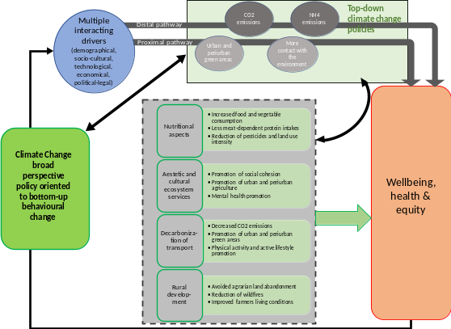

Figure 1. The potential of broad perspective climate change policy oriented to bottom-up behavioral change

Recent Publications (minimum 5)
- Martinez-Juarez P, Chiabai A, Suarez C, Quiroga S. (2019) Reconceptualising urban adaptation strategies: stakeholders’ insights on hard and soft responses to climate change. Sustainability. (In press).
- Sarvašová Z, Quiroga S, Suárez C, Ali T, Lukminee D, Djordjevic I, Hribg M (2018) Understanding the drivers for Natura 2000 payments in forests: a Heckman selection analysis. Journal for Nature Conservation. 46, 28-37.
Doi: https://doi.org/10.1016/j.jnc.2018.07.003
- Van der Vliet N, et al (2018). The INHERIT Model: A Tool to Jointly Improve Health, Environmental Sustainability and Health Equity through Behavior and Lifestyle Change. International Journal of Environmental Research and Public Health, 15(7), 1435; Doi: https://doi.org/10.3390/ijerph15071435
- Chiabai, A., Quiroga S., Martínez-Juarez P., Higgins S., Taylor T. (2018). The nexus between climate change, ecosystem services and human health: Towards a conceptual framework. Science of the Total Environment, 635, 1191-1204.
- Martinez-Juarez P, Chiabai A, Taylor T, Quiroga S . (2015). The impact of ecosystems on human health and well-being: A critical review. Journal of Outdoor Recreation and Tourism. 10, 63-69.

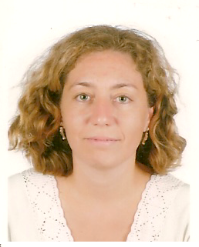 Biography (150 word limit)
Dr. Sonia Quiroga is Professor in the Department of Economics at Universidad de Alcalá in Spain. Her research focuses on the quantitative relations of climate, water, weather and the economy specially understanding the climate change implications. Methodological approaches include the econometric estimation of empirical relationships and risk management tools. She has contributed to a range of EU, WMO, World Bank, UNFCCC, UNECE FAO and Spanish Ministry funded R&D projects and has disseminated research findings in a number of prestigious international research journals
Email: sonia.quiroga@uah.es

Notes/Comments:
I was invited as keynote speach

