Plasticulture Applications for enhanced productivity and sustainable agriculture: An Indian Perspective
Rohit Lall; Joint Project Director, National Committee on Plasticulture Applications in Horticulture(NCPAH), Ministry of Agriculture & Farmers Welfare, Government of India

Abstract (300 word limit)
Plastics as product have inevitable advantages in all spheres on the globe but needs judicious disposal management to address the menace and to avoid soil & air pollution. Use of plastics in agriculture have been termed as “Plasticulture” wherein components/products/equipment’s are integrated to form an application such as micro irrigation systems, polyhouses, plastic mulches, crop covers etc. to generate more quality and enhanced cultivation of the produce with limited resources such as water in per unit area. India being a agrarian driven economy where more than 70% of the population is directly or indirectly related o agriculture contributes not only to suffice the food basket but also to produce more which could provide remunerative income to the Indian growers as India being a varied agro-climatic country can produce almost all agriculture/horticulture produce. Developing field oriented and in-situ experimental details through well-knitted dedicated 22 Precision Farming Development Centres (PFDCs) and having focused approach by providing financial assistance under the flagship schemes to the beneficiaries have throttled the adoption of these applications in last two decades with global footprints in leading the productivity of many crops. Joint ventures of the leading agriculture/horticulture product related companies have also boosted the growth of these technologies and had put India to a self-sufficient agri/horti producer despite of climate resilience and recurring droughts. These applications have not only provided food production sustainability but also have generated employment opportunities to the rural youth besides upliftment of the Indian growers. Dedicated missions, policies and extensive government support across the country have proved to be a milestone in the agriculture history of the country. Thus we could see and also can say that next Green Revolution in India could only be achieved through plasticulture applications & technologies in providing and managing the inputs in precise and regulated manner by use of these technologies.

Image

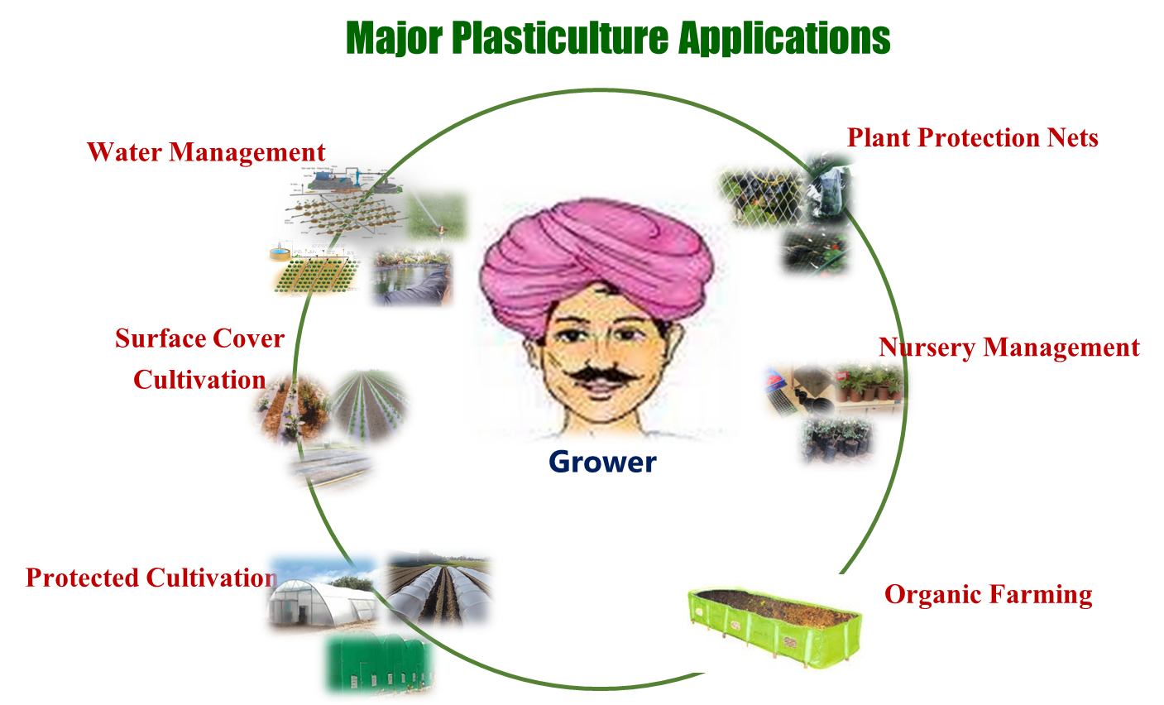

Recent Publications (minimum 5)
- AgriFilm 2018; Madrid, Spain Plasticulture- tool towards doubling farmers income,2018
- Seminar on Role of Agrochemicals for sustainable agriculture, Chandigarh, ICC, New Delhi: Plasticulture for Efficient usage of water;2018
- More Crop Per Drop: Agri Sector & GoI Initiates; 12th World Aqua Congress; 2018
- Protected Cultivation Technology: Tool for doubling farmers income & GoI Initiatives; 11th World Aqua Congress; 2017
- Reference Manual on Irrigation Filters, MoA & FW; 2009


Biography (150 word limit)
I am a post-graduate in Agricultural Engineering (B.Tech) with specialisation in Soil & Water Conservation Engineering (M.Tech). Trained at MASHAV-CINADCO, Israel on Plastics in Agriculture- Innovations & Applications. Have been associated with plasticulture for more than a decade and have contributed technical inputs towards development and uptake of plasticulture interventions under centre sector programs and flagship schemes of GoI. During the association with the current assignment have been a member under technical/sectional committees of Bureau of Indian Standards (BIS) for developing/ revision of various plasticulture standards in the country. Contributed monthly articles for AIPMA Plastic News for the entire year towards creating awareness on plasticulture applications to leading plastics manufacturers and represented internationally at Spain, China, Israel.
.
Email: Rohit.lal79@gmail.com

Notes/Comments:

