Geometric Modulations of Ceramic Components by Stereolithographic Additive Manufacturing
Soshu Kirihara, Osaka University, Japan

Abstract
Stereolithography (STL) have been modified as smart processing to create fine ceramic components. In additive manufacturing (AM) of lamination technologies can fabricate ceramic solid components according to topological geometry. Two-dimensional (2D) cross sectional patterns were created through photo polymerization by ultra violet laser drawing on spread resin paste including ceramic nanoparticles, and three-dimensional (3D) composite models were sterically printed by layer lamination though chemical bonding. An automatic collimeter was equipped with the laser scanner to adjust beam diameter. Fine or coarse beams could realize high resolution or wide area drawings, respectively. As row material of the 3D printing, nanometer sized ceramic particles were dispersed in to photo sensitive liquid resins 50 % in volume fraction. The resin paste was spread on a glass substrate at 50 μm in layer thickness by a mechanically moved knife edge. An ultraviolet laser beam of 355 nm in wavelength was adjusted from 10 to 300 μm in variable diameter and scanned on the pasted resin surface. Irradiation power was changed automatically from 10 to 200 mW for enough solidification depth for 2D layer bonding. The created 3D composite precursor was dewaxed and sintered in the vacuum and air atmosphere to obtain full metal and ceramic components. Through the computer aided smart manufacture, design and evaluation (Smart MADE), geometrically modulated periodic and self-similar patterns with graded and fluctuated structures were processed. Porous electrode of yttria stabilized zirconia for solid oxide fuel cell, alumina photonic crystals to control electromagnetic waves and artificial bones of calcium phosphate scaffolds were created successfully. Their geometric structures were modulated form integer to non-integer dimensions to modify functional properties.

Recent Publications
- Soshu Kirihara, Stereolithographic Additive Manufacturing of Ceramic Components with Micropatterns for Electromagnetic Wave Control, Ceramics in Modern Technologies, 1 [2] (2019) 84-90.
- Koki Nonaka, Soshu Kirihara, Three-Dimensional Smart Processing by Ultra Violet Laser Lithography of Ceramic Additive Manu-facturing, Journal of Materials Science Forum, 941 (2018) 2196-2199.
- Soshu Kirihara, Ultraviolet Laser Lithography of Titania Photonic Crystals for Terahertz-Wave Modulation, Materials, 11 [5] (2018) 835-845.

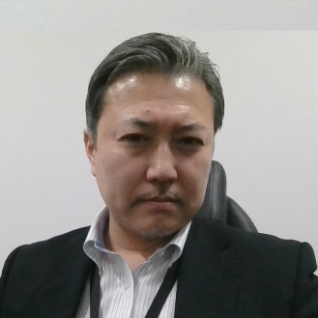
Biography
Soshu Kirihara is a doctor of engineering and a professor of Joining and Welding Research Institute (JWRI), Osaka University, Japan. In his main investigation “Materials Tectonics” for environmental improvements of “Geotechnology”, multi-dimensional structures were successfully fabricated to modulate energy and materials flows effectively. Ceramic and metal components were fabricated directly by smart additive manufacturing, design and evaluation (Smart MADE) using high power ultraviolet laser lithography. Original stereolithography systems were developed, and new start-up company “SK-Fine” was established through academic-industrial collaboration..
Email: kirihara@jwri.osaka-u.ac.jp

Notes/Comments:

