Acidothermally Proses Synthesis of Iron(III) Fluoride Nanoparticles and Single Crystals, Characterization and Gas Sensing Properties Studies
Alireza Aslani-Zakariya*² and Mir Aliakbar Yavari
Department of Chemistry, Faculty of Science, Ataturk University, 25240-Erzurum, Turkey
Tel: +98-9161161165. *Corresponding author (Email: a.aslani110@yahoo.com, nanochemistry@yahoo.com)

- Abstract:
One-Dimensional Fe^{III} Fluoride single crystals and nanopowders have been synthesized and studied by single Crystal X-ray crystallography, Powder X-Ray Diffraction (XRD) and Scanning Electron Microscopy (SEM). Fe₂O₃ nanopowders were obtained by calcination of compound at 600 to 700ºC under air atmosphere and were characterized by, Powder X-Ray Diffraction and Scanning Electron Microscopy (SEM). These FeF₃ nanostructures have been tested for CO gas monitoring by depositing them as thick films on an interdigitated alumina substrate and evaluating the surface resistance of the deposited layer as a function of operating temperature and CO concentrations. The gas sensitivity tests have demonstrated that the FeF₃ nanostructures, spherical morphology, exhibit high sensitivity to CO proving their applicability in gas sensors. The role of the nanostructure on the sensing properties of FeF₃ is also discussed.
Keywords: Iron(III) Fluoride, Nanopowders, gas sensing, Single Crystal.

- Introduction:
The iron with his 26 protons in nucleus is a component of transition elements group. Isotopes like ⁵⁴Fe, ⁵⁶Fe, ⁵⁷Fe and ⁵⁸Fe are extremely stable. It is the last element produced in the nucleus of stars through nuclear fusion, so that the iron is the heaviest element created outside the cataclysmic supernova processes. In abundance, is the tenth in the Universe and the forth on the Earth (the second metal after aluminum). The Earth comprises 80% Iron in a 2160 miles radius sphere. Iron is widely spread in the nature in different chemical compounds. The interesting question about transition metals is that their valence electrons or the electrons they use to combine with other elements are to be found in more than one shell. This is the reason why, they often exhibit several common oxidation states. Normally, the iron has eight electrons on valence shield and due to oxygen’s electronegativity it can form bivalent and trivalent combinations. The iron oxide (Fe₂O₃), most common oxide of iron has the important magnetically properties too. From the viewpoint of the basic research, iron(III) oxide is a convenient compound for the general study of polymorphism and the magnetic and structural phase transitions of nanoparticles. Fluoride exists in many forms, and the harmful nature of the fluoride is contingent upon the type of fluoride it is. Depending on its concentration, the fluoride in drinking water is known for both beneficial and detrimental effects on health, particularly to infants and young children. The toxicity of fluoride on human health is well documented. Recently Iron Halides used for more interest application in materials, chemical and physical science such as catalysis, atom transfer and etc. [1-5]. Developments in the field of uniform nanometer sized particles have been studied extensively in recent times because of their technological and fundamental scientific importance. These nanomaterials exhibit very interesting electrical, optical, magnetic, chemical and related surface properties, which is entirely different from the respective bulk materials. Such magnetic nanomaterials could also fiend applications in refrigeration systems, medical imaging, drug targeting and other biological applications and catalysis. Mesoporous materials with ordered or disordered channel structures which possesses uniform mesoporous and exceptionally high surface area and thermal stability could be an ideal host for the synthesis of such nanostructured materials.
On the other hand, nanoparticles are a class of materials with properties distinctively different from their bulk and molecular counterparts and find use in a variety of different areas, such as electronic, magnetic and optoelectronic, biomedical, pharmaceutical, cosmetic, energy, environmental, catalytic and materials applications. Because of the potential of this technology, there has been a worldwide increase investment in nanotechnology research and development. There is a growing interest in the production and the dispersion of ultra-fine powders. A reduction in particle size to the nanometer scale results in various special properties, such as the quantum size effects, the high surface area and the lower sintering temperature, etc., which is the base to obtain fine grain size ceramics with advanced properties. Techniques for the nanoscale particle preparation have been developed in the last decade years and can be divided into three major classes: chemical, mechanochemical and thermophysical methods. The chemical routes are widely used to produce a powder and nanopowder product owing to the relative simplicity and the low energy consumption. A surfactant-free acidothermally technique (i.e., high-temperature and high-pressure in acid as solvent) has shown to be a suitable way for obtaining materials with small grain size, high specific surface areas, and high crystallinity to prepare specifically materials such as Iron Halide. This acidothermal technique had not been recently reported to synthesis of materials, but in this study acidic solution used for synthesis single crystals of Iron(III) Fluoride. In spite of the advantages that acidothermal synthesis offers, it did not widely explore the relations between synthetic parameters and physical properties of the obtained particles [6 and 7].
A gas sensor is a device that is used to detect the presence or amount of a particular gas. One of the most critical needs in gas sensing is to develop CO sensors for detection in biological functions and in fuel cells that are able to selectively detect hydrogen gas near room temperature and that are relatively inexpensive and portable A large surface-to-volume ratio corresponds to a higher sensitivity, which has led to an interest in oxide nanostructures, which have ultrahigh surface-to-volume ratio. Another very important property of a gas sensor is selectivity being able to distinguish a particular gas from all others. The response and recovery time, or the time taken for the sensor to reach 90% of its saturation after applying or switching off the particular gas, is another important factor in the performance of a gas sensor [8-19].
In this study, we developed a simple acidothermally method to prepare FeF₃ nanopowders, using Iron(III) halide without any additives. The FeF₃ single crystals determined by single crystal X-Ray crystallography and nanopowders of FeF₃ were characterized by X-ray powder diffraction (XRD). Also the morphology and size of the nanopowders were observed by Scanning Electron Microscopy (SEM). We report data about their gas-sensing properties, by using them as active layers in CO resistive sensors. The gas sensing properties of the different nanostructures were compared and discussed as a function of the morphology of the primary nanoparticles. The results presented highlighted the role of the shape of the primary FeF₃ crystallites and an explanation based on the characterization and sensing data acquired has been given.

- Experimental:
  - Materials and Physical Techniques:
All reagents and solvents for the synthesis and analysis were commercially available and used as received. Melting points were measured on an Electrothermal 9100 apparatus and are uncorrected.
Intensity data for compound was collected using a STOE-IPDS 2 diffractometer (Cu/K_{α} radiation, λ = 0.71073 Å) at 293(2) K. The structures were solved by direct methods and refined by full-matrix least-squares techniques on F². All hydrogen atoms were placed in idealised locations and refined by riding on their carrier atoms. Crystal data, (FeF3(H2O)2·H2O)_{n}, M = 166.90, crystal dimensions 0.78×0.76×0.72 mm, triclinic, P4/n, a = 7.822(5) Å, b = 7.822(5) Å, c = 3.884(5) Å, α = 90.00(5) º, β = 90.00(5)º, γ = 90.00(5) º, Z = 2, V = 237.637 Å³, F(000) = 166, Crystal size/mm = 0.19 × 0.1 × 0.1, Crystal shape and color = Brown, Data collection T/ K = 100(2), R_{int} = 0.0228, Obsd data (I>2σ(I)) = 356, Data/restraints/parameters = 361/1/35, GOOF on F² = 1.103, [R1, wR2 (I >2σ(I)) = 0.0160, 0.0453], [R1, wR2 (all data) = 0.0162, 0.0453], Largest diff. peak/hole = 0.315/-0.361, Oxidation state of Fe ion = +3.

  - Synthetic Methods:
3.2.1. Single Crystal Synthesis:
A typical synthesis procedure was as follows: a Teflon-lined autoclave (volume 50 mL) was charged with Fe₂O₃ (0.320 g = 2 mmol) and HF (48% in H₂O = 10 mL). The stainless steel autoclave was then sealed and heated in an oven at 180 °C for 24 hr. After the autoclave had been cooled to room temperature, the product was filtered, washed with methanol and dried in air for 4 hr. All nonhydrogen atoms were refined anisotropically. Crystal data and structure refinement details for (FeF₃(H₂O)₂·H₂O)_{n} are given in Table. 1. Selected bond lengths and bond valence sums for (FeF₃(H₂O)₂·H₂O)_{n} are tabulated in Table. 2.

3.2.2. Nanopowder synthesis:
A solution of Fe₂O₃ (0.320 g = 2 mmol) was added to a HF as play of solvent role (48% in H₂O = 10 mL) at room temperature under stirring. After 30 min stirring the mixture transferred into Teflon-lined stainless steel autoclaves, sealed, and maintained at 200 ◦C for 24 hr. Subsequently, the reactor was cooled down to -20 ◦C temperature rapidly. The resulting white solid products were centrifuged and then washed with acetone and ethanol to remove the ions possibly remaining in the final products, and finally dried at 60 ◦C in argon atmosphere. Then it was calcinated under vacuum at 400 ◦C for 1 h. The resulting powder was collected for further characterization. X-ray powder diffraction (XRD) measurements were performed using a Philips diffractometer of X’pert Company with mono chromatized Cuka radiation. The particle sizes of selected samples were estimated using the Sherrer method. The samples were characterized by a scanning electron microscope (SEM) (Philips XL 30) with gold coating.

  - Sensing tests:
Sensors were made by depositing by drop coating films (1-10 µm thick) of the nanopowders dispersed in alumina substrates (8mm×4mm) with Pt interdigitated electrodes and a Pt heater located on the backside. Before sensing tests, a thermal treatment at 400 ◦C for 2 h was carried out in order to stabilize the microstructure of the sensing film. The sensors were then introduced in a stainless-steel test chamber for the sensing tests. The experimental bench for the electrical characterization of the sensors allows carrying out measurements in controlled atmosphere. Gases coming from certified bottles can be further diluted in air at a given concentration by mass flow controllers. Sensing measurements were carried out in the temperature range from 150 to 400 ◦C, with steps of 50 ◦C, under a dry air total stream of 200 sccm, collecting the sensors resistance data in the four point mode. A multimeter data acquisition unit Agilent 34970A was used for this purpose, while a dual-channel power supplier instrument Agilent E3632A was employed to bias the built-in heater of the sensor to perform measurements at super-ambient temperatures. The CO gas response is defined as the ratio R_{air}/R_{gas}, where R_{air} is the electrical resistance of the sensor in dry air and R_{gas} the resistance at different CO concentrations.

- Result and Discussion:
Reaction between mixture of Fe₂O₃ and HF by acidothermally method in high pressure and high temperature led to formation of the FeF₃(H₂O)₂·H₂O single crystals. Nanopowders of this compound were obtained by direct acidothermally proses without any additive, then it calcinated at argon atmosphere in 600-700ºC to prepare FeF₃ nanoparticles (Scheme 1).

$${Fe}_{2}O_{3}+HF 48\% Solution→\left\{\begin{aligned}\underset{→}{HF+Acidothermal proses+Slowly cooling}\left\{Single Crystals of FeF_{3}{(H_{2}O)}_{2}·H_{2}O\right. \\ \underset{→}{HF+Acidothermal proses+cooling at -20℃}\left\{Nanoscale of \right.FeF_{3}{\left(H_{2}O\right)}_{2}·H_{2}O→ \\ \underset{→}{calcination at 600-700℃ in argon atmosphere}FeF_{3} Nanopowders \end{aligned}\right.$$
Scheme. 1. Materials produced and synthetic methods.

The inorganic framework was initially solved with one Fe atom and two fluorine atoms in the asymmetric unit, and this resulted in ionic chains (FeF₂/2F₄)^{2–} which requires two positively charged moieties to balance the charge. The non-bridging fluorine to mixed F/O sites did improve the refinement. Refining 75%, 25% F/O disorder would lead to a compound with the formula [H₃O][FeF₄(H₂O)]. Refining 50:50 disorder led to the compound FeF₃(H₂O)₂·H₂O, and this is also in agreement with the crystal structure reported for the β-form of iron fluoride hydrate; β-FeF₃·3H₂O. The 50:50 F/OH disorder seems to be more acceptable based on the values of R-factors. In this case it is assumed the existence of two disordered water molecules (two orientations) which generates a tetrahedral looking molecule; this requires the framework to be neutral. The asymmetric unit contains one iron atom, one fluorine atom, one mixed site O/F and one non coordinating water molecule. The metal cations consist of slightly distorted octahedral made of two F⁻ and four O/F disordered sites (V-F/O distances: 1.896(19) -2.000(2)). The structure data’s and bond valence sum calculation confirmed that Fe is in the 3+ oxidation state and did not undergo any reduction during the synthesis (see Table. 1 and 2). The molecular structure plots were prepared using ORTEPIII [20] and Mercury software [21]. The octahedral are connected together through the non-disordered F atoms to form infinite trans-chains are given. Simulated XRD powder pattern based on single crystal data were prepared using Mercury software [21]. Also ORTEP diagrams and perspective view of the packing are shown in Figure. 1(a, b and c). The chains are connected together though H-bonding from both the coordinated and the uncoordinated water molecules as it is shown in Figure. 2.
Figure. 3. Shows the simulated XRD pattern from single crystal X-ray data of NCP of FeF₃(H₂O)₂·H₂O in comparison with the XRD pattern of a typical sample prepared by the acidothermal synthesis method. Acceptable matches, with slight differences in 2h, were observed between the simulated and experimental powder X-ray diffraction patterns (Figures. 3a and b). This indicates that the compound obtained by acidothermally process at nanopowders has single crystalline phases. The morphology of FeF₃(H₂O)₂·H₂O nanopowders prepared by the acidothermally method is interesting and it is composed of normally particles (Figure. 4). Thermal decomposition of the nanopowders of FeF₃(H₂O)₂·H₂O in Argon atmosphere produced FeF₃ nanoparticles, as established by its IR spectrum and powder XRD pattern (Figure. 5). The XRD profile of iron fluoride deposited from a FeF₃ target at a 600 °C substrate temperature corresponds to the well crystallized hexagonal FeF₃ phase (S.G. R3c) (Figure. 5.).
The XRD pattern is in agreement with the typical structure FeF₃ diffraction (hexagonal phase, space group R3c, with lattice constants a = 5.200(1) Å, c = 13.323(2) Å, Z = 2.5621. Sharp diffraction peaks indicate good crystallinity of FeF₃ nanoparticles. No characteristic peak related to any impurity was observed. The broadening of the peaks indicated that the particles were of nanometer scale which is in agreement with that observed from SEM images that is indicates the original morphology of the particles is approximately spherical with the diameter about 70 nm. Estimated by the Sherrer formula, D = 0.891 λ/βcosθ, where D is the average grain size, λ is the X-ray wavelength (0.15405 nm), and β and θ the diffraction angle and full-width at half maximum of an observed peak, respectively, the average size of the particles is 67 nm, which is in agreement with that observed by scanning electron microscopy, as shown in Figure. 6.

  - CO sensing tests:
It is well known that the response of resistive sensors is highly affected by the operating temperature. Therefore, the response of the Iron(III) Fluoride sensors as a function of the operating temperature was first investigated. Figure. 7. shows the response as a function of operating temperature from 150 to 400 ◦C for the FeF₃(H₂O)₂·H₂O sensor exposed to 400 ppm of CO. A rapid increase of the response was observed as the working temperature was increased and reached a maximum at about 300 °C and started decreasing thereafter. This characteristic volcano curve can be interpreted on the basis of adsorption-desorption and reaction processes occurring on the sensing layer surface. For operating temperatures <200 °C the sensor response is low because the adsorbed CO molecules are not activated enough to react with the surface adsorbed oxygen species. However, above 300 °C the decrease in CO gas adsorption is not adequately compensated by the increase of surface reaction and the sensor response decreases. The transient response was found reversible (Figure. 8.). the response time, τ_{res}, defined here as the time required to achieve 90% of the total resistance change when CO is introduced into air, is fast (τ_{res}∼ 25 s). A slower recovery time, τ_{rec}, i.e. the time required to achieve 90% of the total resistance change when CO is turned off and pure dry air is reintroduced into the chamber, has been observed (τ_{res}∼ 150 s). The response as a function of CO gas concentration for all the Iron Fluoride sensors investigated at 300 °C is shown in Figure. 9. The sensors show a good response to CO. The response increased as the CO gas concentration was increased from 100 to 500 ppm. Figure. 10 shows the sensor responses vs. CO concentration. A linear trend was observed, when responses are plotted in a log-log scale, as a function of the gas concentration. It is interesting to observe that all the nanostructured films display the same sensitivity to CO, SCO, as calculated by the slope of the extrapolated straight lines reporting the response as a function of the CO concentration in Figure. 10. The sensitivity with respect to CO was calculated to be 0.042 ppm⁻¹. Instead, the responses at a given CO concentration and the detection limits, DL, defined as the lower concentration in which the response significantly differentiated from the noise signal, i.e. 3 times the standard deviation of noise (instrumental detection limit), are different among the investigated sensors. FeF₃(H₂O)₂·H₂O sensor, exhibits a slightly greater response. The extrapolated limit of detection for the FeF₃(H₂O)₂·H₂O sensor is about 0.5 ppm, allowing a monitoring of CO down to concentrations in the sub-ppm range. Even though a direct comparison with recent literature reports on CO sensing of various FeF₃ nanostructures cannot be made because of the different experimental conditions adopted the results we obtained clearly indicate the good performances of our sensors.

- Conclusion:
In summary a new single crystal and nanopowders of Iron fluoride have been synthesized by using an Acidothermally method. FeF₃(H₂O)₂·H₂O were structurally characterized by single crystal X-Ray diffraction. The crystal structure of it consists of a one-dimensional compound. Nanopowders of this compound prepared by direct and simple acidothermally method without any additive. This method for preparation of metallic nanopowders may be had some advantages such as: it takes place in shorter reaction times, produces better yields and also it may produce the particles at nano-size. These nanopowders were investigated in the monitoring of carbon monoxide, showing the maximum of response around 300 °C. The higher response was obtained for the FeF₃(H₂O)₂·H₂O sensor based on FeF₃ nanoparticles exhibiting simple morphology. In summary, from this study, it can be deduced that the performance of resistive FeF₃ based sensors to CO gas can be controlled by tuning the morphology of the metallic nanoparticles by a rapid synthesis procedure assisted by acidothermally, providing a simple way to fabricate highly sensitive CO gas sensors.

- Supplementary data:
CCDC 986447 contains the supplementary crystallographic data for FeF₃(H₂O)₂·H₂O. These data can be obtained free of charge via http://www.ccdc.cam.ac.uk/conts/retrieving.html, or from the Cambridge Crystallographic Data Centre, 12 Union Road, Cambridge CB2 1EZ, UK; fax: (+44) 1223-336-033; or e-mail: deposit@ccdc.cam.ac.uk.

- Acknowledgements:
This work Proffer to Prof. Dr. Veysel Turan YILMAZ. Supporting of this investigation by the Lorestan University, Khorram Abad, Lorestan, Islamic Republic of Iran, Baqiyatallah University Medical of science Tehran, Iran and Ataturk University of Erzurum, Turkey, is gratefully acknowledged.

- References:
[1] N. Yamazoe, Sens. Actuators B 5 (1991) 7.
[2] N. Bonini, M.C. Carotta, V. Guidi, C. Malagu, G. Martinelli, L. Paglialonga, M. Sacerdoti, Sens. Actuators B 68 (2000) 274.
[3] E. Comini, G. Sberveglieri, M. Ferroni, V. Guidi, C. Frigeri, D. Boscarino, J. Mater. Res. 16 (2001) 1559.
[4] Z.W. Pan, Z.R. Dai, Z.L. Wang, Science 291 (2001) 1947.
[5] E. Comini, G. Faglia, G. Sberveglieri, Z. Pan, Z.L. Wang, Appl. Phys. Lett. 81 (2002) 1869.
[6] C.B. Murray, C.R. Kagan, M.G. Bawendi, Annu. Rev. Matter Sci. 30 (2006) 545.
[7] G.-M. Chow, N. IvanovaNoskova, Nano-structured Materials Science and Technology, Kluwer Academic publishers, Dordrecht, 1998.
[8] X. Wen, W. Zhang, S. Yang, Z.R. Dai, Z.L. Wang, Nano. Lett. 2 (2002) 1397.
[9] R. Paul, J. Wolfe, P. Hebert, M. Sinkula, Nat. Biotechnol. 20 (2003) 277.
[10] G. Blaser, T. Ruhl, C. Diehl, M. Ulrich, D. Kohl, Physica A: Statistical and Theoretical Physics 266 (1999) 218–223.
[11] G. Korotcenkov, Sensors and Actuators B 107 (2005) 209–232.
[12] B. Levy, Journal of Electroceramics 1 (1997) 239–272.
[13] A. Aslani, A. Morsali, V. T. Yilmaz, O. Büyükgüngör, Inorg. Chim. Acta 362 (2009) 1506.
[14] Seyid Javad Musevi, Ertan Sahin, Alireza Aslani, Powder Technology, 229, (2012) 30-36,.
[15] Alireza Aslani, Ali Morsali, Veysel T. Yilmaz, Canan Kazak, Journal of Molecular Structure, 929, 1-3, (2009) 187-192.
[16] Alireza Aslani, Ali Morsali, Inorganica Chimica Acta, Volume 362, 14, (2009) 5012-5016.
[17] Homa Sadeghzadeh, Ali Morsali, Ultrasonics Sonochemistry, 18, 1, (2011) 80-84.
[18] Alireza Aslani, Ali Morsali , Matthias Zeller, Solid State Sciences, 10, 11, (2008) 1591-1597
[19] Mojtaba Khanpur and Ali Morsali, Polyhedron 29 (2010) 1520–1524
[20] L.J. Farrugia, J. Appl. Crystallogr. 30 (1997) 565.
[21] Mercury 1.4.1, Copyright Cambridge Crystallographic Data Centre, 12 Union Road, Cambridge, CB2 1EZ, UK, 2001–2005.

Table. 1. Crystal data and structure refinement details for FeF3(H2O)2·H2O.
Table. 2. Selected bond lengths, bond valence sums and site occupacy factors for $FeF_{3}{(H_{2}O)}_{2}·H_{2}O$
Figure. 2. A fragment of the 1D FeF₃(H₂O)₂·H₂O.
Figure. 3. The XRD patterns of (a) simulated from single crystal X-ray data and (b) nano-structure of FeF₃(H₂O)₂·H₂O
Figure. 4. SEM photograph of FeF₃(H₂O)₂·H₂O nanoparticles.
Figure. 5. XRD patterns of iron fluoride prepared by calcination of FeF₃(H₂O)₂·H₂O in argon atmosphere.
Figure. 6. SEM photograph of FeF₃ nanoparticles (produced by calcination of FeF₃(H₂O)₂·H₂O in argon atmosphere.
Figure. 7. Heating-cooling curves showing the electrical resistance of FeF₃(H₂O)₂·H₂O film as a function of temperature.
Figure. 8. Response to 400 ppm of CO vs. the operating temperature of the FeF₃(H₂O)₂·H₂O sensor.
Figuer. 9. Transient response of FeF₃(H₂O)₂·H₂O sensor to exposure of 100ppm of CO at 300 ◦C.
Figure. 10. Response to different CO gas concentration for the FeF₃(H₂O)₂·H₂O sensors at 300 ◦C.
Figure. 11. (a) Calibration curves of the FeF₃(H₂O)₂·H₂O sensors at 300 °C; (b) calibration curves of the FeF₃(H₂O)₂·H₂O sensors showing the measured sensitivity to CO and the extrapolated detection limit related to FeF₃(H₂O)₂·H₂O sensor.

Table. 1. Crystal data and structure refinement details for FeF3(H2O)2·H2O.
Compound | Iron Fluoride
Formula | FeF3(H2O)2·H2O
Fw (g/mol) | 166.90
Space group | P4/n
a | 7.822(5)
b | 7.822(5)
c | 3.884(5)
α | 90
β | 90
γ | 90
V / Ǻ3 | 237.6(4)
Z | 2
Crystal size /mm | 0.19 * 0.1 * 0.1
Crystal shape and colour | Brown
Data collection T/ K | 100(2)
F(000) | 166
Rint | 0.0228
Obsd data (I>2σ(I)) | 356
Data/restraints/parameters | 361/1/35
GOOF on F2 | 1.103
R1, wR2 (I >2σ(I)) | 0.0160, 0.0453
R1, wR2 (all data) | 0.0162, 0.0453
Largest diff. peak / hole | 0.315 / -0.361
Oxidation state of Fe ion | 3+

Table. 2. Selected bond lengths, bond valence sums and site occupacy factors for $FeF_{3}{(H_{2}O)}_{2}·H_{2}O$
Bond | Bond Length (ºA) | Sij*S.O.F | Bond | Bond Length (ºA) | Sij*S.O.F
Fe01-F1 | 1.896(19) | 0.556×0.5 | Fe01-OW2 | 2.000(20) | 0.521×0.5
Fe01-F1^{i} | 1.896(19) | 0.556×0.5 | Fe01-OW2^{i} | 2.000(20) | 0.521×0.5
Fe01-F1^{ii} | 1.896(19) | 0.556×0.5 | Fe01-OW2^{ii} | 2.000(20) | 0.521×0.5
Fe01-F1^{iii} | 1.896(19) | 0.556×0.5 | Fe01-OW2^{iii} | 2.000(20) | 0.521×0.5
Fe01-F2 | 1.936(3) | 0.499 | Fe01-F2^{iv} | 1.948(3) | 0.483
∑Fe01 = 3.13 [(i) = 0.5-x, 0.5-y, z] [(ii) = y, 0.5-x, z] [(iii) = 0.5-y, x, z] [(iv) = x, y, 1+z]
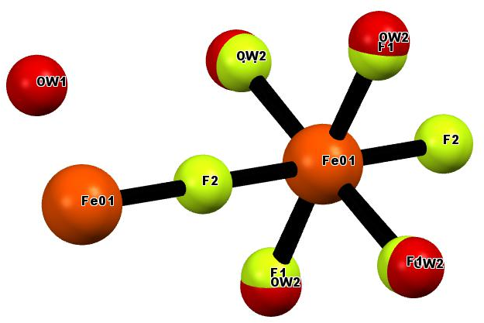
(a)
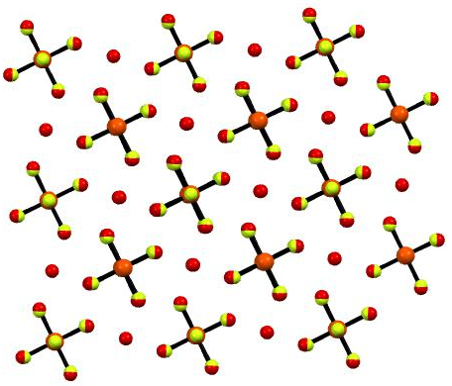
(b)
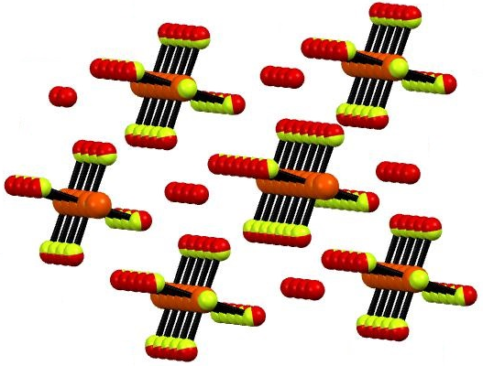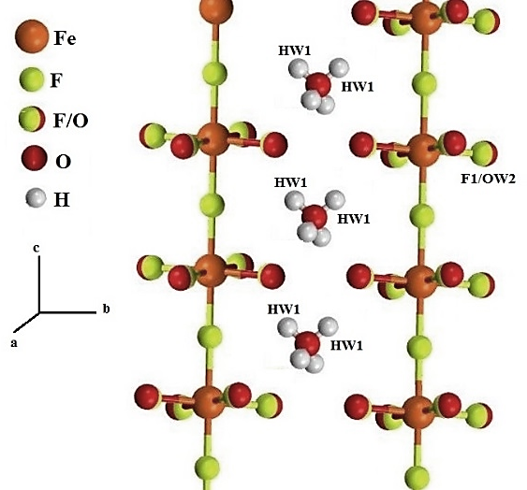
(c)
Figure. 1. A fragment of the 1D FeF₃(H₂O)₂·H₂O.

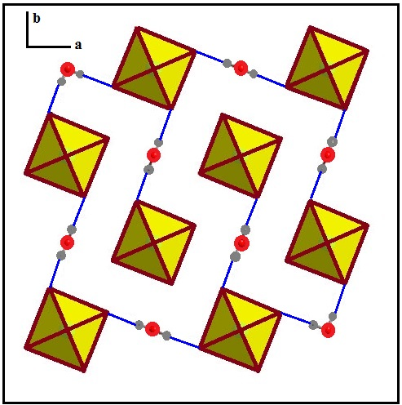
Figure. 2. Polyhedral presentation of FeF₃(H₂O)₂·H₂O viewed down the c axis, showing part of the hydrogen bonding, note that only one orientation of the water molecules is presented.
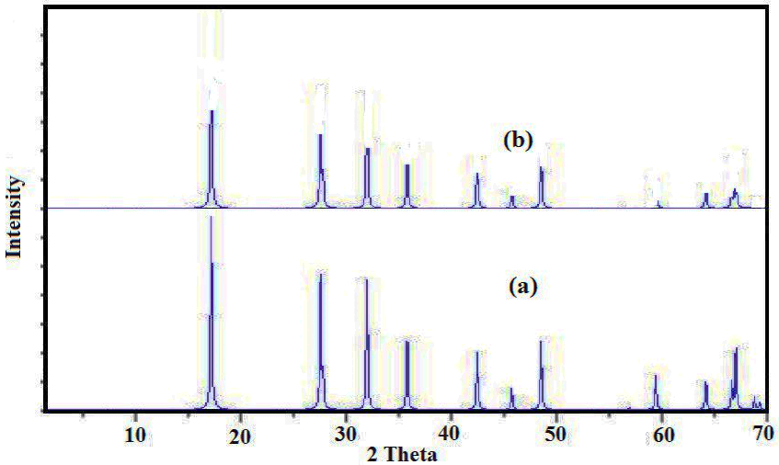
Figure. 3. The XRD patterns of (a) simulated from single crystal X-ray data and (b) nano-structure of FeF₃(H₂O)₂·H₂O

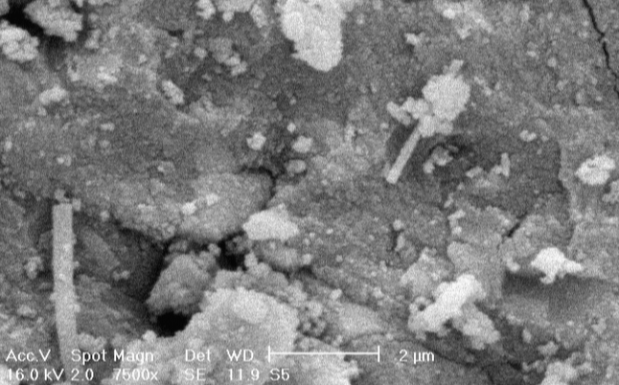
Figure. 4. SEM photograph of FeF₃(H₂O)₂·H₂O nanoparticles.

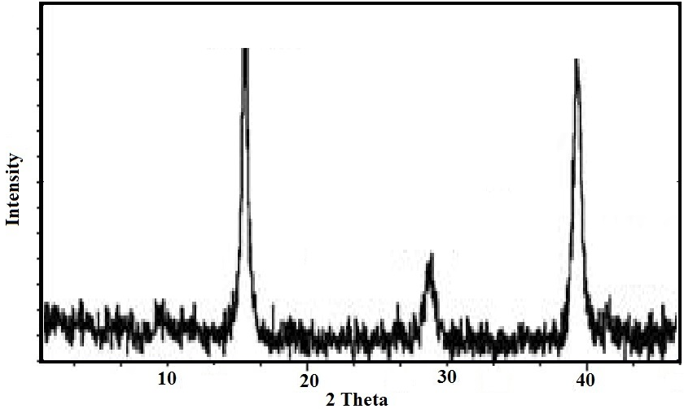
Figure. 5. XRD patterns of iron fluoride prepared by calcination of FeF₃(H₂O)₂·H₂O in argon atmosphere.

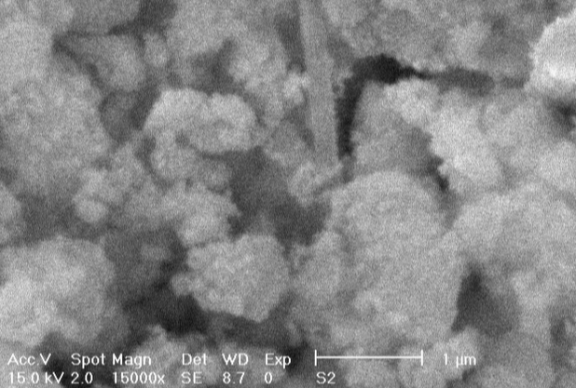
Figure. 6. SEM photograph of FeF₃ nanoparticles (produced by calcination of FeF₃(H₂O)₂·H₂O in argon atmosphere.

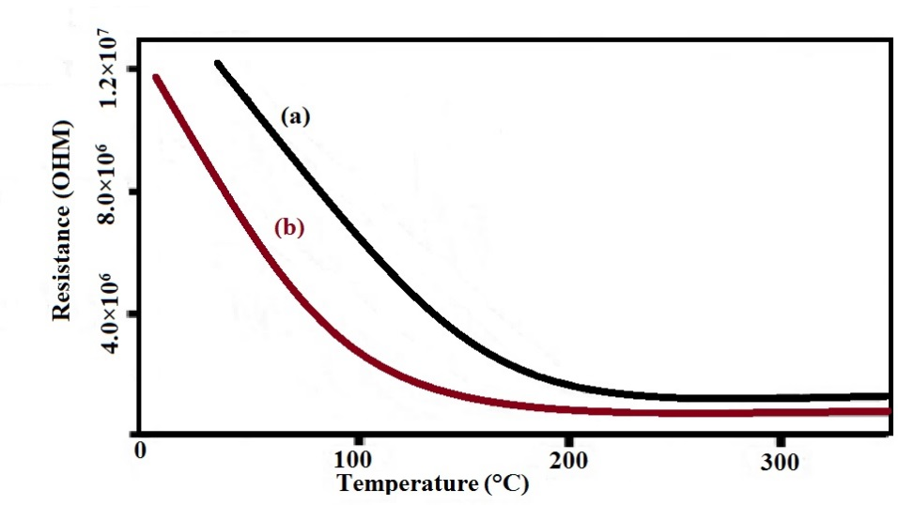
Figure. 7. Heating-cooling curves showing the electrical resistance of FeF₃(H₂O)₂·H₂O film as a function of temperature.
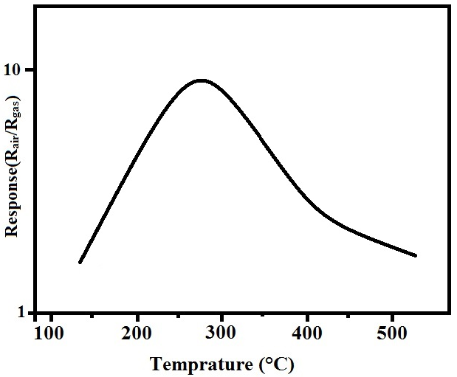
Figure. 8. Response to 400 ppm of CO vs. the operating temperature of the FeF₃(H₂O)₂·H₂O sensor.

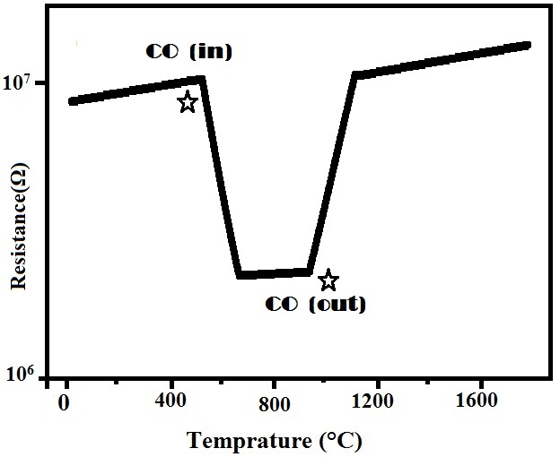
Figuer. 9. Transient response of FeF₃(H₂O)₂·H₂O sensor to exposure of 100ppm of CO at 300 ◦C.
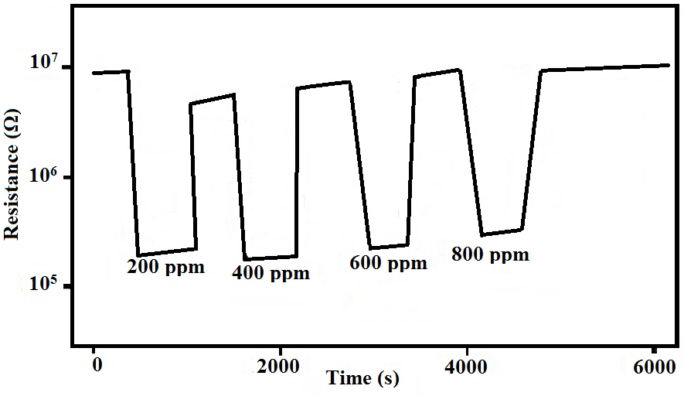
Figure. 10. Response to different CO gas concentration for the FeF₃(H₂O)₂·H₂O sensors at 300 ^{º}C.

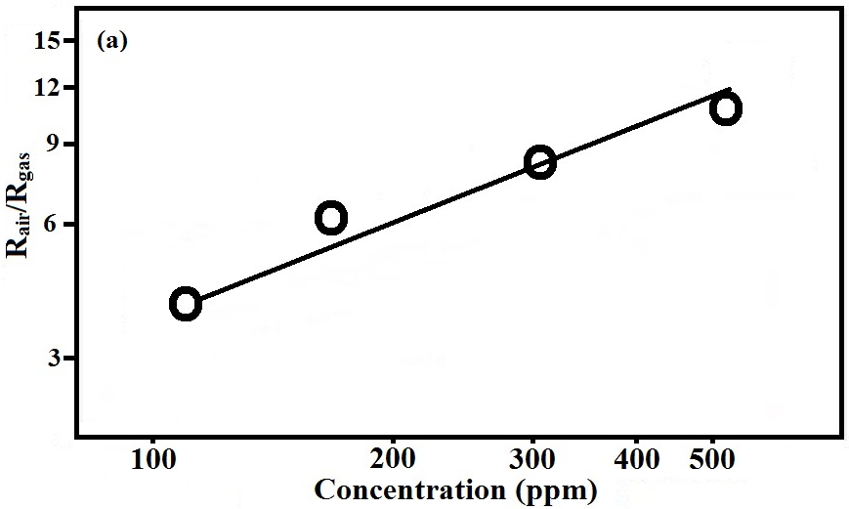
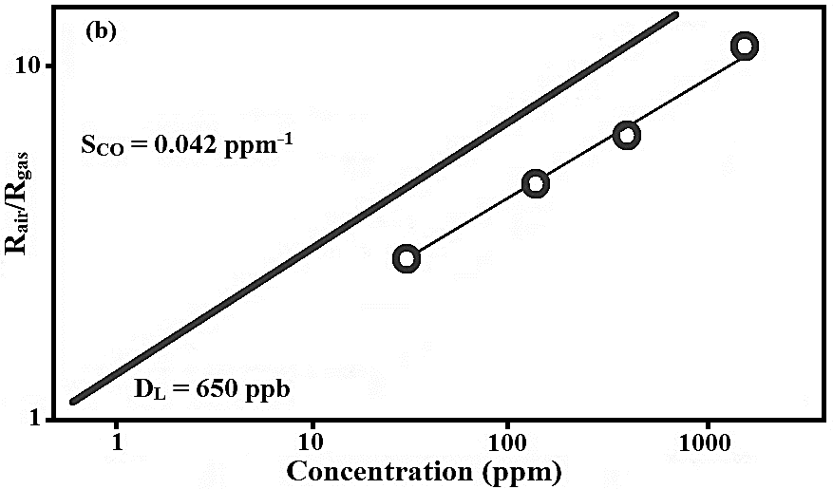
Figure. 11. (a) Calibration curves of the FeF₃(H₂O)₂·H₂O sensors at 300 °C; (b) calibration curves of the FeF₃(H₂O)₂·H₂O sensors showing the measured sensitivity to CO and the extrapolated detection limit related to FeF₃(H₂O)₂·H₂O sensor.

