Synthesis, Characterization and Biological Activity Studies of new mixed ligand Zn(II) Coordination Polymers at Bulk and Nano-sized
Alireza Aslani-Zakariya*² and Mir Aliakbar Yavari
Department of Chemistry, Faculty of Science, Ataturk University, 25240-Erzurum, Turkey
Tel: +98-9161161165. *Corresponding author (Email: a.aslani110@yahoo.com, nanochemistry@yahoo.com)

- Abstract:
Anticancer cells and antimicrobial activity of new 3D Zn(II) coordination polymer at bulk and nano-sized have been studied and these new supramolecular compounds characterized by elemental analysis, IR spectroscopy, Raman and its structures studied by single Crystal X-ray crystallography. ZnO nanoparticles were obtained by calcination of compound at 500ºC under air atmosphere and were characterized by X-Ray Diffraction (XRD), Scanning Electron Microscopy (SEM).
The in-vitro anticancer studies reveal that the mixed ligand Zn(II) coordination polymers at bulk and nano-sized had the best anticancer activity against MCF-7 (HBA = Human breast adenocarcinoma) cells with IC₅₀ values of 5.89 μM and 7.90 Μm. These coordination polymers effects on the antibacterial activity (against Staphylococcus epidermidis (Se) ATCC 14990, Bacillus subtilis (Bs) ATCC 6633, Bacillus cereus (Bc) ATCC 14579, Pseudomonas aeruginosa (Pa) ATCC 9027 and Escherichia coli (Ec) ATCC 25922 strains).
Keywords: Zinc(II) Coordination Polymers, Nanostructure, Anticancer, HBA, Antimicrobial

2. Introduction:
Coordination polymer are defined as a polymeric substance containing a coordination compound or metal complex in its repeating unit. The metal complex is not necessarily part of the polymer backbone. Fifteen to twenty years ago, the main interest in coordination polymers depended on the expectation of increased thermal stability for the materials. Thermal, moisture and oxidative stabilities of many coordination polymers fell below expectation at that time, and despite the vast number of coordination polymers already prepared many problems and limitations still exist. However as shown by more recent studies, many earlier problems have been overcome, and new, unanticipated application have been realized. In the last decade coordination compounds with infinite one-, two-, and three-dimensional network structures have been intensively studied in particular compounds with back-bonds constructed by metal ions and ligand form a family of organic-inorganic or Schiff-base, which are called "Coordination Polymer" [1]. Research in the coordination polymers has rapidly grown in recent years due to an increasing demand for functional materials with conducting, magnetic, porosity, nonlinear optical, porous, thermal, fluorescence and antimicrobial properties [2].
In contrast to inorganic nanomaterial’s, specific syntheses of nano-structured Coordination Polymers or Metal-Organic Frameworks seems to be surprisingly sparse, and to date most investigations on supramolecular coordination complexes have been carried out only in the solid state and studies of their properties were limited to investigations at the macroscopic scale. The potential use of supramolecular coordination complexes as materials for Nano technological applications would seem to be very extensive as nano-scaled materials often exhibit the new interesting size-dependent physical and chemical properties that cannot be observed in their bulk size. For this reason, nano-scale coordination polymers are interesting candidates for applications in many fields, including catalysis, membrane application, magnetism, antimicrobial, nonlinear optics, luminescence, antimicrobial, antifungal and molecular sensing, but nano-scale particles of metal-organic coordination polymers have rarely been investigated yet [3-9].
This Paper focuses on the simple synthetic preparation of a new nano-structure Zn(II) 3-D mixed-ligand coordination polymer of zinc(II), and conversion of it to nano-structured zinc(II) oxide by calcination at moderately elevated temperature. Also studies of these compound to antimicrobial and anticancer activity is very interest.
The mixed ligand coordination polymers were also tested for their in vitro antibacterial activity against Staphylococcus aureus var. Oxford 6538, Klebsiella pneumoniae ATCC 100131, Escherichia coli ATCC 10536, and Pseudomonas aeruginosa ATCC 9027 strains using the paper disc diffusion method (for the qualitative determination) and the serial dilutions in liquid broth method (for determination of MIC) [10 and 11].

3. Experimental:
3.1. Materials and Physical Techniques:
All reagents and solvents for the synthesis and analysis were commercially available and used as received. IR spectra were recorded using Perkin-Elmer 597 and Nicolet 510P spectrophotometers. Microanalyses were carried out using a Heraeus CHN-O- Rapid analyzer. Melting points were measured on an Electrothermal 9100 apparatus and are uncorrected. The thermal behavior was measured with PL-STA 1500 apparatus.
Intensity data for compound was collected using a STOE-IPDS 2 diffractometer (Cu/K_{α} radiation, λ = 0.71073 Å) at 293(2) K. The structures were solved by direct methods and refined by full-matrix least-squares techniques on F². All hydrogen atoms were placed in idealised locations and refined by riding on their carrier atoms. Crystal data, (C₃₆H₂₄N₄O₈Zn₂)_{n}, M = 771.39, crystal dimensions 0.78×0.76×0.72 mm, triclinic, P -1, a = 10.399(5) Å, b = 11.460(5) Å, c = 14.812(5) Å, α = 108.171(5) º, β = 99.646(5)º, γ = 95.795(5) º, Z = 2, V = 1631.17 Å³, Dc = 0.945 g/cm³, Wavelength 0.71069 Å, F(000) = 784, Theta range for data collection 2.74º to 30.62º, Limiting indices -14 ≤ h ≤ 14, -16 ≤ k ≤16, -21 ≤ l ≤ 20, Reflections collected/unique 9788/5610[R(int) = 0.3615], R1 (I > 2σ(I), wR2 (All data) 0.1189, 0.3397, Absorption coefficient 1.53 mm⁻¹, Calculated density 0.945 g cm⁻¹.

3.2. Synthetic Methods:
To isolate single crystals of [Zn₂(μ-4,4΄-bipy)(μ-BDCA)₂]_{n} Mixed Ligand Coordination-Polymer, 4,4´-bipyridine (4,4΄-bipy) (0.168 g = 1 mmol), (BDCA) benzene 1,4-dicarboxilic acid (0.166 g = 1 mmol) and Zn(CH₃COO)₂.3H₂O (0.474 g, 2 mmol) were placed in the main arm of a branched tube. Methanol/H₂O (3:1) were carefully added to fill both arms. The tube was sealed and the ligand-containing arm immersed in an oil bath at 65 ºC while the other arm was kept at ambient temperature. After 6 days, colorless crystals that deposited in the cooler arm were isolated, filtered off, washed with acetone and Ethanol and air dried.
In order to prepare nanopowders of (C₇H₉N)₄Cu₂F₂(µ-F)V(F)₁₆, 15 ml KF solution of with 0.181 g (1 mmol) in a vessel was positioned in a high-density ultrasonic probe, operating at 36 kHz with a maximum power output of 800 W. Into this solution 30 ml 0.10 g (1 mmol) of CuF₂ and 3,5-Dimethyle pyridine solution were added drop wise at 1.5 h. Nanopowders was filtered off, washed with acetone (10 ml), Acetone (8 ml) and dried in vacuum over silica gel at room temperature. The product was then dried in vacuum over P₄O₁₀ at 50 ºC. Yield: 0.851 g, 91.04%. A single crystal suitable for X-ray analysis was obtained by slow evaporation of an acetonitrile solution of the product at room temperature.
Anal. Calc. for [C₃₆H₂₄N₄O₈Zn₂]: C, 56.05; H, 3.136; N, 7.263. Found: C, 56.2; H, 3.14; N, 7.26%. IR (cm⁻¹) selected bands, 3372(br), 1572(m), 1311(m), 1197(vs), 814(s), 715(m), and 666(m).
The precipitates were filtered off, washed with methanol/water and then dried in air. The different concentrations of metal and ligand solution (0.025, 0.05, 0.075 and 0.1M) with the same aging time (30 min) were tested at different power of ultrasonic irradiation (60, 120 and 180 kHz).

3.3. Biological Studies:
3.3.1. Anticancer Cells Activity:
The MCF-7 (human breast adenocarcinoma) and HT-29 (colon carcinoma) cells were maintained in minimum essential medium (MEM) supplemented with 10 % of fetal caw serum (FCS), and 25 mg of gentamycin at 37 °C in a humidified atmosphere with 5 % CO₂. A concentration of 100 mL of a cell suspension in culture medium [7500 cells/mL for (MCF-7) and 2500 cells/mL for (HT-29)] were plated into each of 96 well plates and incubated for three days under culture conditions. After the addition of various concentrations of the test compounds, the cells were incubated for another 72 h and 48 h respectively. The medium was then removed and the cells fixed with 1 % glutardialdehyde solution and stored under phosphate buffered saline (PBS) at 5 °C. Cell biomass was determined by a crystal violet staining, followed by the extraction of the bound dye with ethanol, and a photometric measurement at 625 nm. Mean values were calculated and the effects of the compounds were expressed as % Treated/Control_{corr} values according to the following equation:
$$\frac{T}{C_{corr}}\left(\%\right)=\left[\frac{\left(T-C_{0}\right)}{\left(C-C_{0}\right)}\right]×100$$
Where (C₀ = the biomass of control cells at the tie of compound addition; C = the biomass of control cells at the time of the test end; T = the biomass of probes/samples at the time of the test end. The test compounds were prepared fresh as stock solutions in DMF and diluted with the cell culture medium to the final assay concentrations (0.1 % v/v DMF). Cis-platin was used as the reference drug. The IC₅₀ value was determined as the concentration causing 50 % inhibition of cell proliferation.

3.3.2. Antimicrobial activity:
The mixed ligand coordination polymers of Zn(II) at bulk and nano-sized, nanoparticles of ZnO and ligands were tested for their in vitro antibacterial activity against S. aureus var. Oxford 6538, K. pneumonia ATCC 100131, E. coli ATCC 10536, and P. aeruginosa ATCC 9027 strains. Suspensions in sterile peptone water from 24 h cultures of microorganisms were adjusted to 0.5 McFarland. Muller-Hinton petri dishes of 90 mm were inoculated using these suspensions. Paper disks (6 mm in diameter) containing 10 µL of the substance to be tested (at a concentration of 2048 µg/mL in DMSO) were placed in a circular pattern in each inoculated plate. Incubation of the plates was done at 37 ºC for 24 h. Reading of the results was done by measuring the diameters of the inhibition zones generated by the tested substances, using a ruler. Streptomycin was used as a reference substance. Determination of MIC (µg/mL) was done using the serial dilutions in liquid broth method. The materials used were 96-well plates, suspensions of microorganism (0.5 McFarland), Muller–Hinton broth (Merck) and solutions of the substances to be tested (2048 µg/mL in DMSO). The following concentrations of the substances to be tested were obtained in the 96-well plates: 1024; 512; 256; 128; 64; 32; 16; 8; 4; 2 µg/mL. After incubation at 37 ºC for 18-24 h, the MIC for each tested substance was determined by macroscopic observation of microbial growth. It corresponds to the well with the lowest concentration of the tested substance where microbial growth was clearly inhibited.

4. Results and discussion:
Reaction between mixture of 4,4΄-bipy and BDCA with a mixture of zinc(II) acetate led to formation of the new zinc(II) 3D coordination polymer [Zn₂(μ-4,4΄-bipy)(μ-BDCA)₂]_{n}. Nanoparticles of this Nano Coordination Polymers (NCP) were obtained by ultrasonic irradiation in a Methanol/water solution and single crystalline material was obtained using a slow evaporation (Scheme 1).
$$Zn{(OAC)}_{2}+4,4-bpyr+BDCA→→\left\{\begin{aligned}\underset{→}{\left(MeOH\right) in Branched-Tube}\left\{Single Crystal of {[{Zn}_{2}{(-4,4΄-bipy)}_{2}{(-BDCA)}_{2}]}_{n}\right. \\ \underset{→}{Ultrasond Irradiation+MeOH}\left\{Nanoscale of \right.{\left[{Zn}_{2}{\left(-4,4΄-bipy\right)}_{2}{\left(-BDCA\right)}_{2}\right]}_{n}→ \\ →\underset{→}{Calcination at 500-600℃}Nanoparticle of ZnO\end{aligned}\right.$$
Scheme. 1. Materials produced and synthetic methods.

The relatively weak IR absorption bands around 3025-3035 cm⁻¹ are due to the C-H modes involving the aromatic ring hydrogen atoms. The absorption bands with a variable intensity in the frequency range 1339-1598 cm⁻¹ correspond to vibrations of the pyridine rings. Determination of the structure of [Zn₂(μ-4,4΄-bipy)(μ-BDCA)₂]_{n} by single crystal X-ray diffraction showed that the complex in the solid state (Figures.2. (a, b and c) consists of three-dimensional polymeric units, i.e. It shows that this Compound is a 3D network containing two trigonal-bipyramidal Zn centers in the repeat unit, the Zn centers have the same coordination environment. Each Zn center is attached to 3 carboxylic oxygen’s of the BDC linker in a trigonal plane and the axial positions of the trigonal bipyramid are occupied by two bpy ligands. Two different types of bonding are present for the BDC ligand; the carboxylate groups of BDCA are attached to the Zn center as both a monodentate and bidentate fashion. Anisotropy thermal parameters, observed and calculated structure factors, full lists of bond distances, bond angles and torsion angles are given in the supplementary material. Also ORTEP diagrams and perspective view of the packing are shown in Figure. 2(a, b and c).
The molecular structure plots were prepared using ORTEPIII [12] and Mercury software [13]. Simulated XRD powder pattern based on single crystal data were prepared using Mercury software [13]. The observed anisotropic thermal parameters, the calculated structure factors, and full lists of bond distances, bond angles and torsion angles are given in the Supplementary data. Raman spectra of ZnO nano particles are shows in Figure. 1. ZnO wurtsit structure shows six Raman active modes. Raman spectra of ZnO nanoparticles show two sharp peaks at 330 and 445 cm⁻¹.
Figure. 3 shows the simulated XRD pattern from single crystal X-ray data of NCP of [Zn₂(μ-4,4΄-bipy)(μ-BDCA)₂]_{n} in comparison with the XRD pattern of a typical sample of 1 prepared by the sonochemical process and evaporation method. Acceptable matches, with slight differences in 2h, were observed between the simulated and experimental powder X-ray diffraction patterns (Figures. 3a and b). This indicates that the compound obtained by sonochemical process has single crystalline phases, almost identical to that obtained by the branched-tube method.
The morphology of [Zn₂(μ-4,4΄-bipy)(μ-BDCA)₂]_{n} prepared by the sonochemical method (Figure. 4) is interesting and it is composed of normally particles (Figure. 4). Thermal decomposition of the nanoparticles of NCP in air produced ZnO nanoparticles, as established by its IR spectrum and powder XRD pattern (Figure. 5). The XRD pattern is in agreement with the typical wurtzite structure ZnO diffraction (hexagonal phase, space group P6₃mc, with lattice constants a = 3.24982(9) Å, c = 1.6021 Å, Z = 2, JCPDS No. 36-1451). Sharp diffraction peaks indicate good crystallinity of ZnO nanoparticles. No characteristic peak related to any impurity was observed. The broadening of the peaks indicated that the particles were of nanometer scale which is in agreement with that observed from SEM images that is indicates that the original morphology of the particles is approximately spherical with the diameter about 50 nm. Estimated by the Sherrer formula, D = 0.891 λ/βcosθ, where D is the average grain size, λ is the X-ray wavelength (0.15405 nm), and β and θ the diffraction angle and full-width at half maximum of an observed peak, respectively, the average size of the particles is 57 nm, which is in agreement with that observed by scanning electron microscopy, as shown in Figure. 6.

4.1. Antimicrobial Activity:
A comparative study of MIC values of the NCP of [Zn₂(μ-4,4΄-bipy)(μ-BDCA)₂]_{n} indicates that the CP, NCP and NP of ZnO generally have a better activity to antimicrobial activity. The synthesized coordination polymers at bulk and nano-sized have comparable inhibitory effects (low to moderate MIC values 8 and 512 µg/mL) on the growth of tested strains (Table. 2). The antibacterial results evidently show that the activity of the coordination polymers became more pronounced. So, all the compounds (CP, NCP and ZnO nanoparticles) shown high bactericidal activities against K. pneumoniae (MIC = 64 µg/mL), S. aureus (MIC = 32 µ/mL) and P. aeruginosa (MIC = 128 µg/mL) which exerts a visible increase of antimicrobial action. The structure of the tested compounds seemed to be the principal factor influencing the antimicrobial activity. Coordination polymer of mixed ligand Zn(II) at nano-sized was found to have better activity against all the bacterial species, form in the DMSO solution. The high bactericidal activity of the. The present investigations of antimicrobial screening data revealed that all of the newly synthesized compounds exhibited poor activity compared to that of the control drugs. Because the MIC values are not spectacular, no statistical calculations were made.

5. Conclusion:
In summary a new single crystal and nano-sized of mixed ligand 3D Zn(II) coordination polymers have been synthesized by using a branched-tube and sonochemical irradiation. [Zn₂(μ-4,4΄-bipy)(μ-BDCA)₂]_{n} were structurally characterized by single crystal X-ray diffraction. The crystal structure of it consists of a three-dimensional mixed ligand coordination polymer and shows the coordination number in the Zn(II) ions is six. Calcination of this NCP under air produces nano-sized particles of ZnO. This paper is one of the few samples using sonication as an alternative synthetic procedure to form coordination polymers [5, 6 and 14-16]. This method for preparation of coordination polymers may be had some advantages such as: it takes place in shorter reaction times, produces better yields and also it may produce the coordination polymer at nano-size. My student and our research group study of many properties of Coordination polymer at Bulk and Nano size such as magnetism, antimicrobial and optical properties, and so published them in this journal. The antibacterial data given for the compounds presented in this paper allowed us to state that the coordination polymers generally have a better activity than the free ligands and the antimicrobial activity depends on the tested compound structure. The sensitivity spectrum of the microbial strains towards the ligands and the corresponding coordination polymers was determined by qualitative and quantitative methods. The quantitative antimicrobial activity test results proved that both the ligand and complex combinations have specific antimicrobial activity, depending on the microbial species tested. Even if none of the presented compounds are effective against the tested microorganisms comparable with reference used drugs, the antibacterial assay against other Gram negative and Gram-positive strains is in progress.

6. Supplementary data:
CCDC 973815 contains the supplementary crystallographic data for [Zn₂(μ-4,4΄-bipy)(μ-BDCA)₂]_{n}. These data can be obtained free of charge via http://www.ccdc.cam.ac.uk/conts/retrieving.html, or from the Cambridge Crystallographic Data Centre, 12 Union Road, Cambridge CB2 1EZ, UK; fax: (+44) 1223-336-033; or e-mail: deposit@ccdc.cam.ac.uk.

7. Acknowledgements:
This work Proffer to Prof. Dr. Veysel. T. Yilmaz. Supporting of this investigation by the Lorestan University, Khorram Abad, Lorestan, Islamic Republic of Iran and Ataturk University of Erzurum, Turkey, is gratefully acknowledged.

8. References:
[1] J. C. Bailar, Preparative Inorganic Reaction. Vol1, Interscience, York, 1964.
[2] C. Janiak. Dalton Trans, (2003) 2781.
[3] A. Aslani, A. Morsali, V. T. Yilmaz, O. Büyükgüngör, Inorg. Chim. Acta 362 (2009) 1506.
[4] Seyid Javad Musevi , Ertan Sahin , Alireza Aslani, Powder Technology, 229, (2012) 30-36,.
[5] Alireza Aslani , Ali Morsali , Veysel T. Yilmaz , Canan Kazak, Journal of Molecular Structure, 929, 1-3, (2009) 187-192.
[6] Alireza Aslani, Ali Morsali, Inorganica Chimica Acta, Volume 362, 14, (2009) 5012-5016.
[7] Homa Sadeghzadeh, Ali Morsali, Ultrasonics Sonochemistry, 18, 1, (2011) 80-84.
[8] Alireza Aslani , Ali Morsali , Matthias Zeller, Solid State Sciences, 10, 11, (2008) 1591-1597
[9] Mojtaba Khanpur and Ali Morsali, Polyhedron 29 (2010) 1520–1524
[10] A. Barry, Procedures and theoretical considerations for testing antimicrobial agents in agar media, in: Lorian (Ed.), Antibiotics in Laboratory Medicine, fifth ed., Williams and Wilkins, Baltimore, 1991.
[11] National Committee for Clinical Laboratory Standard, NCCLS: Methods for Antimicrobial Dilution and Disk Susceptibility Testing of Infrequently Isolated or Fastidious Bacteria; Approved Guideline, Document M45-A, vol. 26 (19), Willanova, PA, USA, 1999.
[12] L.J. Farrugia, J. Appl. Crystallogr. 30 (1997) 565.
[13] Mercury 1.4.1, Copyright Cambridge Crystallographic Data Centre, 12 Union Road, Cambridge, CB2 1EZ, UK, 2001–2005.
[14] N. Soltanzadeh, A. Morsali, Ultrasonic Sonochemistry. 17 (2010) 139-144.
[15] Z.R. Ranjbar, A. Morsali, Journal of Molecular Structure. 936 (2009) 206-211.
[16] S. Khanjani, A. Morsali, Journal of Molecular Structure. 935 (2009) 27-32.

Table. 1. Antibacterial activities of mixed ligands Zn(II) coordination polymers at Bulk and Nano-sized and ZnO Nanoparticles as MIC values (µg/mL).
Figure. 1. The Raman spectra of ZnO nanoparticles Prepared by calcination from CP [Zn₂(μ-4,4΄-bipy)(μ-BDCA)₂]_{n} (a) and prepared by calcination from NCP [Zn₂(μ-4,4΄-bipy)(μ-BDCA)₂]_{n} (b)
Figure. 2. A fragment of the three-dimensional CP of [Zn₂(μ-4,4΄-bipy)(μ-BDCA)₂]_{n}.
Figure. 3. The XRD patterns of (a) simulated from single crystal X-ray data and nano-structure of [Zn₂(μ-4,4΄-bipy)(μ-BDCA)₂]_{n}
Figure. 4. SEM photograph of [Zn₂(μ-4,4΄-bipy)(μ-BDCA)₂]_{n} nanoparticles.
Figure. 5. XRD pattern of ZnO Nanoparticles prepared by calcination of compound NCP of [Zn₂(μ-4,4΄-bipy)(μ-BDCA)₂]_{n} (a) and calcination of CP of [Zn₂(μ-4,4΄-bipy)(μ-BDCA)₂]_{n} (b).
Figure. 6. SEM photograph of ZnO nanoparticles (produced by calcination of strawlike
nanostructure NCP of [Zn₂(μ-4,4΄-bipy)(μ-BDCA)₂]_{n}.

Table. 1. Antibacterial activities of mixed ligands Zn(II) coordination polymers at Bulk and Nano-sized and ZnO Nanoparticles as MIC values (µg/mL).
Compounds | Gram-Positive Bacteria |  | Gram-Negative Bacteria
Compounds | Kp⁽¹⁾ | Sa⁽¹⁾ | Pa⁽²⁾ | Ec⁽²⁾
CP⁽³⁾ of [Zn₂(μ-4,4΄-bipy)(μ-BDCA)₂]_{n} | 16 | 8 | 32 | 16
NCP⁽³⁾ of [Zn₂(μ-4,4΄-bipy)(μ-BDCA)₂]_{n} | 8 | 4 | 16 | 8
NP⁽³⁾ of ZnO | 8 | 4 | 8 | 16
BDCA⁽⁴⁾ | 16 | 8 | 32 | 16
4,4΄-bipy⁽⁵⁾ | 64 | 32 | 32 | 64
Streptomycin | 8 | 4 | 16 | 8
⁽¹⁾Kp (Klebsiella pneumoniae ATCC 31488); Sa (Staphylococus aureus var. ATCC 6538).
⁽²⁾Pa (Pseudomonas aeruginosa ATCC 9027); Ec (Escherichia coli ATCC 10536).
⁽³⁾CP (Coordination Polymer), NCP (Nano Coordination Polymer), NP (Nano-Particle).
⁽⁴⁾BDCA (Benzene Di-Carboxylic Acid Ligand)
⁽⁵⁾4,4΄-bipy (4,4΄-bipyridine Ligand)
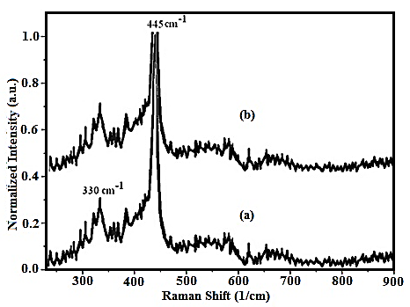
Figure. 1. The Raman spectra of ZnO nanoparticles Prepared by calcination from CP [Zn₂(μ-4,4΄-bipy)(μ-BDCA)₂]_{n} (a) and prepared by calcination from NCP [Zn₂(μ-4,4΄-bipy)(μ-BDCA)₂]_{n} (b)

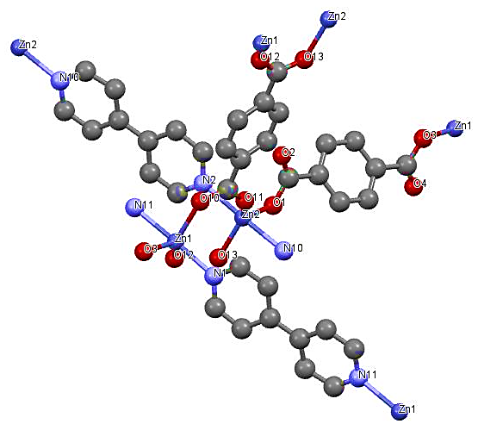
(a)
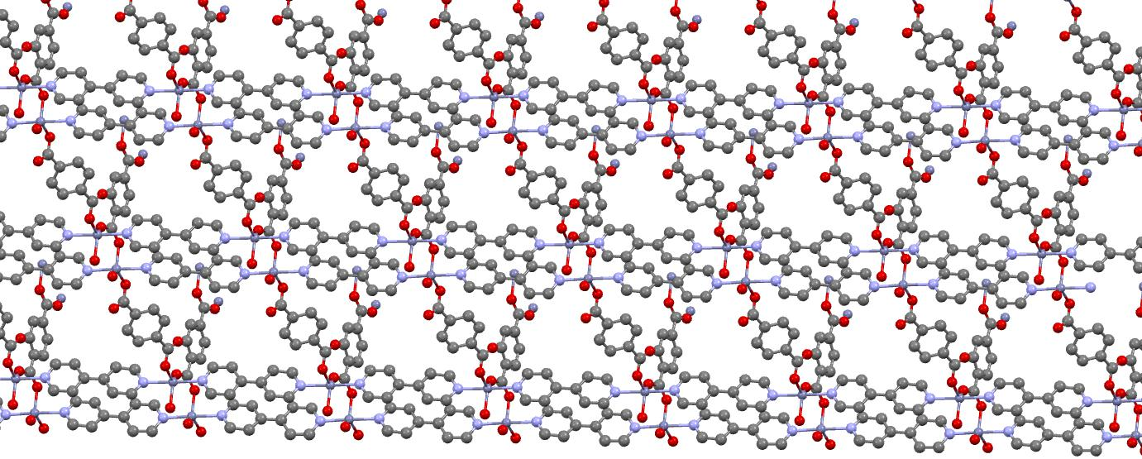
(b)
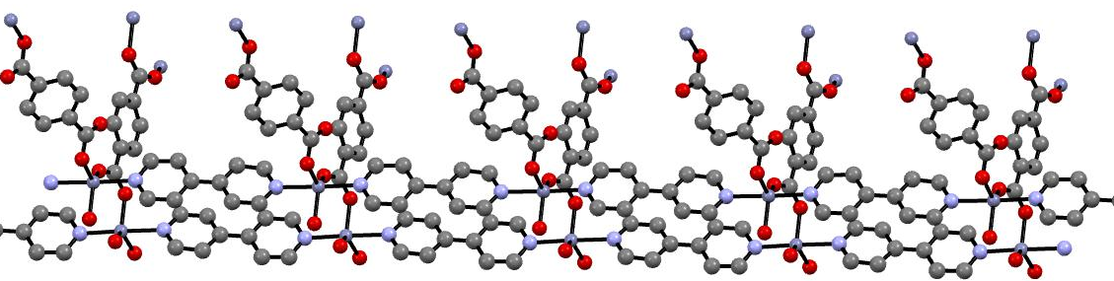
(c)
Figure. 2. A fragment of the three-dimensional CP of [Zn₂(μ-4,4΄-bipy)(μ-BDCA)₂]_{n}.
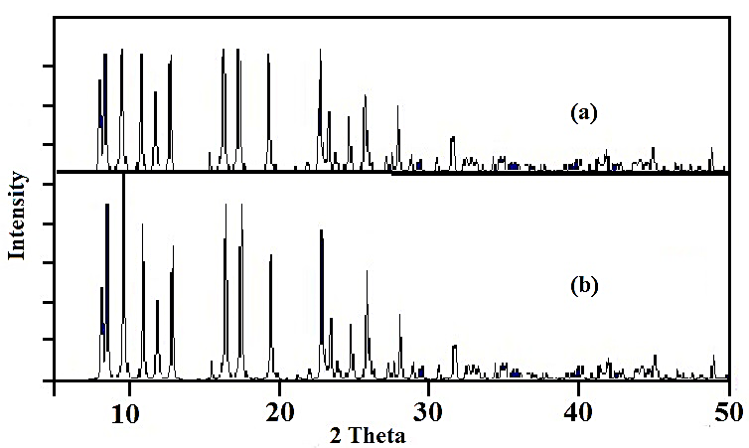
Figure. 3. The XRD patterns of (a) simulated from single crystal X-ray data and (b) nano-structure of [Zn₂(μ-4,4΄-bipy)(μ-BDCA)₂]_{n}

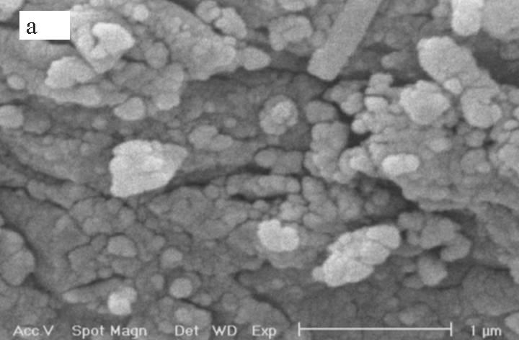
Figure. 4. SEM photograph of [Zn₂(μ-4,4΄-bipy)(μ-BDCA)₂]_{n} nanoparticles.
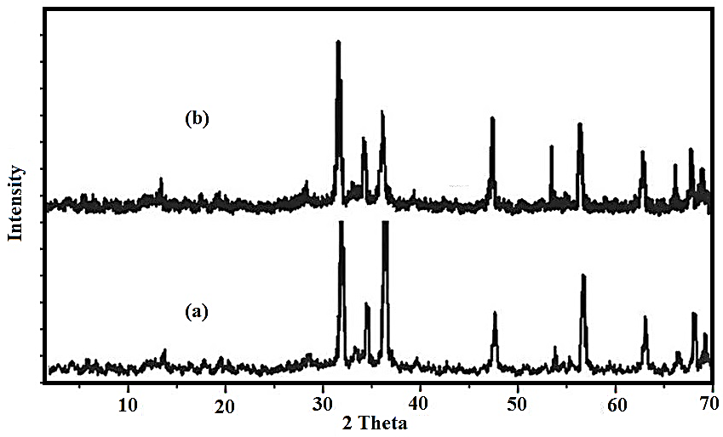
Figure. 5. XRD pattern of ZnO Nanoparticles prepared by calcination of compound NCP of [Zn₂(μ-4,4΄-bipy)(μ-BDCA)₂]_{n} (a) and calcination of CP of [Zn₂(μ-4,4΄-bipy)(μ-BDCA)₂]_{n} (b).

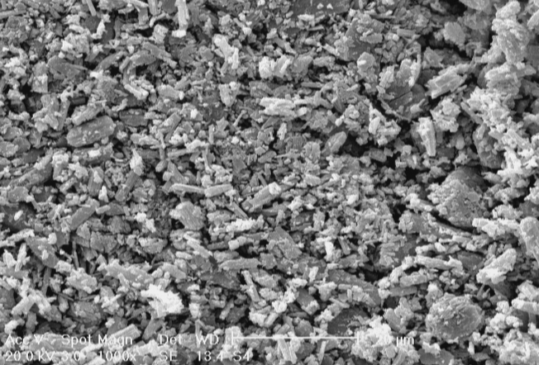
Figure. 6. SEM photograph of ZnO nanoparticles (produced by calcination of straw like
Nanostructure NCP of [Zn₂(μ-4,4΄-bipy)(μ-BDCA)₂]_{n}.

