Choosing Among Different Dimensions in A Newly Designed Dental Implant,
3 Dimensional FEA Comparative Study

Faaiz Alhamdani, PhD, Ibn Sina University, Iraq
Amjed Mahdi, BDS, Ibn Sina University, Iraq
Khawla Hamid, MSc, Ibn Sina University, Iraq

Abstract (300 word limit)
Introduction: There are many dental implant designs, which have been adopted by hundreds of dental implant companies. These designs are modeled following certain micro and macro design criteria. One of these criteria is the dental implant thread design. The aim of introducing a new dental implant with a modified reverse buttress design has been suggested. The objective of the current study to choose the suitable implant material and dimensions among the tested range of implant designs under study using 3D Finite Element Study.
Materials and Methods: A modified Reverse Buttress dental implant in two models (TiG4 and TiG5 models, a range of different implant dimensions (3/13, 3.5/11, 4.11, 4/9, 4.5/9, 4.5/7, 5/9, 5/7, 5.5/9, 5.5/7 mm) were analysed for stress distribution over the surrounding cortical and cancellous bones. A three-dimensional Finite Element Analysis has been carried out in both normal (70 N vertical load) and overload (500 N, 25°) conditions.
Results: in all implant dimensions, maximum Von Mises stress was less than average cortical and cancellous bone elastic modulus. Mann Whitney U Test did not show a statistically significant difference between maximum Von Mises stress in both implant models over both cortical and cancellous bones in normal and over-occlusal loads (p>0.05).
Conclusion: All implant dimensions, showed far fewer stress levels over both cortical and cancellous bones. However, it would be advisable to eliminate the 3/13 mm implant dimension, especially, if the TiG5 model is to be considered, and 5.5/7 mm implant dimension if TiG4 model is to be considered.
Image
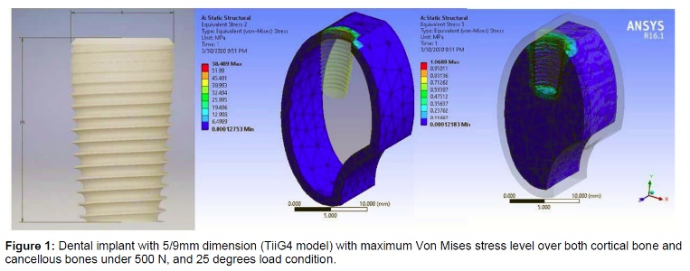
Recent Publications (minimum 5)
- Is my eyesight Gone, Faaiz Alhamdani, Ian Corbett, Justin Durham, JODR, Vol.1 Issue 1. 2016
- Modified approach for lower third molar surgery, short based patient outcome study.SDJ 2015
- An Introduction to Qualitative Research Methodology, Artistic Approach, International Journal of Development Research Vol. 06, Issue, 10, pp.9774-9776, October, 2016
- An introduction to qualitative research data analysis artistic approach, International Journal of Development Research Vol. 06, Issue, 12, pp.10616-10619, December, 2016
- Dental Students› Views of Their Clinical Cognitive Skills. A Qualitative study, Faaiz Alhamdani, JODR, Vol. 4, Issue 1, 2017)
- Factors influencing Management Outcome of Hospitalised Patients with Odontogenic Infection, Suha N Aloosi FICMS, Hydar Abdullah, HDS and Faaiz Alhamdani, PhD, JODR, Volume 4, Issue 2, 2017
- Simultaneous Indirect Sinus Lift and Implant Insertion- Case Report for Extreme Bone Resorption, Faaiz Alhamdani, PhD, JODR, 2018, Vol.5, Issue 2

Biography (150 word limit)

Dr. Faaiz Alhamdani finished his PhD at Newcastle University, the UK in 2012. Part of his PhD project was a qualitative study on patients’ experiences with blow-out fractures of the orbit. Since then he became interested in qualitative research methodologies. Besides his interest in qualitative research, he is also interested in educational research and quality of life research, particularly in Oral and Maxillofacial Surgery. He works now as Vice Dean, College of Dentistry, Ibn Sina University for Medical and Pharmaceutical Sciences, Baghdad-Iraq
He joined IADR 2010. From 2010-2016 he worked as Iraqi Division Secretary. In August 2016 he was elected as President of the Iraqi Division. From 2012 he co-organized most of Iraqi Division (IAOR) events and in August 2017 he was the main organizer and President of the 4th IAOR Scientific Conference in Antalya Turkey. He is also a member of The American Association for Advancement of Sciences.
Email: faaiz68@gmail.com

Notes/Comments

