Obliteration of the pulp canal caused by mandibular distraction: a case report

Sonia Afzal

Abstract

We present a 16-year-old boy with a history of ankylosis of the temporomandibular joint (TMJ) who had been treated with a costochondral graft and mandibular distraction. The distraction seems to have caused pulp canal obliteration of the lower right second premolar and lower right first molar on radiographic examination. To our knowledge this is the only reported instance of such damage related to mandibular distraction. We aim to highlight the risks of this complication and the importance of discussing it with patients as part of the process of informed consent.

This case has highlighted an unreported risk of mandibular distraction that we think is important for consenting purposes, particularly in view of the Montgomery case,7(for example, if a patient places high importance on teeth that require further restorative intervention and may be lost prematurely).We plan to inform our patients of the possibility of this com-plication, and encourage our colleagues engaged in this type of work to do the same when appropriate.

© 2019 The British Association of Oral and Maxillofacial Surgeons. Published by Elsevier Ltd. All rights reserved.

Image

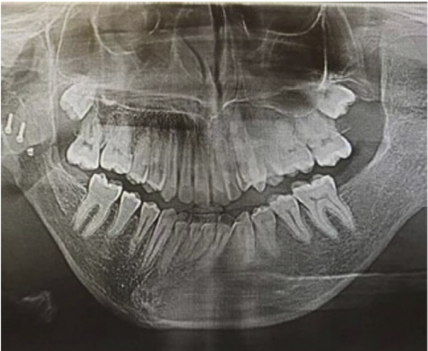

Recent Publications

- Sonia Afzal, Awais Nasir (2020) Cultural impact on covid-19 spread in Pakistan Submitted for publishing

- Olivia Johnson, Sonia Afzal, Valmiki Sharma (2019) Mandibular Distraction Causing Pulp Canal Obliteration: A Case Report The British Journal of Oral & Maxillofacial Surgery

- Shujaat Hasan Idrees, Sonia Afzal Effects of Sensory disturbances in Cleft Lip and Palate patients (2014) Pakistan Oral and dental journal

- Nazli Gul Shujaat, Sonia Afzal Relationship between quality of life and psycho-social functioning among children and adolescents with cleft lip and palate (2014) Pakistan Oral and dental journal

- Nazli Gul Shujaat, Sonia Afzal (2013) Attitudes, practice and addiction towards Water-pipe/ Shisha smoking in Lahore

 Sonia Afzal
I, Sonia Afzal obtain great joy by helping people feel confident about their smiles. My advanced evaluation and treatment planning creates new pathways for improving healthcare. After graduating, I worked as a dentist for two years before I moved to the UK. I learned all about clinical dentistry and understood the importance of interaction and effective communication with patients. Building relationships has been one of my main draws to the profession. Several years of experience in research, teaching and clinical practice has helped me build this personality.
Email: sonia-afzal@hotmail.com

