Orthodontic space opening Vs space closure: Hypodontia Case reports
Ryad Al-Klash,
BDS, DipClinDent, MClinDent, IMOrth (RCS Eng.), FDS (RCS Edi)
UK/Sheffield

Abstract
Hypodontia is the most commonly developmental anomaly in man, it can present to a varying degree of severity: mild, moderate or severe. Early diagnosis of hypodontia is important due to its negative impact on function and physiological status. Malocclusion, periodontal damage, and lack of alveolar growth can be caused by hypodontia³. Thus, a broader understanding of hypodontia patients is vital; eventually leads to an improvement in the outcome of treatment and enhancing the overall quality of life. Case 1: G. N. is a 12-year old girl presents clinically with a class II division I incisal relationship on mild skeletal II base, complicated by: incompetent lips, missing upper lateral incisors, deep and complete overbite to palate, scissors bite affecting the UL4. The upper labial segment was spaced and proclined. The overjet measured 7mm and the molar relationship was a full-unit Class II on the right side and half-unit Class II on the left side. Case 2: E. M. is a healthy 43-year old lady who presented with a class III incisal relationship on skeletal I base, with increased lower vertical facial proportions. This is complicated by: missing upper lateral incisors, reduced overbite, and a heavily restored upper right canine. The overjet measures -1mm and both upper and lower labial segments are spaced and proclined. Discussion: The management of absent teeth involves a multidisciplinary team approach. Generally, edentulous space can be left open for an eventual restoration, or closed by orthodontic treatment. The treatment plan may employ mechanics, which enhance the facial proportions, and may ultimately improve the lip position and facial attractiveness. However, the final decision must be made on an individual basis, and can only be agreed after careful consideration of all factors of patient’s malocclusion.

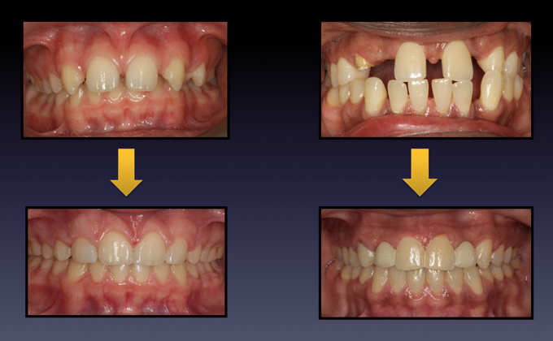

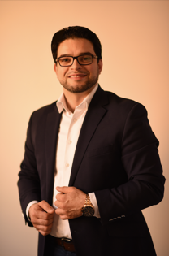
Biography
Ryad is a highly motivated and enthusiastic specialist orthodontist, who works hard to provide excellent level of patient care by closely following the latest evidence-based guidelines. His clinical and research interests lie in the area of congenitally missing teeth (Hypodontia) and the associated multi-disciplinary team approach, ranging from theory to design and implementation. He has managed a wide range of malocclusions, many of which were complex malocclusions that required multi-disciplinary team approach. Likewise, he provides consultations to many parents and their children as part of collaboration with the local general dental practitioners in planning interceptive orthodontic protocols at various ages. Ryad is a university lecturer since 2013, and has been involved in teaching both undergraduate and postgraduate programmes. He contributed to many conferences, workshops and committees. Currently, he is based in the UK and collaborates with the Academic and Clinical Excellence post-graduate diploma (ACE) in orthodontics at London and Manchester.
Email: ryad.alklash@gmail.com

Notes/Comments:

