Hypodontia: A 3-Dimentional soft tissue facial analysis

Ryad Al-Klash,
BDS, DipClinDent, MClinDent, IMOrth (RCS Eng.), FDS (RCS Edi)
UK/Sheffield

Abstract
Introduction: Hypodontia patients have been noted to be unique, and have a different and wide range of variations from the normal facial soft tissue morphology. Their orthodontic treatment plan may employ mechanics which enhance their facial soft tissue proportions. Therefore, it is important to determine whether hypodontia patients have reduced lower soft tissue facial proportions or not. Aim: To assess whether there are differences in the facial soft tissue morphology between patients with hypodontia compared to those without hypodontia, and the differences in facial soft tissue morphology between patients with anterior hypodontia and those with posterior hypodontia. Study design: A prospective matched case control study, comparing the soft tissues of Class I patient with hypodontia, with matched Class I controls. Subjects and Methods: Ethical approval was sought and data was collected at the Royal London Hospital. The study sample group consisted of 18 patients (7 males, 11 females) all aged between 12-16 years inclusive, allocated in to a specific sub-group according to distribution of their missing teeth [Sub-group A (anterior), sub-group B (severe antero-posterior or posterior)]. Fifteen anatomical landmarks were identified and three-dimensionally (3-D) measured using a laser scanning system. All variables were computed and evaluated by measuring the statistical difference using Mann Whitney Test. Results: The lower facial height was reduced in those with hypodontia compared to their matched controls in both genders (p<0.05). Both sub-groups appeared to show a significant reduction in the lower facial height when compared to their matched controls. Conclusion: The findings of this study showed that hypodontia patients with anterior missing teeth and with severe antero-posterior or severe posterior missing teeth appeared to show a significant reduction in the lower facial height. However, the study did not demonstrate differences between sub-groups A and B in relation to their anterior lower facial height.

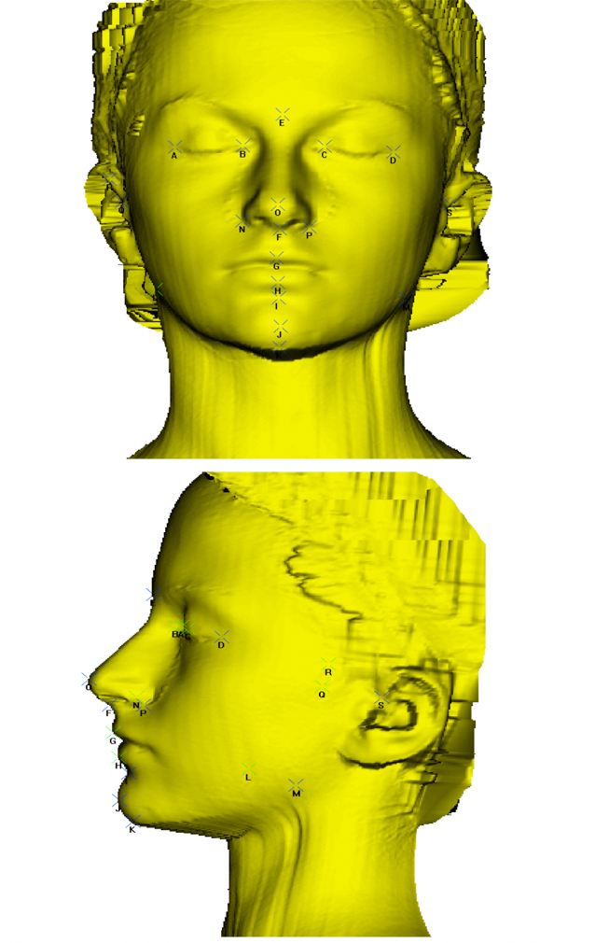


Biography
Ryad is a highly motivated and enthusiastic specialist orthodontist, who works hard to provide excellent level of patient care by closely following the latest evidence-based guidelines. His clinical and research interests lie in the area of congenitally missing teeth (Hypodontia) and the associated multi-disciplinary team approach, ranging from theory to design and implementation. He has managed a wide range of malocclusions, many of which were complex malocclusions that required multi-disciplinary team approach. Likewise, he provides consultations to many parents and their children as part of collaboration with the local general dental practitioners in planning interceptive orthodontic protocols at various ages. Ryad is a university lecturer since 2013, and has been involved in teaching both undergraduate and postgraduate programmes. He contributed to many conferences, workshops and committees. Currently, he is based in the UK and collaborates with the Academic and Clinical Excellence post-graduate diploma (ACE) in orthodontics at London and Manchester.
Email: ryad.alklash@gmail.com

Notes/Comments:

