Geriatric Oral Health is a Public Health urgency
Maryam Tabrizi DMD, MPH- The University of Texas School of Dentistry at Houston, USA

Abstract (300 word limit)
Geriatric oral health is a serious global Public Health issue. Currently, there are over 600 million individuals 60 y/o and over by 2050, this number will rise to 2 billion worldwide. Oral health is the most neglected area of their health care. They face lack of oral health maintenance, lack of access, ability and availability to oral care. In addition, increasing new root carries and periodontal disease due xerostomia. The elderly in long-term care with physical and cognitive disabilities are at higher risk. This population is at higher risk for oral cancer and many do not receive routine oral health maintenance. It is urgent to educate the entire health care team for this serious health issue. Initiate research, develop guidelines eventually provide access oral health and overall health equally for care. Guidelines to differentiate ideal dental treatments and rational dental treatments, oral assessments and evaluation within the standard of care according to World Health Organization to minimize serious oral health diseases and improve function.
Associated with aging is an increase in the incidence and prevalence of age-related comorbidities (i.e. heart disease, hypertension, diabetes, arthritic conditions, etc.) along with a decline in physiologic functioning of the individual. A significant and increasingly common age-related disorder is dementia manifested as a slow, progressive decline in cognitive functions (i.e. intellectual abilities, impairment of memory, abstract thinking, and judgment). The causes of dementia may be varied but the most common cause of dementia is associated with Alzheimer’s disease (AD) .This poster will presents if accepted, a case report and review of the issues and challenges associated with management of the dental patient with AD. Practicing dentistry is no longer limited to oral cavity, dentists are “oral health physicians” who must be aware of overall condition and treat them accordingly.

Image

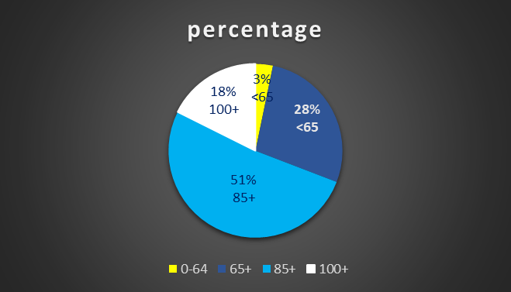

Recent Publications (minimum 5)
- Ortman JM, Velkoff VA, Hogan H. An aging nation: the older population in the United States. Washington, DC: United States Census Bureau, Economics and Statistics Administration, US Department of Commerce; 2014 May 9
- Birks JS, Harvey RJ. Donepezil for dementia due to Alzheimer's disease. Cochrane Database of systematic reviews. 2018(6
- Branch LG, Meng H, Guralnik JM. Disability and functional status. In: Prohaska T, Anderson LA, Binstock R, eds. Public Health for an Aging Society. Baltimore, MD: Johns Hopkins University Press; 2012.
- Syrjälä, Anna‐Maija Hannele, et al "Dementia and oral health among subjects aged 75 years or older." Gerodontology 29.1 (2012): 36-42
5. . Wolff A, Joshi RK, Ekström J, Aframian D, Pedersen AM, Proctor G, Narayana N, Villa A, Sia YW, Aliko A, McGowan R. A guide to medications inducing salivary gland dysfunction, xerostomia, and subjective sialorrhea: a systematic review sponsored by the world workshop on oral medicine VI. Drugs in R&d. 2017 Mar 1;17(1):1-28..

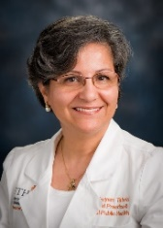 Biography
Dr. Tabrizi has completed her Master of Public Health-MPH at Temple University collage of Public Health at Philadelphia, PA 2014. She has received her Doctor of Dental Medicine-DMD at Temple University School of Dentistry at Philadelphia, PA 1991. She is an Assistant professor at The Texas University School of Dentistry at Houston, Dep of General Dentistry and Public Health, where she is the director of Geriatric educational students’ rotation. She has published papers in reputed journals on the topic of Geriatrics dentistry. She is holding leadership positions in American Public Health Association (APHA), American Dental Education Association (ADEA) Geriatric Dentistry section and an active member of Special Care Dental Association (SCDA). American Association of Public Health Dentistry (AAPHD). Her focus is to bringing Oral Health and Overall Health together to improve oral health and the quality of life of the elderly.

Email: Email Id: maryam.tabrizi@uth.tmc.edu

