The effect of two Phosphodiesterase inhibitors on bone healing in mandibular fractures (animal study in rats)
Name: Mohsen MalekiGorji^{1*} , Arash Golestaneh² , Maryam MalakiGorji³
¹Postgraduate Student, Department of Oral & Maxillofacial surgery, dental school, Islamic Azad University, Isfahan, Iran. ²Assistant professor , Department of Oral & Maxillofacial surgery, dental school, Islamic Azad University, Isfahan, Iran. ³Lecturer in pharmaceutical Sciences/Biotechnology,School of Pharmacy, Queen’s University Belfast,UK

Abstract

Background and Objectives: Despite the advances in maxillofacial surgery, impaired bone healing remains a concern for surgical teams. Many studies have evaluated the effects of sildenafil and pentoxifylline on bone healing. However, their effects on healing of bone fractures have not been well investigated. This study aimed to assess the effects of sildenafil and pentoxifylline phosphodiesterase inhibitors on healing of mandibular fractures in rats.

Materials and Methods: A total of 60 rats were randomly divided into six groups of 10. Mandibular fracture was induced in all rats. After the surgical procedure, C1 group received saline, S1 group received 10 mg/kg sildenafil and P1 group received 50 mg/kg pentoxifylline. The rats were sacrificed after 1 week. C4, S4 and P4 groups received pharmaceutical therapy as in groups C1, S1 and P1 but were sacrificed after 4 weeks. The samples then underwent histological analysis.

Results: The mean rate of healing of mandibular fractures in S1 and P1 groups was significantly higher than that in C1 group at 1 week (P<0.001). The mean rate of healing of mandibular fractures in P1 group was higher than that in S1 group at 1 week (P=0.04). The mean rate of healing of mandibular fractures in S4 (P=0.001) and P4 (P=0.004) groups was significantly higher than that in C4 group at 4 weeks but no significant difference was noted between P4 and S4 groups in this respect (P=0.53).

Conclusion: Sildenafil and pentoxifylline can be used as adjuncts to enhance bone healing.

Keywords: Mandibular Fracture; Bone Healing; Sildenafil; Pentoxifylline
Image
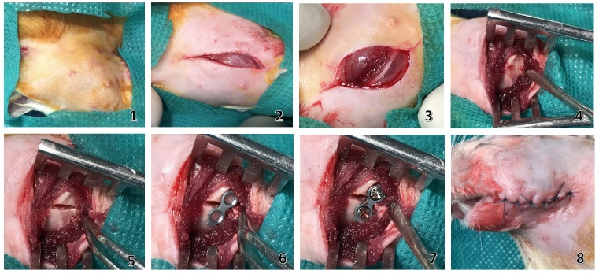
Recent Publications
- . Durmuş K, Turgut NH, Doğan M, et al. Histopathological evaluation of the effect of locally administered strontium on healing time in mandibular fractures: An experimental study. Adv Clin Exp Med. 2017 Oct;26(7):1063-1067.
- Dincel YM, Alagoz E, Arikan Y. Biomechanical, histological, and radiological effects of different phosphodiesterase inhibitors on femoral fracture healing in rats. J Orthop Surg (Hong Kong). 2018 May-Aug;26(2):2309499018777885.
- Vashghani Farahani MM, Masteri Farahani R, et al. Effect of Pentoxifylline Administration on an Experimental Rat Model of Femur Fracture Healing With Intramedullary Fixation. Iran Red Crescent Med J. 2015 Dec 28;17(12):e29513.
- Schlundt C, El Khassawna T, Serra A, et al. Macrophages in bone fracture healing: Their essential role in endochondral ossification. Bone. 2018 Jan;106:78-89
- Çakir-Özkan N, Bereket C, Sener I, et al. Therapeutic Effects of Sildenafil on Experimental Mandibular Fractures. J Craniofac Surg. 2016 May;27(3):615-20.

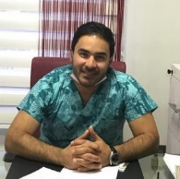

Biography

Dr.Mohsen Maleki Gorji graduated from Tehran Azad University, Iran, Now he is chief-resident of Oral and maxillofacial surgery in Isfahan Azad University,Iran. He is talented in animal studies. He presented in many national and international congress.
Phone Number: +989357723837
Mail ID:Mohsen_malekigorji@yahoo.com

