Ozone Gas & Water in Dentistry

Dentistry is considered one of the oldest medical professions. The field of Dentistry has been dated back to 5000 BC. It wasn’t until 1700’s that dentistry has become a more defined profession.

Pierre Fauchard of France 1678 – 1761 is known today as the Father of Modern Dentistry.

We have come a long way since the 1700. Traditional dental offices are based on the drill & fill concept. Most traditional dental offices operate on a reactive treatment plan rather then a proactive treatment plan. A patient comes in with a cavity, the decay needs to be removed and a different variety of filling material can be placed inside the tooth. The dental hygienist continues to remove the hard and soft deposits on peoples’ teeth.
Costs for dental treatment continue to rise.

The public is starting to seek out a gentler way of treatment, they are starting to seek out alternative treatment from a holistic dental practice. Is there another way to treat decayed teeth other than drill, fill & gum disease with all the scraping?
People are now searching for less painful, less traumatic types of treatments.

Most dental office employs Dental Hygienists. As trained professionals we have the honour of helping people to become healthier. Patients in Canada and the USA see their dentist/dental hygienist more then they visit their family doctor. This enable the Dental professional to give greater level of care to our patients.
As a Biological Dental Hygienist, we are able to offer a greater level of care.
Dental Hygienists are now screening for oral cancers on a regular basis. We are able to check and monitor blood pressures & can have the patient follow up with their blood sugar with their primary care physician. Dental Hygienists are no longer seen as “teeth cleaners” We have adopted a Preventive Role. This involves more involvement with the patient, reviewing homecare techniques, looking at the how the role of inflammation affect the whole body, not just in the patients mouth. This does involve scraping/scaling/root planning, to remove hard and soft deposits but we also look at the bacterial cascade that is set up in the bodies of our patients when the DH.
Inflammation = Infection, Infection = Disease.

How can we help our patients?
The dental professional needs to take a step back and look at how to prevent decay and understand how inflammation in the mouth can affect the rest of the body. If we do not pay attention to the bacterial cascade that happens every time we clean patients teeth.
There are many different methods of treating dental decay and gum disease.
One of the newest modalities of treatment is Ozone. Ozonated gas or ozonated water can be used to treat many conditions in the dental office.

Ozone Dental Therapy:

Another tool in our toolbox.

Ozone can be used in dentistry to treat many

Inactivation of bacteria, viruses, fungi, yeast and protozoa: Ozone therapy disrupts the integrity of the bacterial cell envelope through oxidation of the phospholipids and lipoproteins. In fungi, O3 inhibits cell growth at certain stages.
Ozone therapy: A clinical review
M. Elvis and J. S. Ekta

- It’s kinder and gentler.
- It doesn’t make noise
- It doesn’t hurt
- It doesn’t make the patient uncomfortable
- It’s versatile and can be used on every patient, every day
- Kinder, Gentler way of doing dentistry
- Remove as little tooth/tissue structure as possible/ conserve healthy tooth structure
- Focus on prevention, remineralization and healing
- Consider biology of individual mouth.
- Treat root causes of disease

WHAT IS OZONE

- Highly reactive
- Very unstable molecule
- Has huge oxidative properties
- Has distinctive smell.
- Is the strongest antimicrobial agent known.

Discovery of Ozone:

- 1785, Van Marum noticed that air near his electrostatic machine acquired a characteristic odour when electric sparks were passed
- Martinus Van Marum (1750-1837) "discovers" a light blue gas,
with the help of Mr. Cuthbertson

http://lateralscience.blogspot.com/2012/07/martinus-van-marum-1750-1837-discovers.html

- 1801, Cruickshank observed the same odour at the anode during electrolysis of water.
- 1840, Shonbein named the substance, which gave off this odour, ozone, from the Greek word “ozein”- to smell.
http://acshist.scs.illinois.edu/awards/OPA%20Papers/2001-Rubin.pdf pg 41

- The vast majority of historical references to ozone indicate Shonbein was the first scientist to name ozone, although there are some references to another German scientist, Christian Fernandez as the first.
https://ozonewithoutborders.ngo/wp-content/uploads/2017/07/Ozone-Therapy-A-review-2013-Holmes.pdf

1870 saw the first reports on ozone being used therapeutically to purify blood by Dr C Lender in Germany. There is evidence of the use of ozone as a disinfectant from 1881 as mentioned by Dr Kellogg in his book on diphtheria. In October of 1893, the world's first water treatment plant using ozone was installed in Ousbaden, Holland, and today there are over 7000 municipalities around the world that use ozone to clean their water and sewage. In 1885, the Florida Medical Association published "Ozone" by Dr Charles J Kenworth MD, detailing the use
Dr Julian Holmes. April 2013
A Review of the Use of Ozone in Healthcare. Dr Julian Holmes. April 2013
of ozone for therapeutic purposes and in 1886 the ability of ozone to disinfect polluted water was recognized in Europe. Test results from Germany showed that ozone was effective against bacteria and in 1893 ozone was reported in algae control. In September 1896 the electrical genius Nikola Tesla patented his first ozone generator, and in 1900 he formed the Tesla Ozone Company. Tesla sold ozone machines to doctors for medical use, and modern ozone production units are still based on one of his designs from the 1920s. Tesla also produced ozonated olive oil and sold it to naturopaths. In 1898, the Institute for Oxygen Therapy was started in Berlin by Drs Thauerkauf and Luth. These doctors injected ozone into animals and bonded ozone to magnesium, producing ‘Homozon’.
Beginning in 1898, Dr Benedict Lust, a German doctor practicing in New York, who was the originator and founder Naturopathy, wrote many articles and books on ozone. In 1902, J H Clarke's "A Dictionary of Practical Materia Medica," London describes the successful use of ozonated water in treating anaemia, cancer, diabetes, influenza, morphine poisoning, canker sores, strychnine poisoning and whooping cough. In 1903 at Niagara Falls, NY a water purification plant went on-line, and by 1915 at least 49 major ozone installations for water purification are on line throughout Europe. In the early 1900’s, the London Underground was ventilated with ozone to keep the air in the tunnels fresh and bacteria free.
In 1911, "A Working Manual of High Frequency Currents" was published by Dr Noble Eberhart MD. Dr Eberhart was head of the Department of Physiologic Therapeutics at Loyola University. He used ozone to treat tuberculosis, anaemia, chlorosis, tinnitus, whooping cough, asthma, bronchitis, hay fever, insomnia, pneumonia, diabetes, gout and syphilis. In 1913, the Eastern Association for Oxygen Therapy was formed by Dr Blass and his German associates.
During World War 1 ozone was used to treat wounds, trench foot, gangrene and the effects of poison gas. Dr Albert Wolff of Berlin also used ozone for colon cancer, cervical cancer and decubitis ulcers in 1915. Around World War I poisonous gas
Dr Julian Holmes. April 2013
A Review of the Use of Ozone in Healthcare. Dr Julian Holmes. April 2013
research lead to the development of inexpensive chlorine gas, and due to the costs of large scale ozone manufacture, interest in ozone for water purification began to decline.
In 1920, Dr Charles Neiswanger MD, the President of the Chicago Hospital College of Medicine, published "Electro Therapeutical Practice." Chapter 32 was entitled “Ozone as a Therapeutic Agent." In 1926, Dr Otto Warburg of the Kaiser Institute in Berlin announced that the cause of cancer is lack of oxygen at the cellular level. Dr Otto Warburg received the Nobel Prize for Medicine in 1931 and again in 1944, the only person to ever receive two Nobel Prizes for Medicine. He was also nominated for a third.
In 1929, a book called "Ozone and Its Therapeutic Action" was published in the US listing 114 diseases and how to treat them with ozone. Its authors were the heads of all the leading American hospitals. A Swiss dentist, Dr Edwin A Fisch was using ozone in dentistry before 1932, and introduced it to the German surgeon Dr Erwin Payr who used it from that time forward. Drs Aubourg and Lacoste were French physicians using ozone insufflation from 1934-1938.
The use of ozone in the United States can be traced back to the 1940's and in 1948; Dr William Turska of Oregon began using ozone, employing a machine of his own design. In 1951, Dr Turska wrote the article "Oxidation". Dr Turska pioneered injection of ozone into the portal vein, thereby reaching the liver.
From 1953 onward, the German doctor Hans Wolff used ozone in his practice, writing the book "Medical Ozone," and training many doctors in ozone therapy. In 1957, Dr J Hansler patented an ozone generator which has formed the basis of the German expansion of ozone therapy over the last 35 years. Today over 7000 German doctors use ozone therapy daily.
In 1961, Dr Hans Wolff introduced the techniques of major and minor autohemotherapy. By 1965 Scotland (UK) was using ozone for colour control in surface water, and this is the first report of ozone being used to control colour of substances. At the same time,
Dr Julian Holmes. April 2013
A Review of the Use of Ozone in Healthcare. Dr Julian Holmes. April 2013
Swiss research lead to the use of ozone to oxidize micro pollutants such as phenolic compounds and several pesticides.
In 1977, Dr Renate Viebahn provided a technical overview of ozone action in the body, and in 1979, Dr George Freibott began treating his first AIDS patient with ozone. A paper published in 1980 by Dr Horst Kief also reported success treating AIDS with ozone. In 1987, Drs Rilling and Viebahn published "The Use of Ozone in Medicine," which is regarded by many as the standard text on the subject. In 1990, the Cuban ozone institute reported on their success in treating glaucoma, conjunctivitis and retinitis pigmentosa with ozone.
One of the most common uses of ozone is for the treatment of water. Scientists and doctors studied the ozonation system at Ousbaden, in Holland and later built an industrial plant at Nice, France. Nice, rather than Ousbaden, for some reason is referred to as "the birthplace of ozonation for drinking water treatment".
From a scientific view point, the gas’s correct name is ‘trioxygen’ as it is a gas made up of three oxygen molecules. Ozone is found in low concentrations at ground level and is more noticeable after thunder storms, by the sea-side, and has been found to be released in certain geological events.[1]

USES OF OZONE

- World War 1, ozone was used to treat gunshot and trauma wounds, trench foot, gangrene and the effects of poison gas.

Germans doctors in the trenches used ozone to disinfect wounds during World WarI. German doctors expanded the world of ozone by introducing ozone treat blood, either by direct gas administration or removing 50-200 mL blood, ozonating it, and returning it.Sep 25, 2018

Ozone therapy as a primary and sole treatment for acute bacterial ...

https://www.ncbi.nlm.nih.gov › pmc › articles › PMC6178636

- 1915 - Dr. Albert Wolff of Berlin also used ozone for treating colon cancer, cervical cancer and decubitis ulcers in 1915.
http://www.ozonehelps.com/history-of-ozone-since-1840.html

- 1920 - Dr. Charles Neiswanger MD, the President of the Chicago Hospital College of Medicine, published “Electro Therapeutical Practice.” Chapter 32 was entitled “Ozone as a Therapeutic Agent.”
- 1932 - Dr E Fisch first dental use of ozone.
- 1950’s - ozone used to treat cancers
HISTORY OF OZONE THERAPY

- 1934- FDA/AMA stop O3 medical use
- 1961- Cuban success using ozone to treat eye infections.
- 1977 - Dr. Renate Viebahn - technical overview of ozone action in the body.
- 1979 - Dr. George Freibott began treating his first AIDS patient with ozone
- 1990’s - Reynolds & HIV treatments with ozone.
- 1994- Atkins decision allows treatment of practitioners choice.

Frank Schallenberger, MD-

MD, HMD, ABAAM
Teaches medical ozone techniques/ Written two books on ozone
Head of AAOT- Nevada
https://www.antiagingmedicine.com/staff/frank-shallenberger/

Renate Viebahn- German chemist, consultant.

The Use of Ozone in Medicine: A Practical Handbook Paperback – Dec 1 1994
Extensive research in ozone and medicine/ Wrote medical ozone book/ Has company that makes ozone eqiuipment/ Father

Dr. Joachim Hänsler,
did ozone research in the 1950’s- Germany
https://www.o3belgium.be/50-ans-d-ozonozan

Phil Mollica, DDS- Along with Bob Harris has taught dental ozone and naturopathic courses for many years- New Jersey

OZONE USES AROUND THE WORLD

- O3 used in Europe, Russia and Cuba in medicine and dentistry for last century.
- Research and clinical evidence to treat most diseases with ozone
- 7000 Municipalities around the world use O3 to purify their water.
- Over 8000 German M.D.’s use ozone therapy today.

STUCTURES OF OZONE MOLECLUE

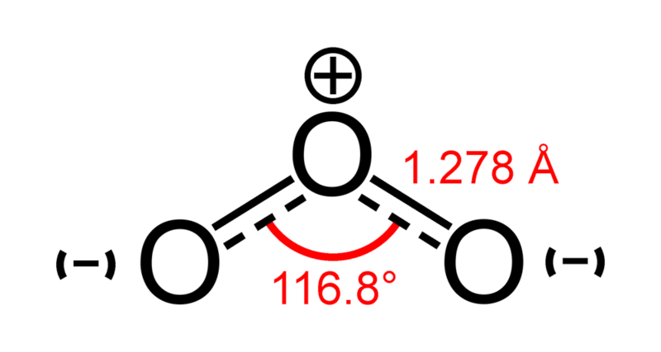

Ozone VS Chloride

- 150x more powerful sterilant
- 3500x faster acting in bactericidal action
- Safer & less reactant by-product compounds
- Overall- healthier and less toxic than chlorine

Ozone therapy is a form of alternative treatment that is designed to increase the amount of oxygen delivered to the body through the use of pure ozone gas.

“Ozone has been used to medically to disinfect & treat disease since its discovery. In 1896 Nikola Tesla patented the first ozone generator in the United States. Ozone has been used as a safe and effective water purifier for more than a century. Ozone deactivates pathogenic microbes in the human body in much the same way it does in water, unsurprising since our bodies are made up of 70% water” (1)

MECHANISM OF ACTION
“Inactivation of bacteria, viruses, fungi, yeast and protozoa: Ozone therapy disrupts the integrity of the bacterial cell envelope through oxidation of the phospholipids and lipoproteins. In fungi, O3 inhibits cell growth at certain stages.” (2)

How is medical grade ozone made?
Ozone is made by passing pure oxygen gas through a crystal tube through which an electrical spark is directed. The electrical energy breaks apart the oxygen molecules as described above, and what emerges from the other side is a mixture of oxygen and ozone.

“The potential application of ozone therapy in human body and its biological horizons are listed in Antimicrobial effect of ozone is the most studied. Oxygen/ozone therapy in dentistry contains a multiplicity of protocols to deal with dental infection. Three fundamental forms of application to oral tissue are applied” (3)

An Ozone Generator must be made with medical grade, chemically inert components to ensure high purity for ozone therapy.

OZONE USES IN DENTISRTY

- Restorative
- Oral Surgery
- Periodontology
- Endodontics
- Pedodontics
- Implantology
- Whitening
- Desensitizing teeth
- Cold sores/Herpetic lesions
- Water Line Disinfection

Streps and lactobacilli cannot form a biofilm on dentin pre-treated with ozone
Knight GM et al Aus Dent J 2008 Dec; 53 (4): 349-53

Heal Ozone –

A specialized cup is placed around affected tooth.
99% reduction of microorganisms after 20 seconds of HealOzone

Noack and Kneist
ORCA and Caries Res 2006

OZONE AND PATHOGENS
- Bacteria, fungi, viruses and prions lack antioxidants.
- The ozone breaks down the polysaccharides in their cell walls or disrupts their replication cycles.
- Effectively lyses them!

OZONE ACTION IN THE BODY
- Disinfectant
- Oxygen Donor
- Immunomodulator
- Inducer of antioxidant enzymes
- Metabolic Enhancer
- Induce Endothelial Nitric Oxide Synthetase
- Possibly stem cell activator
- Rubber gloves AND bacterial cell walls are polysaccharides—
- Instant disruption

OZONE VS ANTIBOTICS

- Most antibiotics show specificity towards certain bacterial strains.
- Ozone shows generalized bactericidal effects against all bacterial strains.

OZONATED WATER

Extremely potent

Oxygenates tissue
Leaves no chemical residue
Ozonated water has a half-life of 37
min at 20 C.
4ug/ml (min dose) O3 H2O applied for
10 sec leaves no visible trace of
microorganisms.

USES IN DENTISTRY
- Water Disinfection
- Preprocedural Rinse
- Syringe into pockets
- Ultrasonic scaler
- Endo canal rinse
- Injections

OZONATED OILS

- Medical
- Dental
- Veterinary

- Ozone gas changes into ozonides when diffused into oils.
- Ozone reacts with the double carbon bond to
give an ozonoid, and this is estimated to have a reactivity of 50 – 70% to that of ozone gas.
- The amount incorporated is proportional to the amount of double bonds/omega fatty-acids within the particular oil.

- Periodontal Disease and Lesions
- Endodontic Applications and Fistulas/ Endo treatment in canals - on files
Implant Treatment and Peri-Implantitis
- Oral Surgeries
- Treatment of Oral Herpes, Apthous Ulcers, Angular Chelitis and other Lesions
Ozonated oils applied daily can help heal the lesions
- Oral Lichen Planus
- Calculus/Biofilm Debridement
- Denture Sore Mouth & Angular Cheilitis
- Extractions – Alveolar Site
- Infections / Fistulae
- Peri- implantitis
- Burns
- May be ingested - encapsulated for taste

OZONE GAS

Ozone gas applied to aphthous ulcers/cold sores can help shorten healing times.

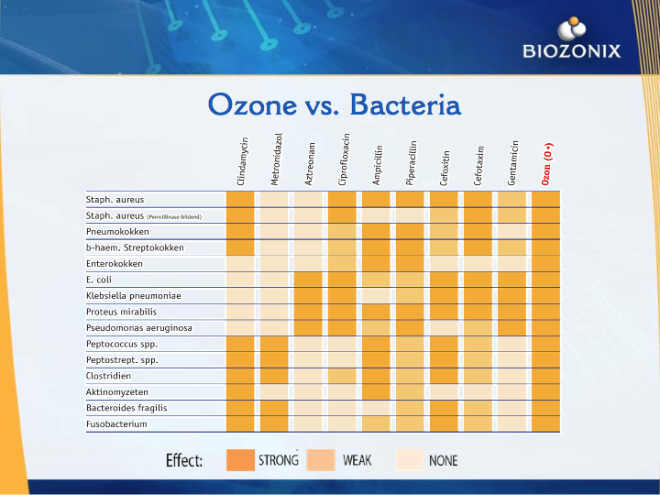

Global Ozone Organizations:
ISCO3- International Umbrella Ozone Organization
AAOT- American Academy of Ozone Therapy
Most European and South American countries have their own medical ozone organizations.
Brazil just lobbied their government to approve ozone treatments in dentistry, but not medicine.

General uses of ozone
Hotel & home use:
    - Removal of unwanted odors – air purifying – fish smell, cigarette smoke
    - Room sterilization (Legionnaires)
    - Water sterilization – ice manufacture, showers
    - Hand washing / cross infection control
    - Food preparation / preservation Public buildings
    - Sterilize air-conditioned rooms and spaces
    - Reduction in air-born infections – SARS, TB, Influenza
    - Disinfect water supplies

Ozone in Medical treatments

- Infectious Diseases
- Degenerative Ischemic Diseases
- Cancer/HIV
- Metabolic Syndrome
- Hematological Diseases
- Pulmonary Diseases
- Tinnitus/Sudden Hearing Loss
- Dermatology
- Orthopedic Conditions

Diseases Treated with Ozone
- RA/ Lupus/ Scleroderma
- RSD / CRPS
- Burns
- Parkinson’s / Alzheimer disease
- ASO / Atherosclerosis
- Diabetic neuropathy / retinopathy / ulcers
- Allergies /asthma
- Glaucoma / Macular degeneration / Conjunctivitis (all forms)
- Anything with “itis” at the end of it
- Psoriasis / Eczema & most every other skin condition

Conditions Treated with Ozone:
All viral, bacterial and fungal diseases and infections:
- Measles; Herpes (all forms); Lyme; AIDS; Acne; Hepatitis A, B, C; Gangrene; Flu; Rhinovirus;
- Candidiasis; Tinea; C. dif.; E. coli; Krohn’s; Pneumonia; Polio; Warts; Stealth viruses (echovirus); Shingles (post-herpetic pain); Protozoal infections of all kinds.
- Bells palsy; MS; ALS (Viral?)

Ozonated Water:
- Extremely potent
- Oxygenates tissue
- Leaves no chemical residue
- Ozonated water has a half-life of 37 min at 20 C.
4ug/ml (min dose) O3 H2O applied for 10 sec leaves no visible trace of microorganisms.

It is time to help our patients to be HEALTHY

Dentistry is considered one of the oldest medical professions. The field of Dentistry has been dated back to 5000 BC. It wasn’t until 1700’s that dentistry has become a more defined profession.

We have come a long way since the 1700. Traditional dental offices in the 21th centery are based on the drill & fill concept. Most traditional dental offices operate on a reactive treatment plan rather then a proactive treatment plan. It is time to look at how to help our patients become healthier. With the use of Ozone in Dentisrty we are able to help our patients do just that, become healthier. Ozone has been used worldwide to treat many different ailments. Now we are able to use ozonated gas to treat dental decay and ozonated water to treat dental infections/periodontal disease

A patient comes in with a cavity, the decay needs to be removed and a different variety of filling material can be placed inside the tooth. The dental hygienist continues to remove the hard and soft deposits on peoples’ teeth.
Costs for dental treatment continue to rise.

The public is starting to seek out a gentler way of treatment, they are starting to seek out alternative treatment from a holistic dental practice. Is there another way to treat decayed teeth other than drill, fill & gum disease with all the scraping?
People are now searching for less painful, less traumatic types of treatments.

Most dental office employs Dental Hygienists. As trained professionals we have the honour of helping people to become healthier. Patients in Canada and the USA see their dentist/dental hygienist more then they visit their family doctor. This enable the Dental professional to give greater level of care to our patients.
As a Biological Dental Hygienist, we are able to offer a greater level of care.
Dental Hygienists are now screening for oral cancers on a regular basis. We are able to check and monitor blood pressures & can have the patient follow up with their blood sugar with their primary care physician. Dental Hygienists are no longer seen as “teeth cleaners” We have adopted a Preventive Role. This involves more involvement with the patient, reviewing homecare techniques, looking at the how the role of inflammation affect the whole body, not just in the patients mouth. This does involve scraping/scaling/root planning, to remove hard and soft deposits but we also look at the bacterial cascade that is set up in the bodies of our patients when the DH.
Inflammation = Infection, Infection = Disease.

How can we help our patients?

