Study of photocatalytic hydrogels on removing pigments
Seyyed Masud Naserzade, MSc. Of Chemical engineering, University of Tehran, Iran

Abstract (300 word limit)
Following the global water crisis, advanced countries have different methods to solve this issue. The industrial pigment is one of the first recognizable contaminants and creates an unfavorable appearance. Synthetic dyes are used in a wide range of advanced technologies, including paper, plastics, rubber, leather, food production, cosmetics, textiles, and dyeing. Several methods have been proposed to remove these materials. These methods include membrane filtration, coagulation, advanced oxidation, ozonation, electrical-coagulation, and adsorption, photocatalyst. All of these methods have their advantages and disadvantages. Among these methods, adsorption and degradation by photocatalytic hydrogels has been confirmed compared to other methods due to low cost and simplicity of operation and has one the best performance in removing pigment from effluents, and one Technology is effective. Photocatalytic and Polymeric superadsorbents are considered appropriate for retrieving and removing metals and metal cations due to their features such as unique structure, reasonable price, ease of use, reusability, and high chemical and mechanical resistance.

Image
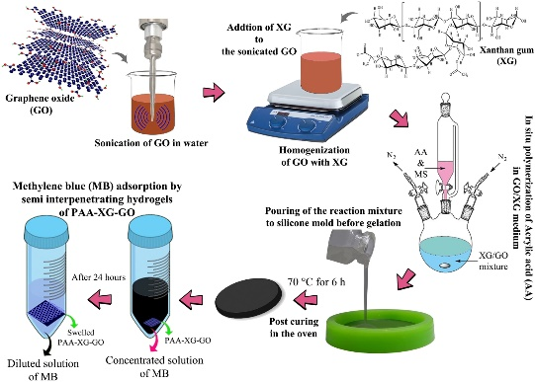
Recent Publications (minimum 5)
- Makhado, E., Pandey, S., Modibane, K. D., Kang, M., & Hato, M. J. (2020). Sequestration of methylene blue dye using sodium alginate poly (acrylic acid)@ ZnO hydrogel nanocomposite: kinetic, isotherm, and thermodynamic investigations. International journal of biological macromolecules, 162, 60-73.
- Mahdi, M. A., Aljeboree, A. M., Jasim, L. S., & Alkaim, A. F. (2021). Synthesis, Characterization and Adsorption Studies of a Graphene Oxide/Polyacrylic Acid Nanocomposite Hydrogel. NeuroQuantology, 19(9), 46.
- Gao, B., Yu, H., Wen, J., Zeng, H., Liang, T., Zuo, F., & Cheng, C. (2021). Super-adsorbent poly (acrylic acid)/laponite hydrogel with ultrahigh mechanical property for adsorption of methylene blue. Journal of Environmental Chemical Engineering, 9(6), 106346.
- Liu, Y., Xiang, Y., Xu, H., & Li, H. (2021). The reuse of nano-TiO2 under different concentration of CO32-using coagulation process and its photocatalytic ability in treatment of methyl orange. Separation and Purification Technology, 120152.
- Heng, Z. W., Chong, W. C., Pang, Y. L., & Koo, C. H. (2021). Self-assembling of NCQDs-TiO2 nanocomposite on poly (acrylic acid)-grafted polyethersulfone membrane for photocatalytic removal and membrane filtration. Materials Today: Proceedings.

Biography (150 word limit)
Seyyed Masud Naserzade has his expertise in evaluation and optimization in improving pigment removal. His contextual evaluation model based on previous scholars such as Hanes Woolf for improving water purification. He has used several models after years of experience in research, evaluation in his thesis.
Email: Masud.naserzade@ut.ac.ir

Notes/Comments: I am young and new scholar, I just ask to give me a chance for an international presentation.

