Abstract

Title: An automatic demulsification sponge for separation of oil/water emulsion

Jui-Tai Wu, Jeng-Yi Wu, Chiung-Chi Liu, Ping-szu Tsai*

Department of Chemical and Materials Engineering, National Kaohsiung University of Science and Technology, Taiwan

Keywords: Demulsification, oil/water emulsion, quaternary amine polymer, sponge, electrostatic adsorption.

- Abstract

The oil droplets contained in wastewater often caused considerable troubles in wastewater treatment. Especially for the oil-water emulsions containing oil droplets with small particle size. The engineers and the researchers are always pursuing advanced materials and technology to deal with them.
Recently, a polymer with a quaternary amine structure was synthesized in our laboratory. We have applied such polymer to sterilization and separation of oil-water emulsions and achieved good results.
When such a monomer is specifically polymerized in sponges having particular pore structure, the emulsion-containing wastewater was separated perfectly(efficiency > 99%). Besides, these sponges exhibited a surprising automatic demulsification effect in just a few minutes. The application of the basic principles of electrostatic adsorption, concentration diffusion, aggregation, and density convection are used to explain the mechanism of the automatic demulsification effect. We believed that the discovery of this phenomenon will help the academic and engineering communities to develop more efficient automatic demulsification sponges in the near future.

Image:

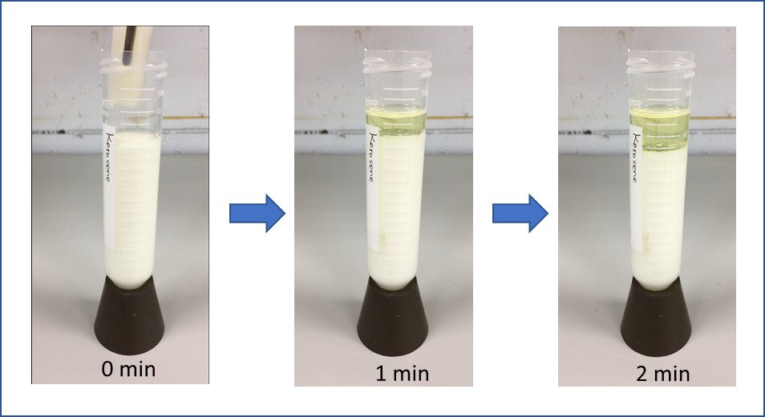

- References:

1 J.Y. Wu, C.W. Huang, P.S. Tsai, 2019. Preparation of poly[3-(methacryloylamino) propyl] trimethyl ammonium chloride coated mesh for oil–water separation. Desalination and Water Treatment, 158, 301-308.

- Y. Guan, F. Cheng, Z. Pan, X. Xue, F. Wang, and X. Liu, 2019. Superwetting Polymeric Three Dimensional (3D) Porous Materials for Oil/Water Separation: A Review. Polymers, 11(5), 1-34.

- H. Huang, Y. Li, L. Zhao, Y. Yu, J. Xu, X. Yin, S. Chen, J. Wu, H. Yue, H. Wang, L. Wang, 2019. A Facile Fabrication of Chitosan Modified PPS-Based Microfiber Membrane for Effective Antibacterial Activity and Oil-In-Water Emulsion Separation. Cellulose, 26(4), 2599-2611.

Biography:

Dr. Ping-Szu Tsai currently is a Professor of the Department of Chemical and Materials Engineering. He received his B.S. degree in chemical engineering from National Taiwan University of Science and Technology, Master degree in college of Pharmacy from Kaoshiung Medical University and Ph.D. degree in chemical engineering from National Cheng Kung University. Dr. Tsai joined National kaoshiung University of Science and Technology in 1992. Dr. Tsai’s current research interests include oil/water separation technology, organic/inorganic nanohybrids, regeneration bitumen, emulsified bitumen/diesel, ,transparent/superhydrophobic coating and synthesize of functional polymers.

Presenting author details



Full Name: Ping-Szu Tsai
Session name/ number: Nanotechnology in Water Treatment/12
Category: Poster presentation

