DEVELOPMENT OF A SMARTPHONE APPLICATION FOR THE MEASUREMENT OF ALCOHOL CONSUMPTION AND INTOXICATION: THE ALCOHOL INTOXICATION MONITOR (AIM)
Alptekin Aydin MBPS-MSc
Department: MSc Addiction Studies, Institute of Psychiatry, Psychology and Neuroscience, King's College

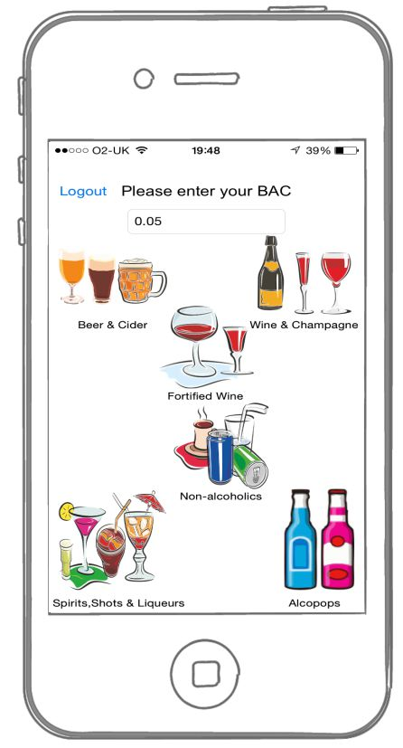

Abstract
Background: Interactive mobile phone technology can improve public health outcomes, and prompt behaviour change allowing interventions to be easily delivered to large numbers of people. Study aim: This study will develop a smartphone app that allows continuous recording of alcohol use and identify a research plan to assess the validity and reliability of geo positioning and assess the validity and reliability of the AIM app user reports of their consumption, intoxication and whether mood influences alcohol consumption. The study will determine whether the Geo-location function of the smartphone works correctly and accurately. Methods:This study uses smartphone technology with an integrated application for ecological momentary assessment (EMA) in a natural environment. The app is designed to incorporate the recording of alcohol consumption, BAC Level (blood alcohol concentration), coordinated Geographic Information System (GIS) to place drinking in location, time and recurrence and includes measures of subjective intoxication and mood state with a short version Profile of Mood States (POMS) Results: A smartphone app was developed and validated. The app, the Alcohol Intoxication Monitor (AIM), measures alcohol BAC level and mood states and also provides real-time assessment of dynamic processes as well as interactive feedback and assessment.
Conclusion: This study found that the geo-location function of AIM worked accurately and that real-time mobile assessment of drinking behaviour in real-life situations using AIM is feasible.
The data collected by AIM could be combined with alcohol-related incident reports from local hospitals or police forces to provide a more comprehensive picture of alcohol problem “hot spots”. AIM could also be expanded to incorporate brief interventions for alcohol problems and collect data to help show the effectiveness of this intervention.

Image

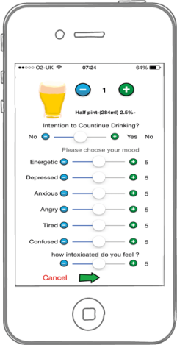
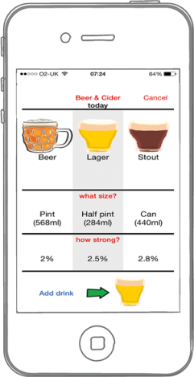
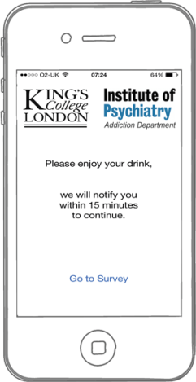
The AIM APP

 Alptekin Aydin
I am a member of British Psychology Society and The Federation of Drug & Alcohol Professions (FDAP). I Graduated from Istanbul University, Psychology. I have completed MSc Courses in Addiction Studies-Institute of Psychiatry, Psychology & Neuroscience (IoPPN) King's College London. On June 2014, towards my Masters degree I had my clinical replacement at the Beresford Project Alcohol service, in Greenwich, under the supervision of Dr Francis Keaney. Since 2015 I have been working with Redcard Gambling Support as a Gambling Addiction Therapist also voluntarily help Hackney Council on Stoptober Campaign.(Stoptober is a 28 day long event run each October during which participants are encouraged to stop smoking. Public Health England created the annual campaign and continues to fund it.) Since 19th July 2016 continuing working on my private clinic Muswell Hill North London Therapy.
Email: alptekinaydin@hotmail.com

Notes/Comments:

Currently I have been working on a new location based e-health apps integrated with Assessments, CBT and self-helped guidance and panic button. I Will explain about these briefly at the end of my presentation.

