Abstract Template

Title:
Auriculoterapy in the process of slimming: case study.

This is a case study where a 23-year-old female patient who had tried to lose weight several times since she was 16 years of age worked with auricular acupoints within a two-month follow-up period. process.
We used the current auriculotherapy protocol for weight loss assembled through the authors' bases described in the study, together with the combination of several techniques that we followed during the study period in this course.
Other support was also used in the dietary slimming process based on Traditional Chinese Medicine using the Handbook of Hero as a complement.
We performed an auricular protocol of applications, being auriculoterapia once every 7 days with a total of 10 sessions, using auriculo points according to energy diagnosis and proponents of authors for weight loss. The points made in this patient were Shen Men, Liver, Spleen, Stomach, Heart, Subcortex, Anxiety, Hunger and Central Nervous System (SNV), thirst hunger triad and vices. We used the same points in all sessions, manual lymphatic drainage with comfort massages, reeducation with the tonification of the earth element, also responsible for the process of nutrient transformation, where a range of tonifying Spleen / Pancreas food was added, guiding the patient to use in the daily diet such as pineapple, chard, brown sugar, watercress, chestnut, eggplant and exclude others like milk, because this patient by the diagnosis has fluid retention transforming into swelling and for traditional Chinese medicine we call deficiency Spleen / pancreas .
The study was carried out from July 2014 to September 2014.

Image:


Reference:

1 Ysao Yamamura
The Art of Inserting 2nd Edition: 2004 Roca
2 Giovanni Maciocia The Basics of Chinese Medicine 2007 ed: Roca
3Marcelo Pereira 2001 Ear surgery and auricular acupuncture fundamentals 2008, Brunilda T. Reichmann.
4 Sonia Hirsch 2010 Hero Manual Chinese diet therapy

A Bachelor's degree in nursing at age 24, a public health specialist at Uninove São Paulo University in São Paulo, a specialist in acupuncture at CETN University, he took an Advanced acupuncture curse at the University of Xiamem, China. currently members of Abena, the Brazilian Association of acupunctures nurse.

. Presenting author :
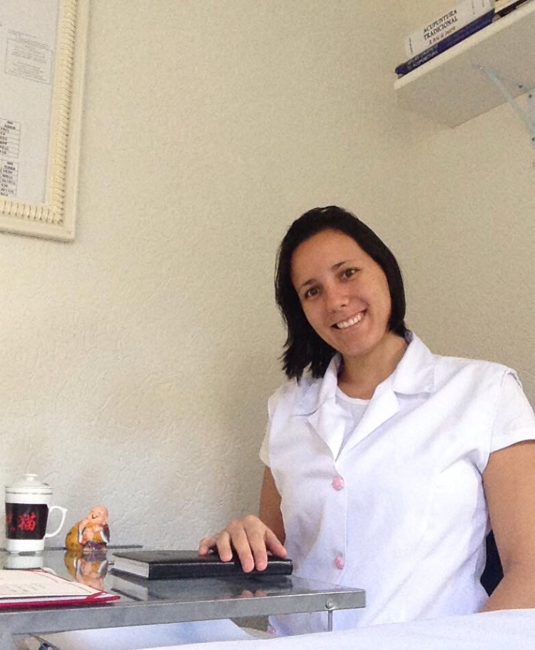

Full Name: Carla Cardoso De Oliveira
Contact number: Brasil 55 11973672935
Category: ( Poster presentation)
Passport Number: FJ186209

