Auricular Acupuncture for Cognitive Impairment and Dementia: A Systematic Review
Chan-Young Kwon1, Boram Lee1, Hyo-Weon Suh1,2, Sun-Yong Chung1,2, and Jong Woo Kim1,2
1 Department of Clinical Korean Medicine, Graduate School, Kyung Hee University, Kyung Hee Dae-ro 26, Dongdaemun-gu, Seoul 02447, Republic of Korea
2 Department of Neuropsychiatry, Kyung Hee University Korean Medicine Hospital at Gangdong, Dongnam-ro 892, Gangdong-gu, Seoul 05278, Republic of Korea

Abstract
In this systematic review and meta-analysis, we investigated the efficacy and safety of auricular acupuncture (AA), which is a safe and non-pharmaceutical treatment inserting needle or attaching medicinal herb to acupoints in the outer ear, for cognitive impairment and dementia.

Twelve electronic databases were searched, and 9 randomized controlled trials (RCTs), to August 2017, evaluating effects of AA on cognitive impairment and/or dementia were included. The results are as follow.

(1) For vascular dementia (VD) patients, AA showed mixed results on cognitive function and insignificant differences in self-care ability compared to Western medication (WM). However, when AA combined with WM, the clinical effectiveness was better compared to WM alone.
(2) For mild cognitive impairment (MCI) patients, AA combined with WM did not showed significant improvement in cognitive function compared to WM. However, when AA combined with herbal medicine (HM), significant improvements in cognitive function and self-care ability were occurred, compared to HM alone.
(3) There was no report about adverse event associated with AA.
(4) The methodological quality of included RCTs was generally poor.

For the efficacy of AA on cognitive impairment and/or dementia, limited evidence suggested that AA may help to enhance the clinical effectiveness of WM in VD patients and to improve cognitive function and self-care ability of MCI patients when it combined with HM. However, more rigorous and large-scale RCTs are needed to confirm the efficacy and safety of AA on these population.
Image
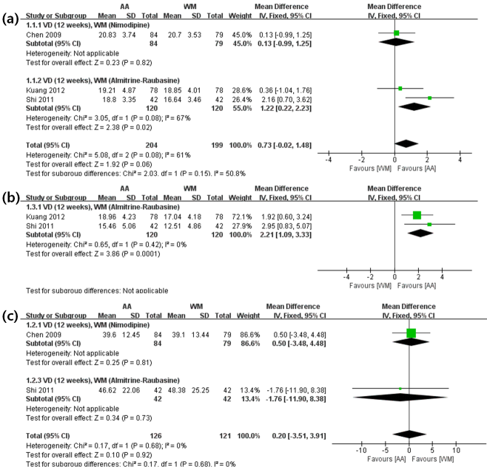
Figure. Forest plots for comparison of auricular acupuncture (AA) versus Western medication (WM). (a) The Mini-Mental State Examination (MMSE) (b) The Hierarchic Dementia Scale (HDS) (c) Activities of daily living (ADL)
Recent Publications
- Kwon CY, Lee B (2018) Clinical effects of acupressure on nakchim: A systematic review. Integrative Medicine Research https://doi.org/10.1016/j.imr.2018.01.002
- Kwon CY, Choi EJ, Chung SY, Kim JW (2017) Meditation in Clinical Practice Guidelines. Korean Journal of Meditation 7(2):33-45.
- Jung IH, Kwon CY, Kim JW, Chung SY (2017) Clinical Effect of Herbal Medicine Treatment on Insomnia in a Public Health Center. Journal of Oriental Neuropsychiatry 28(4):419-429.
- Yoon SH, Kim YS, Kwon MG, Kwon CY (2017) Randomized Controlled Trials of Miniscalpel Acupuncture for Lumbar Spinal Stenosis Cited in the China National Knowledge Infrastructure Database. The Acupuncture 34(3):59-69.
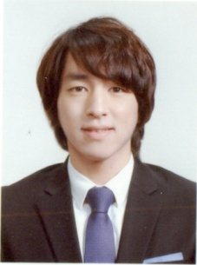
5. Kwon CY, Lee B, Cho JH (2017) Conventional Western Medicine and Complementary and Alternative Medicine on Leg Cramps: A Literature Review. Journal of Korean Medicine 38(3):13-29.

Biography
Chan-Young Kwon is a Korean Medicine Doctor (KMD) and a specialist on oriental neuropsychiatry. He received a master’s degree from Kyung Hee University in 2016, and he’s doing his doctoral studies. He has published several papers about neuropsychiatric conditions including posttraumatic stress disorder (PTSD), depression, headache, insomnia, and emotion freedom technique (EFT). And he participated in the process of developing KM clinical practice guideline on depression. Now he works at a public health center in south Korea.
Email: beanalogue@naver.com

