RNA amendments control gene expression during development

Israr Khan

Affiliations
Department of Genetics, Hazara University Mansehra, Pakistan.

Abstract: RNA chemical modifications in coding and non-coding RNAs have been known for decades. They are generally installed by specific enzymes and, in some cases, can be read and erased by other specific proteins. The impact of RNA chemical modifications on gene expression regulation and the reversible nature of some of these modifications led to the birth of the word epitranscriptomics, in analogy with the changes that occur on DNA and histones. Among more than 100 different modifications identified so far, most of the epitranscriptomics studies focused on the N 6 -methyladenosine (m6A), which is the more abundant internal modification in protein coding RNAs. m6A can control several pathways of gene expression, including spicing, export, stability, and translation. In this review, we describe the interplay between m6A and non-coding RNAs, in particular microRNAs and lncRNAs, with examples of its role in gene expression regulation. Finally, we discuss its relevance in cell development and disease.

Keywords: epitranscriptomics, m6A, RNA modifications, non-coding RNAs, microRNAs, lncRNAs, cell reprogramming, ESC development

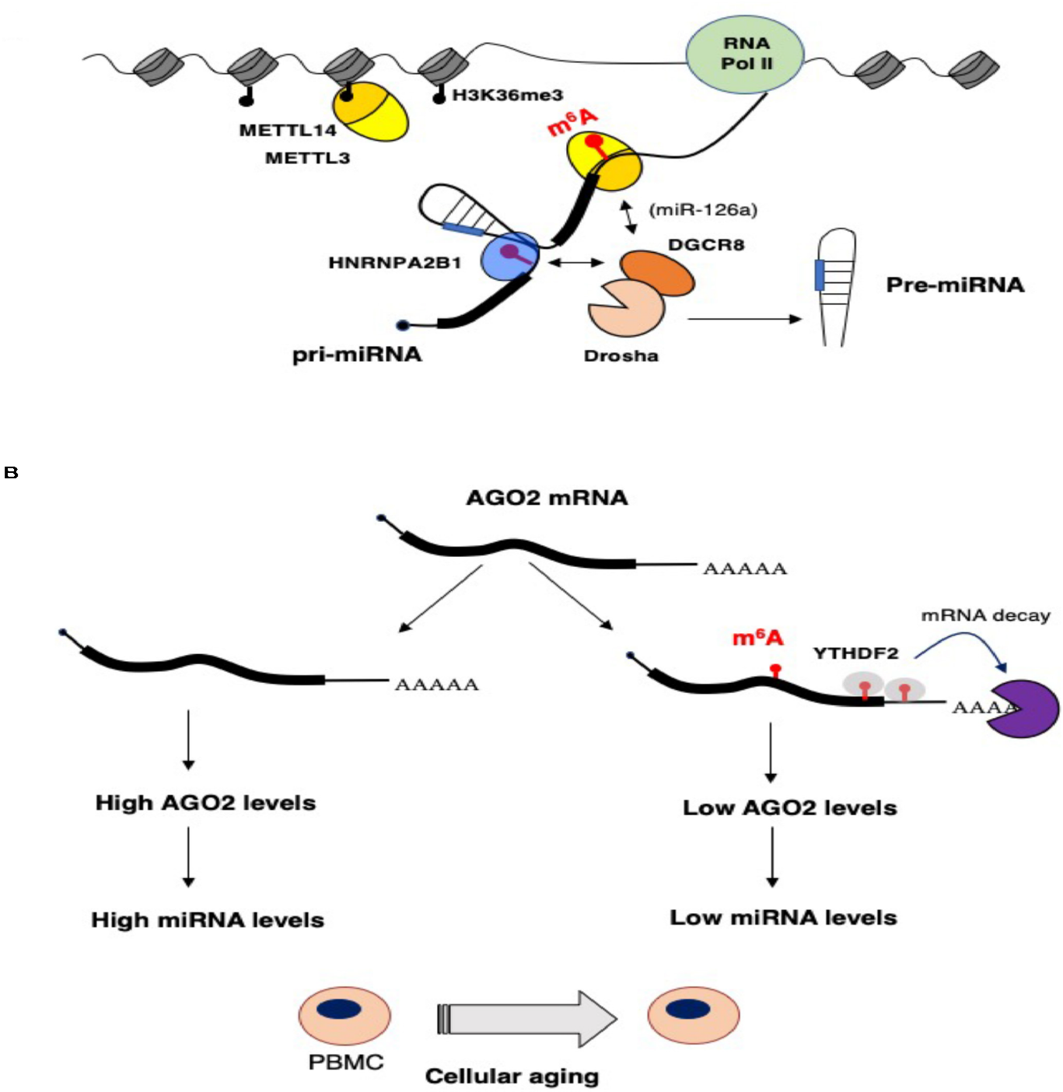

FIGURE 1 | Impact of epitranscriptomics on microRNAs biogenesis and function. (A) m6 A stimulates microRNA processing by recruiting the Drosha cofactor DGCR8 by the m6 A reader HNBRPA2B1 or, in the case of the miR-126a, by direct interaction with METTL14. (B) During aging of peripheral blood mononuclear cells (PBMCs), AGO2 and, eventually, miRNA levels are decreased by higher m6 A modification of AGO2 mRNA. This results in enhanced mRNA decay that is very likely mediated by the YTHDF2 reader

