Genome-wide analysis of NeuroD family of bHLH transcription factor

Shouhartha Choudhury¹ Prosenjit Paul² and, Supriyo Chakraborty^{3*}
¹Department of Biotechnology, Assam University, Silchar-788011
²School of Life Sciences, Assam University, Silchar-788011

Keywords: Type 2 diabetes, NEUROD1, NEUROD Family, bHLH transcription factor, Gene expression
Abstract
The present study investigated NeuroD (Beta2) family is a basic helix-loop-helix transcription factor widespread in genome. In NeuroD family particular gene expresses in neurons, beta-pancreatic cells and, enteroendocrine cells. It is involved differentiation of nervous system and development of pancreas. The NEUROD1 (Neurogenic differentiation 1) found to convert reactive glial cells into functional neurons in brain. NEUROD1 induces differentiation of nervous system and regulate insulin gene expression by binding to critical E-box motif on insulin promoter and mutation result type 2 diabetes mellitus. It is logically assumed, NUEROD1 regulate insulin and found to Chromosome 2 of human. The genomic complement of NeuroD family of bHLH transcription factor is an essential component for identification of the specific gene. We accumulate eukaryotes genome i.e. Homo sapiens and Mus musculus for comparative and functional analysis. The genome-wide analysis results suggested NeuroD family and their bHLH domain, motifs, phylogeny, chromosome location and, gene expression. In this study, we performed bioinformatics and computational technique to the current knowledge of NeuroD family of bHLH transcription factor.

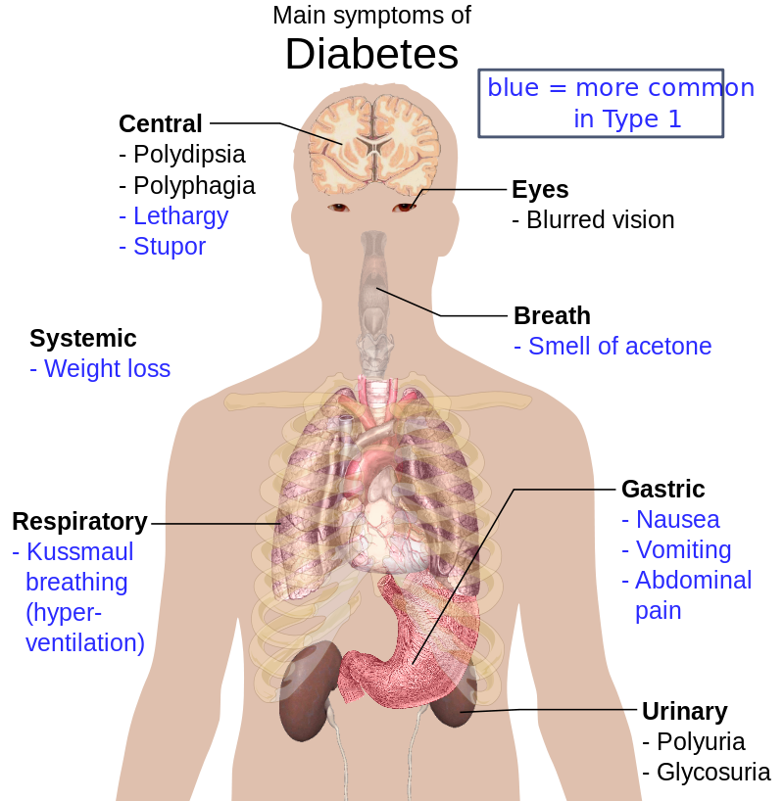

Reference
- Latchman, D.S., Transcription factors: an overview. The international journal of biochemistry & cell biology, 1997. 29(12): p. 1305-1312.

- Malecki, M.T., et al., Mutations in NEUROD1 are associated with the development of type 2 diabetes mellitus. Nature genetics, 1999. 23(3): p. 323.

- Liu, M., et al., Loss of BETA2/NeuroD leads to malformation of the dentate gyrus and epilepsy. Proceedings of the National Academy of Sciences, 2000. 97(2): p. 865-870.
Biography
Shouhartha Choudhury has completed his B.Tech and M.Tech in Bioinformatics from India and now pursuing integrated pre-Ph.D. research in School of Life Sciences, Department of Biotechnology, Assam University, Silchar-788011

Author details


Full Name: Shouhartha Choudhury
Contact number: +91-9954411181
Twitter account: Shouhartha Choudhury
Linked In account: Shouhartha Choudhury
Session name/ number:
Category: (Oral and poster presentation)
Passport Number:

