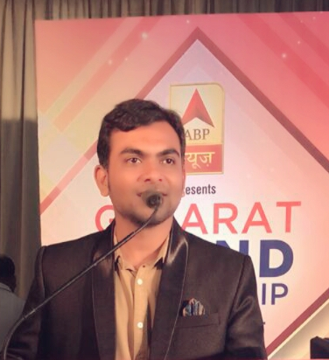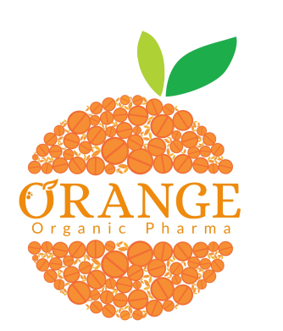

Title: Advance treatment for Diabetes- Glucobeet
Name: Dr. Shridhar J Pandya, M.Pharm, PhD
Research head, Orange Organic Pharma-India

Abstract
Diabetes is a condition that impairs the body's ability to process blood glucose, otherwise known as blood sugar. In the United States, the estimated number of people over 18 years of age with diagnosed and undiagnosed diabetes is 30.2 million. The figure represents between 27.9 and 32.7 percent of the population. Patient’s satisfaction is major limitation with allopathic or insulin because it can’t able to give symptomatic relief in diabetes as with poor compliance. Alternative therapies like herbal supplements, Ayurvedic products also helpful to reduces blood sugar level and improve function of beta cell, hence function of beta cell and alpha cell can be utilize properly. It is also helpful to reduce or stop other medicines and insulin also.
Our Glucobeet Trademark of Orange Organic Pharma are available in herbal and dietary health supplement tablet dosage form. It works with same function as above mention. Glucobeet is very beneficial to type-1 & type-2 Diabetic patients. It is doctor recommended product available in market since from last 4 years and yet not found any side effect. Glucobeet is manufactured with 100 % extract based ingredients. Ingredients & Excipients incorporate for granulation and tableting is also approved by FDCA & FSSAI guideline as per pharmacopoeial limits. Product manufactured under GMP certified company. Glucobeet helpful to Target on brain signal for adequate insulin secretion by microencapsulation. It Heals damaged β-cell, attacked by immune system by unique isolated herbs. Glucose and stored Glycogen in organ system gives Symptomatic relief of diabetes. It Improves metabolic condition by hepatoprotective extracts. It is very beneficial to control type-1 and type-2 diabetes and also helpful to reduce or stop other medicines and insulin.

Biography
Dr. Shridhar J Pandya has completed his PhD at the age of 28 years from JNU University-India and postdoctoral studies from Pune university in Pharmaceutics as a specialization. He is university top during post-graduation. He is the director and Research head of Orange Organic Pharma-India and having 12 years experience in pharma field. He has published more than 25 national and international papers in reputed journals. He is inventor of more than 50 herbal formulas in various disease conditions. He is expertise in to design formulation in herbal dosage.

Presenting author details Full name: Dr. Shridhar Pandya, Contact number:+919824917109Category: (Oral presentation)

