Abstract Template

Title: 3D Printed Biomaterials for Tissue Engineering
Ghareib W Ali¹ and Wafa A. Ismail¹
1Department of Biomaterials, National Research Institute, Giza, Egypt.

Keywords: Biomaterials, Green Synthesis, Tissue Engineering

- Abstract Body (up to 250 words)
The present study investigated the synthesis and in vitro evaluation of 3D bio-printed chitosan based scaffold. Chitosan based scaffolds are considered as bio-combatable and biodegradable biomaterial. It can be applied directly for several surgical sites. Physic-chemical characterization were performed. FTIR, FESEM, XRD and Thermal analysis were used. In vitro degradation behavior within biological solution was followed. The results improved the successful synthesis of 3d printed chitosan based scaffold with the desired characteristics. The biodegradation process exhibited the controllable degradation behavior that permit the integration of the other tissues.

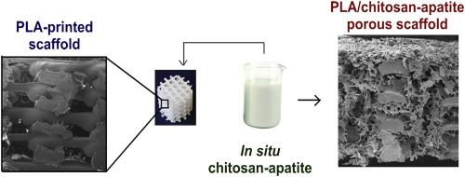
Image: https://doi.org/10.1016/j.polymer.2016.06.030

- Reference:

- AnamarijaRogina, LidijaPribolš, AndrijaHanžek, LuisGόmez-Estrad, GloriaGallego FerrerdeIng, Marijanović, MaricaIvanković, HrvojeIvankovića, 2016. Macroporous poly(lactic acid) construct supporting the osteoinductive porous chitosan-based hydrogel for bone tissue engineering
Polymer, 98, 5172-181.

Biography:
Wafaa Ghareib has completed his PhD at the age of 33 years from Ain-Shams University. He has published more than 10 papers in reputed journals and has been serving as an editorial board member of repute.

Presenting author details

Full Name: Wafaa Ghareib Contact number: +201011103286 Linked In account:
Ghareib W Ali
Session name/ number:
Category: (Oral presentation/ Poster presentation) Passport Number:
A20280944

